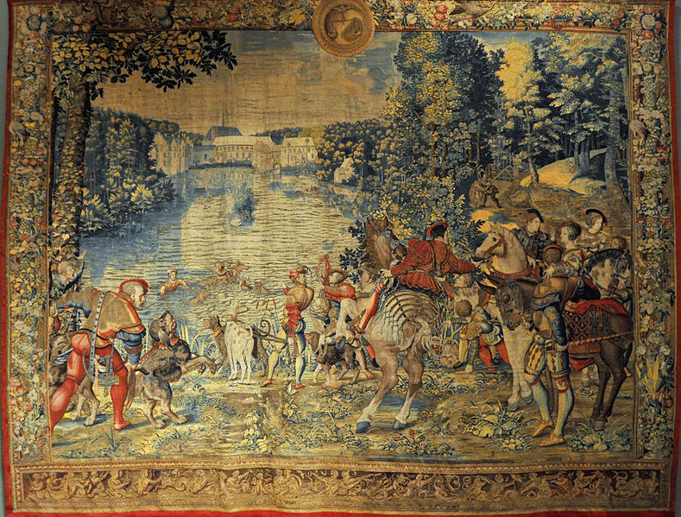
Figure thirty. The month of September, from a twelve piece set of The Hunts of Maximillian, ca.1528-31. Wool, silk and silver and gilt wrapped thread, (440 x 605cm) ©Departement des Objets d’Art, Musee de Louvre, Paris.

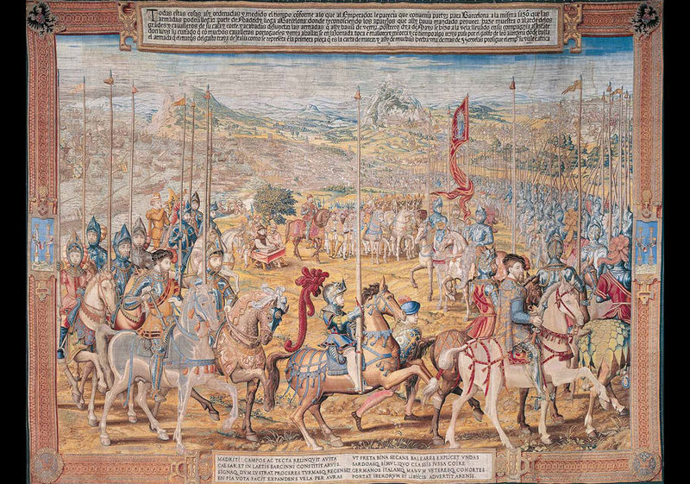
Figure thirty one. Review of the Troops at Barcelona, from the 12 piece series ‘The Conquest of Tunis’, Brussels, c. 1554, gold, silver, silk, and wool tapestry, (532 x 715 cm). © Patrimonio Nacional, Madrid, Palacio Real.

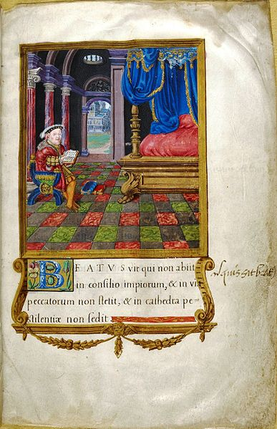
Figure thirty two. Henry VIII as the biblical King David from his Latin Psalter, 1542 ©The British Library.

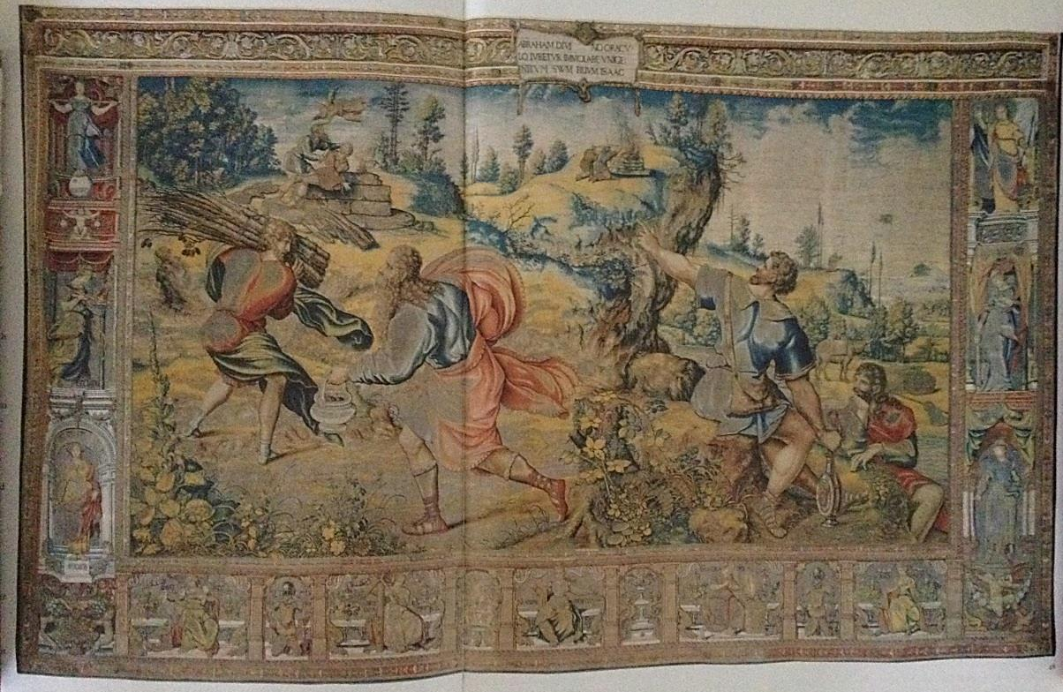

Figure thirty three. The sacrifice of Isaac, from the series ‘The story of Abraham,’ Brussels, c.1540, wool, silk and gilt wrapped thread, (488x792cm). ©The royal collection, Hampton court palace, lent by her majesty Queen Elizabeth II (1008).

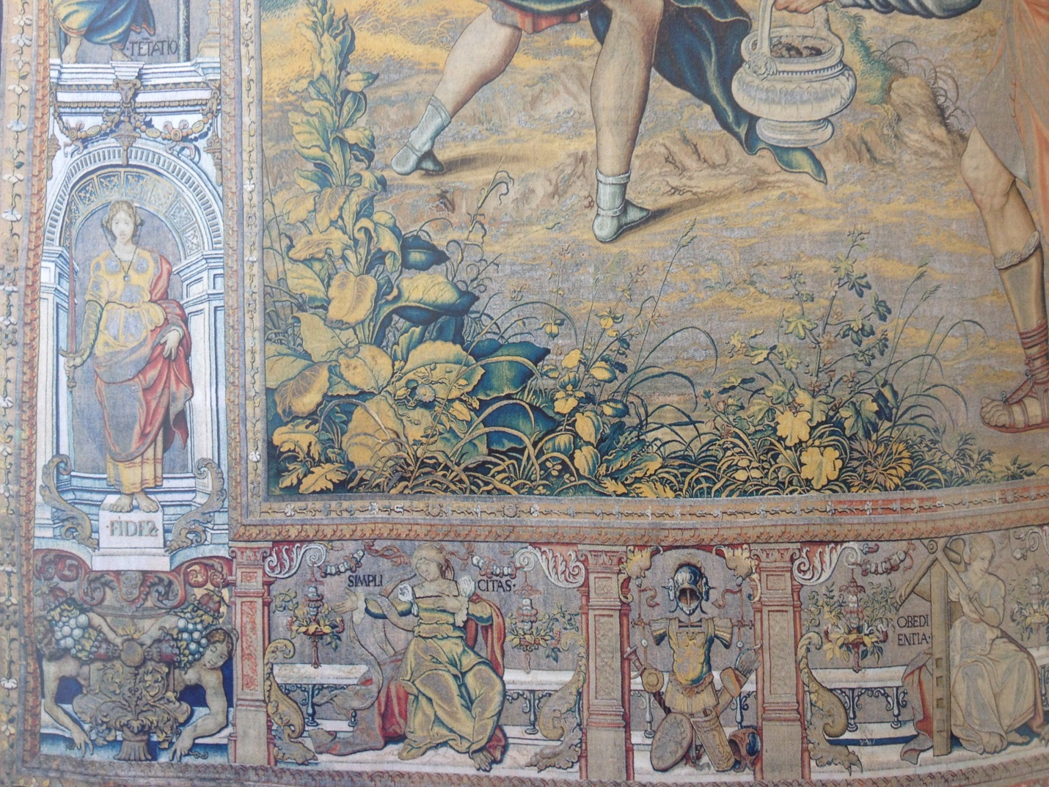
Figure thirty three b. Detail of borders from The sacrifice of Isaac showing personifications of faith, simplicity, and obedience. ©The royal collection, Hampton court palace, lent by her majesty Queen Elizabeth II (1008).

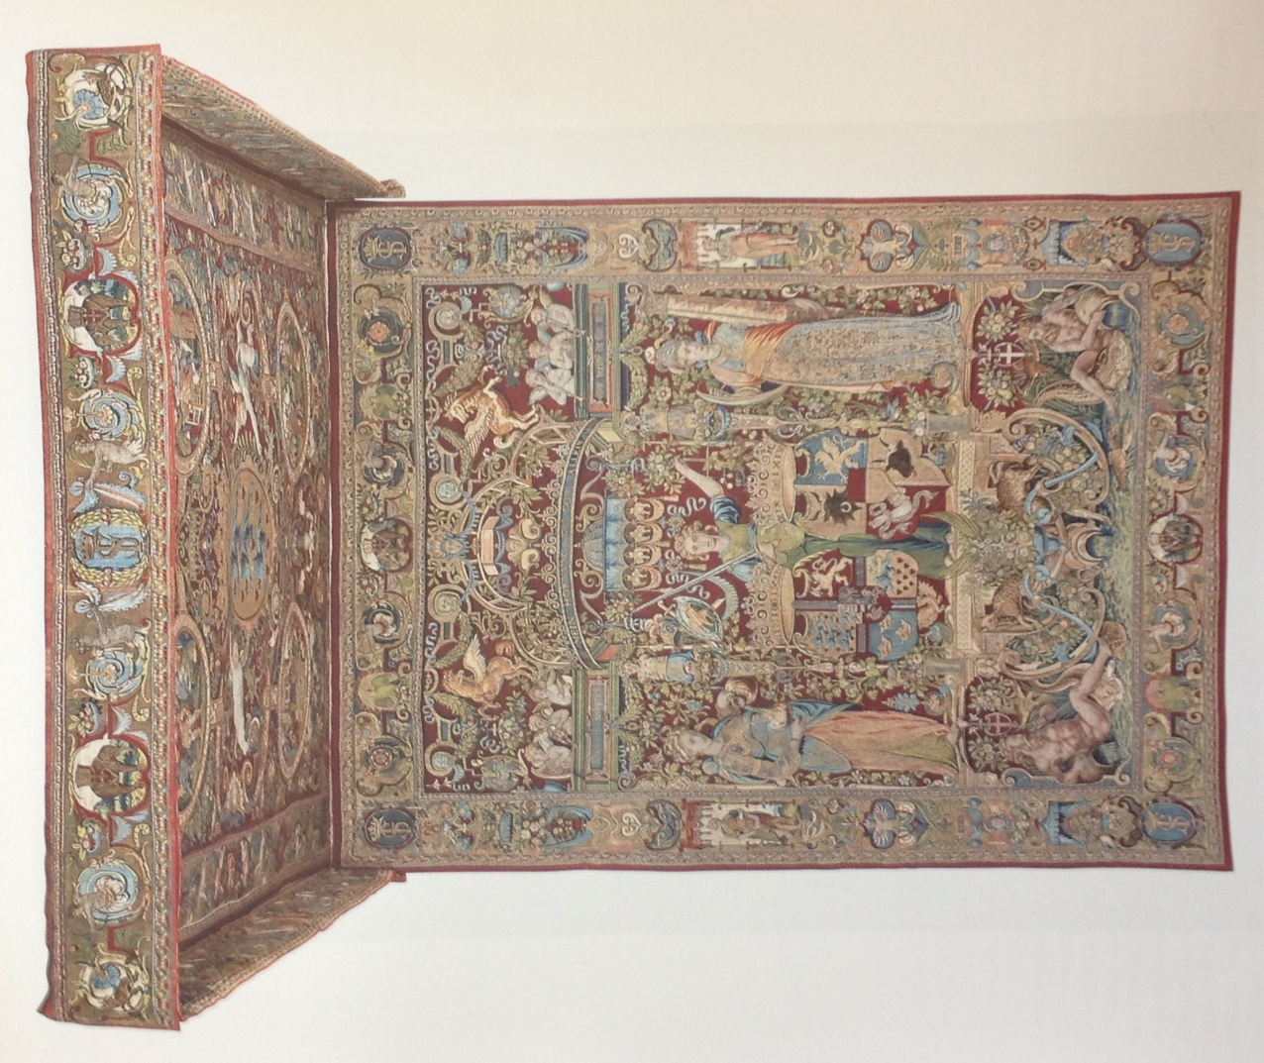
Figure thirty four. Throne Baldachin from the set The genealogy of the Danish kings, ca.1585-6, wool, silk, and gilt wrapped thread. Backcloth (275x353cm), canopy (403x275cm). ©Nationalmuseum, Stockholm (Indep 2 LKR 28861, 28862).
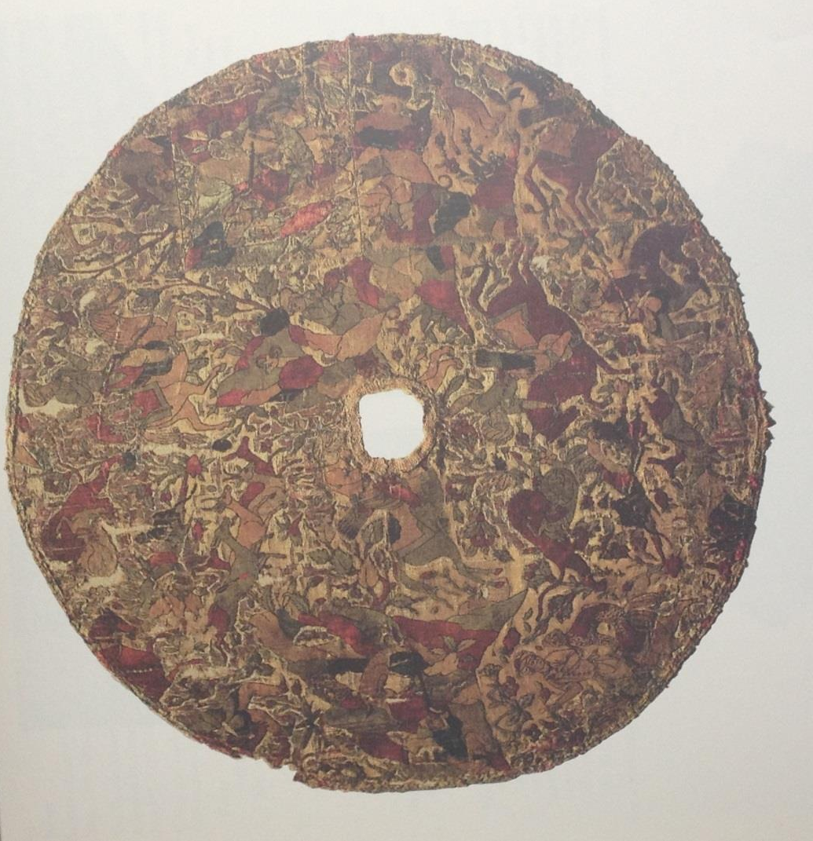

Figure thirty five. Velvet showing hunt scene, part of the decoration of tent ceiling, Iran 16TH century. Velvet, satin and gilt foil, (96cm) ©Museum of fine arts, Boston. Gift of Mrs. Walter Scott Fitz (28.13)

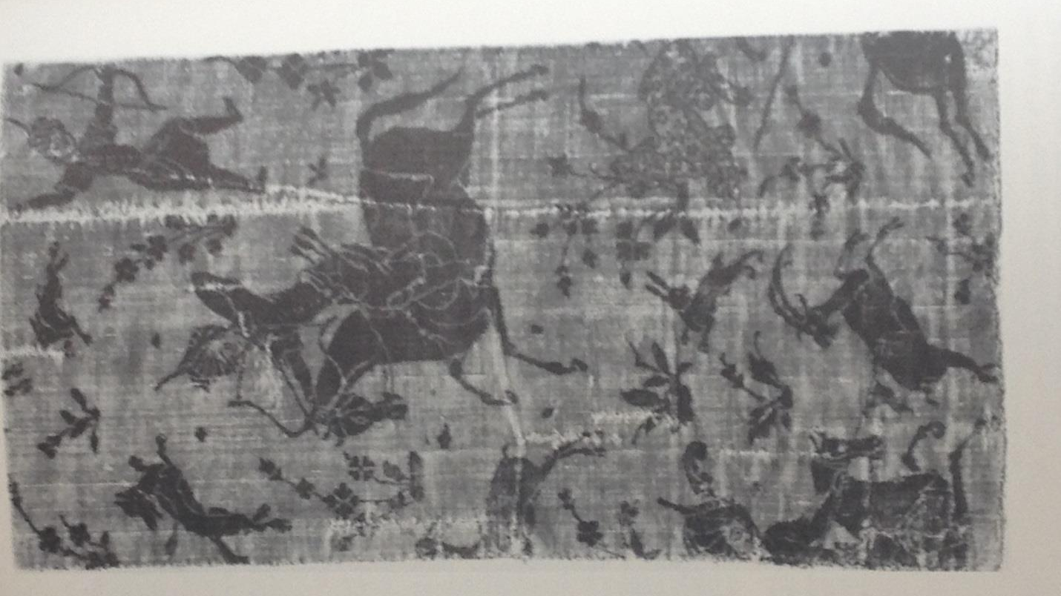
Figure thirty six. Velvet fragment showing a hunt scene, Iran 16th Century. (36cmx20xcm) ©Cooper Hewitt museum, the Smithsonian institution, national museum of design. (1969-100-1) Gift of friends of Louisa Bellinger.

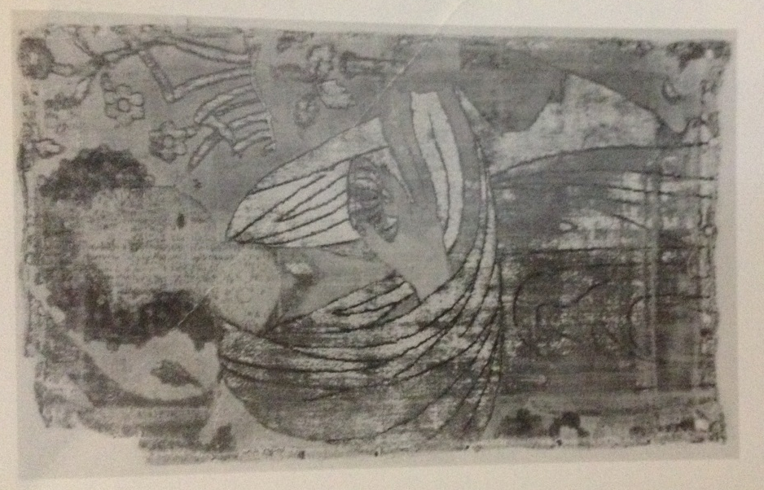

Figure thirty seven. Velvet showing a woman in landscape, Iran, seventeenth century (41.5X24.5cm) ©The Textile museum, Washington DC, acquired by George Hewitt Myers in 1952. Acquired by George Hewitt Myers in 1952 (3.321).

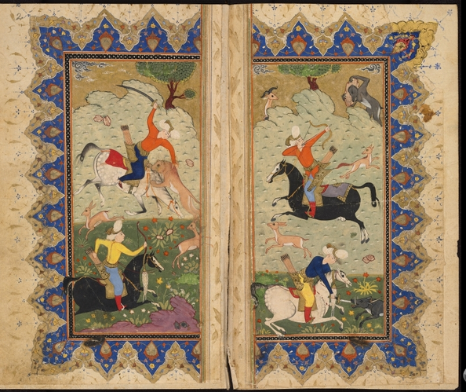

Figure thirty eight. Miniature hunting scene, from a manuscript of ʿAbd al-Vasiʿ al-Jabali, Divan (Collected poems), copied c 1600–05. ©Bodleian Library, University of Oxford, MS Ouseley Add 19, fol 1v.

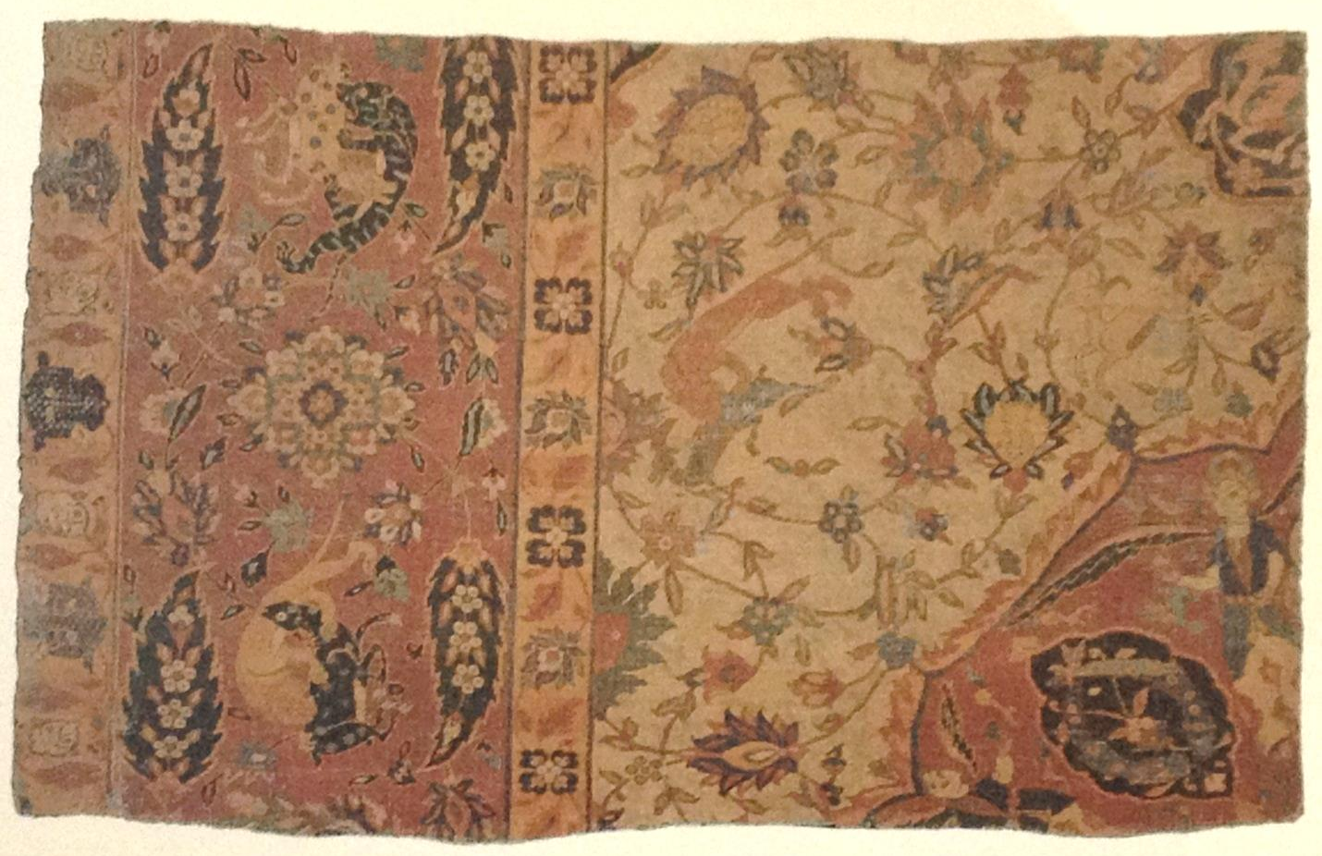

Figure thirty nine. Pile carpet fragment showing lion motifs and animals in combat, Iran 16th century, (77cmx120.5cm) ©The textile museum, Washington DC. Acquired by George Hewitt Myers in 1951 (R.33.2.1).

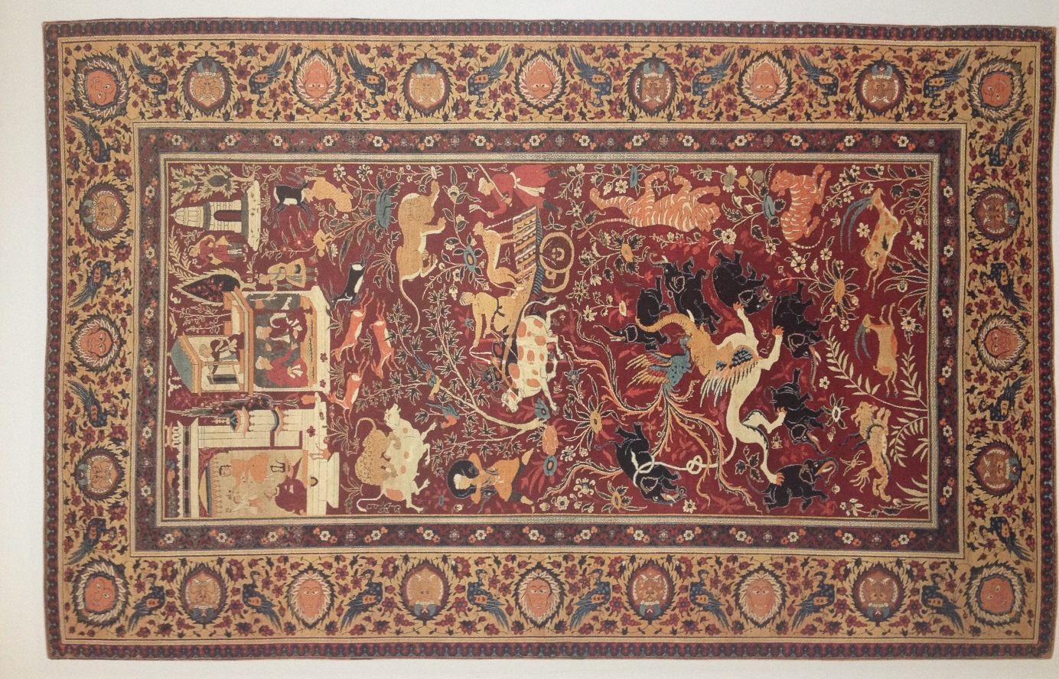

Figure forty. Carpet with pictorial design of courtly pastimes and animals in combat. Northern India ca.1590-1600. ©Museum of fine arts, Boston, gift of Mrs. Fredrick L. Ames in the name of Fredrick L. Ames (93.1480).

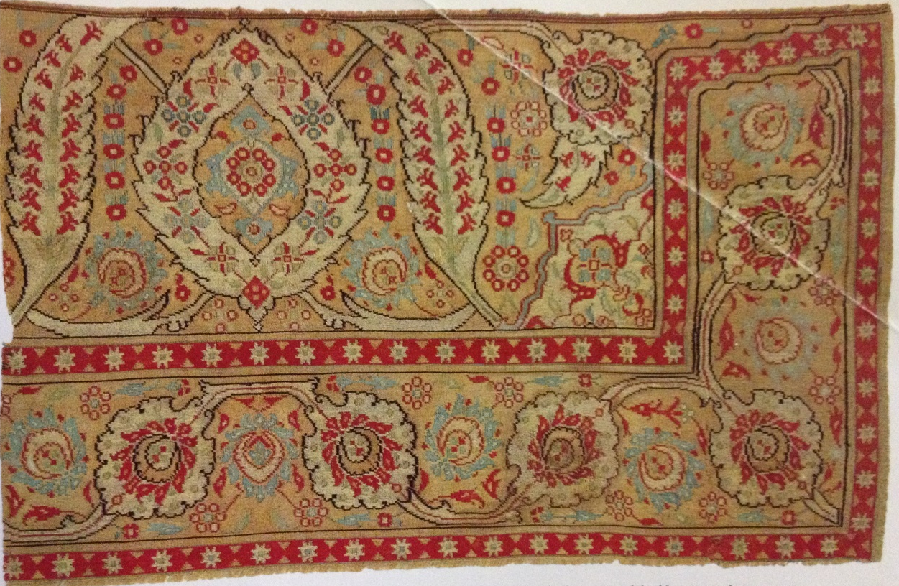
Figure forty one. Fragment of Tapestry-woven saddlecloth. Turkey, second half sixteenth century ©The Textile Musuem, Washington D.C (1.38).

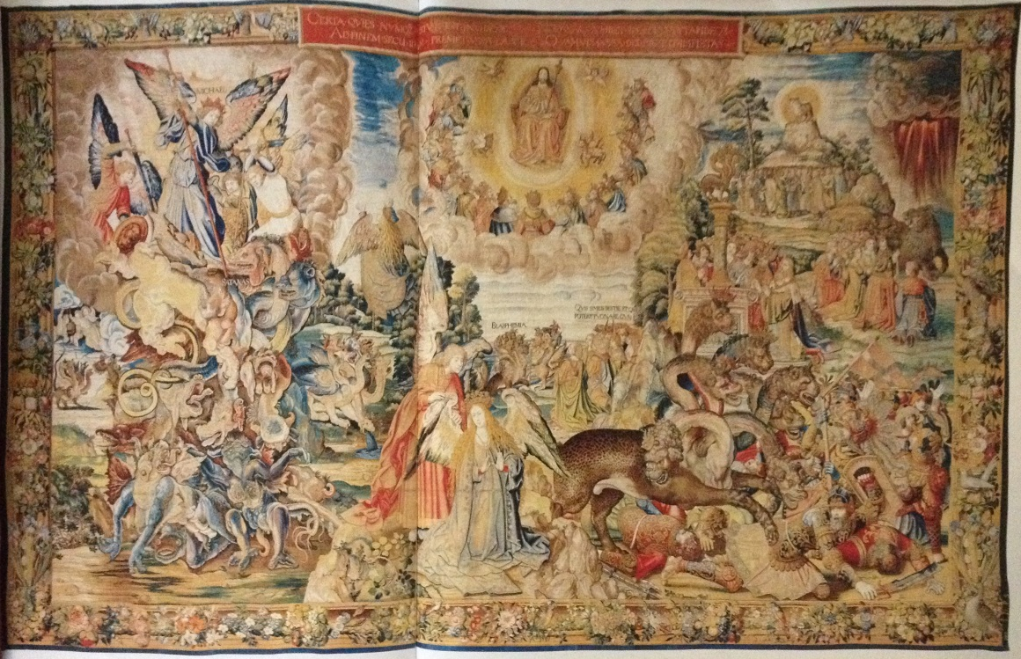
Figure forty two. Saint Michael overcoming Satan, from the eight piece set The Apocalypse. Brussels ca.1553-6, Wool and silvery and gilt wrapped thread, (525x850cm). ©Patrimonio Nacional, Palacio Real de la Granja de San Ildefonson (Ta-11/5, 10026366).
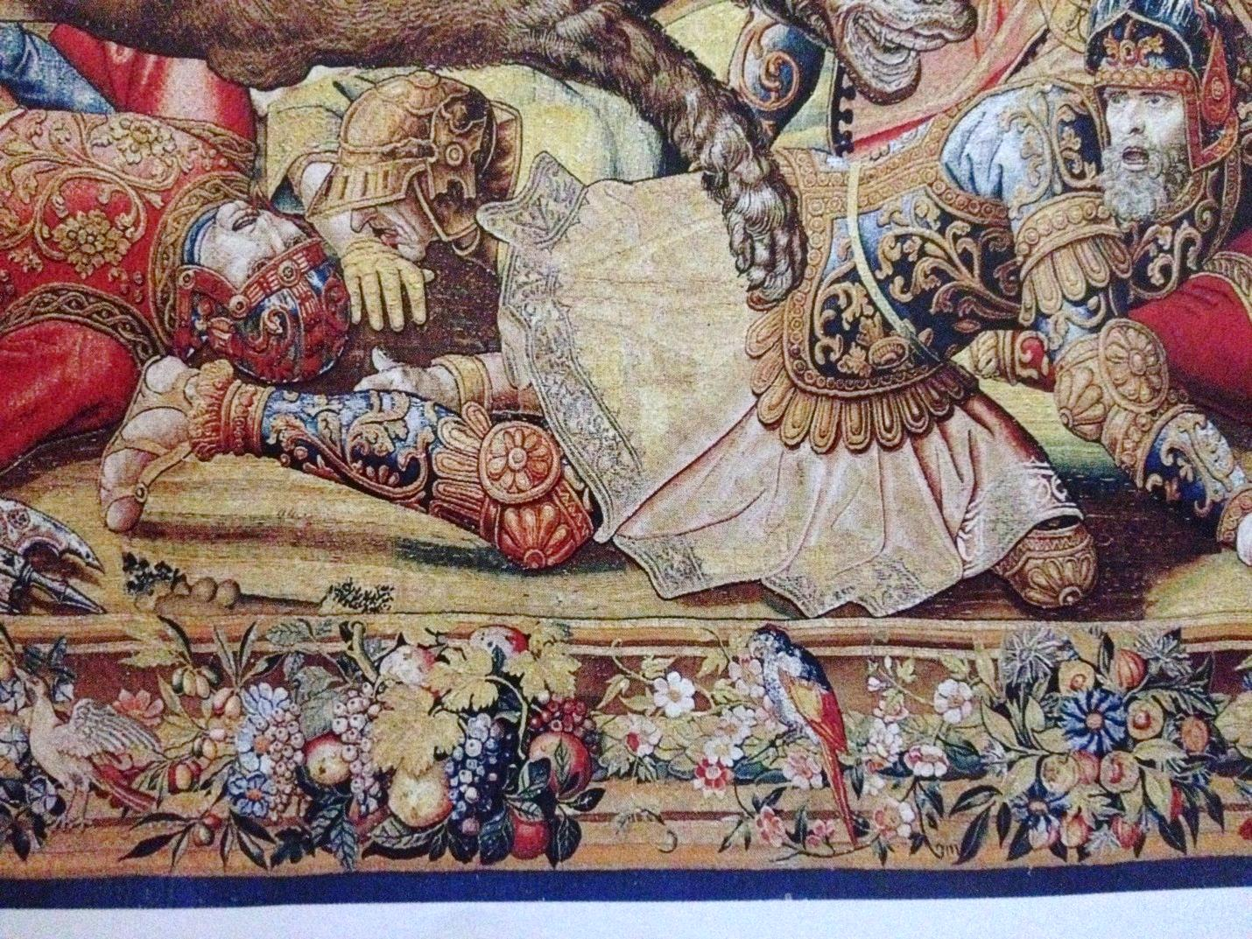

Fiugre forty two B. Border detail of figure forty two, Saint Michael overcoming Satan, showing pomegranates, fruits and fauna. ©Patrimonio Nacional, Palacio Real de la Granja de San Ildefonson (Ta-11/5, 10026366).

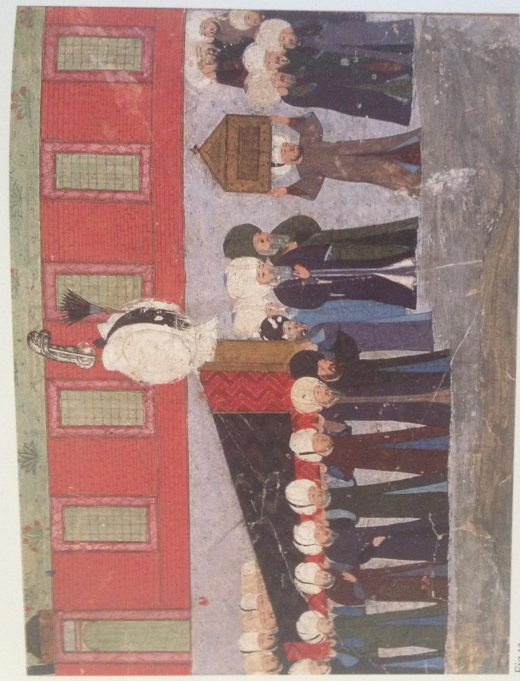
Figure forty three. ‘The burial of Sultan Suleyman’ from the Suleymanname 1579-89, folio 115b. ©Chester Beatty Library, Dublin (Ms.t.413).
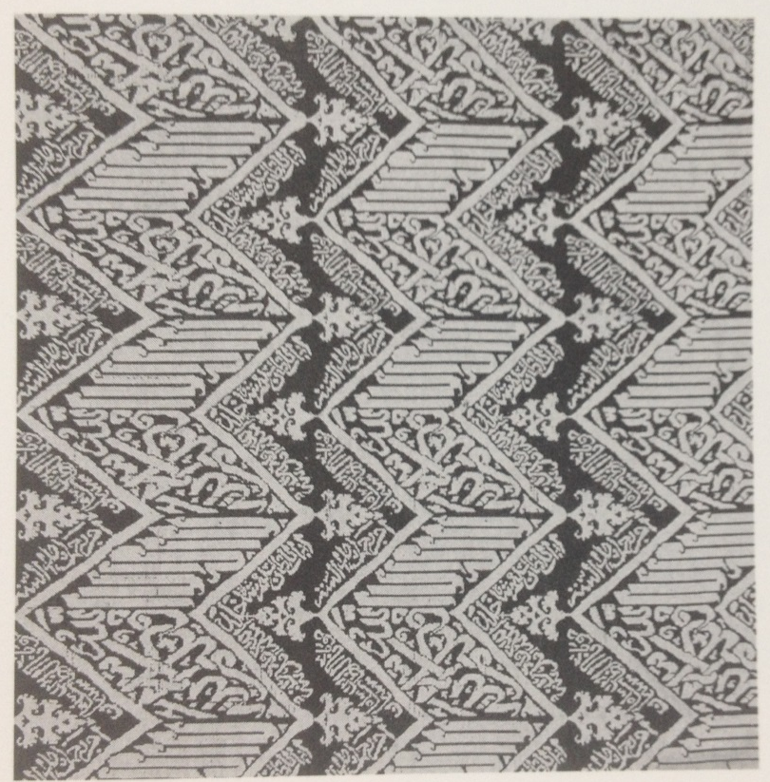
Figure forty four. Suleyman I Tomb cover, brocaded silk with repeated Qur’anic inscriptions, c.1566. ©Topkapi palace museum, Istanbul (13/1957).

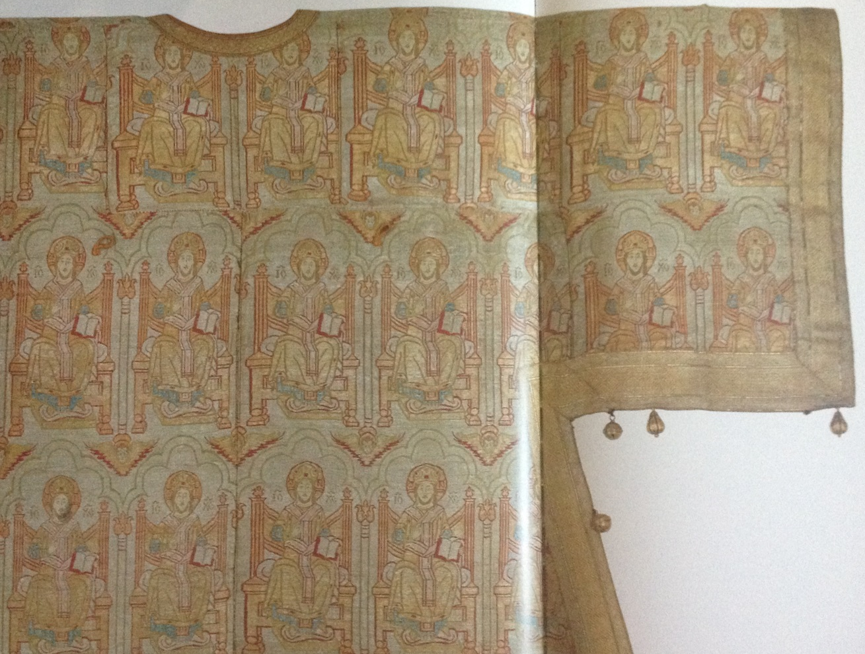

Figure forty five. Russian orthodox dalmatic showing Christ, Istanbul before 1634. ©Kremlin armory museum, Moscow (inv.no.tk-10).

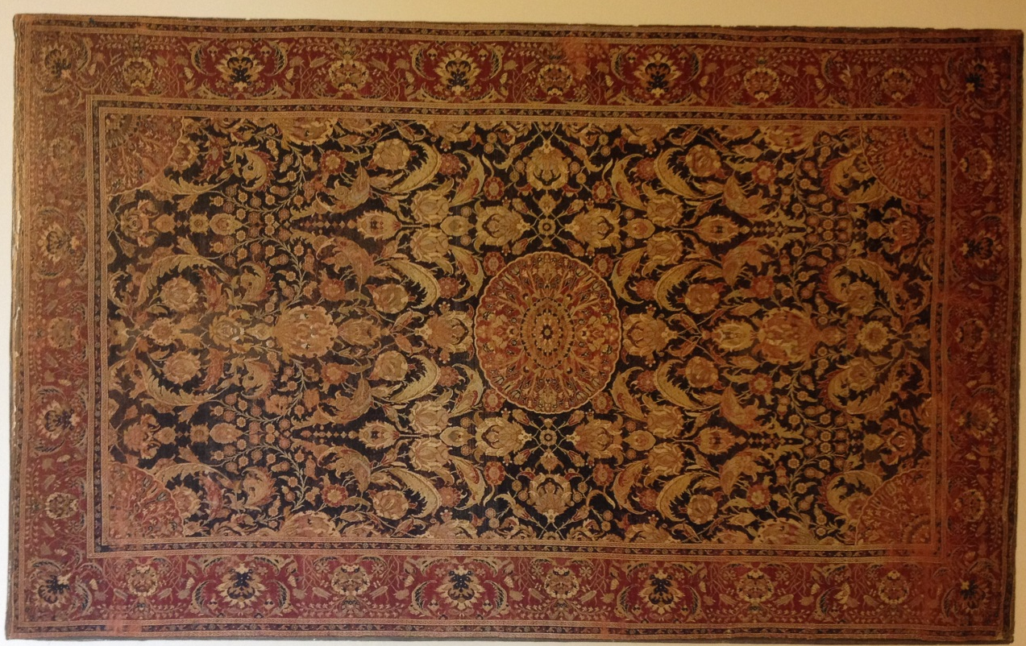

Figure forty six. Prayer rug with saz design, Turkey, second half sixteenth century. ©Österreichisches Musuem fǘr Angewandte Kunst, Vienna (T.8327).

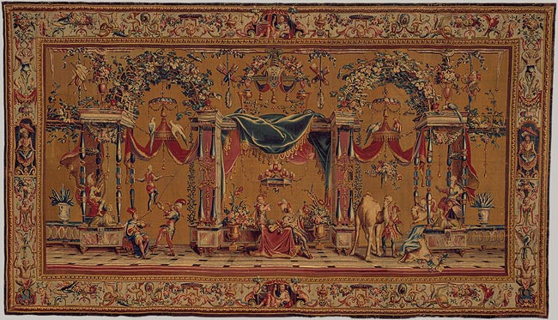

Figure forty seven. The Camel. From the six piece set of Grotesques, Beauvais, Paris, c.1690-1711 (297x528cm). ©The Metropolitan Museum of Art, New York, gift of John M. Schiff 1977 (1977.437.1).

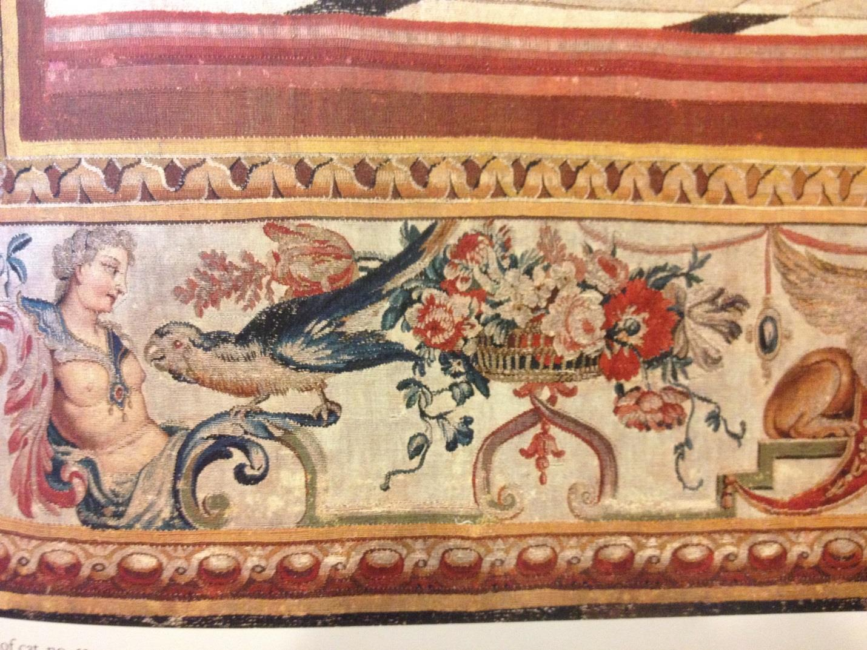

Figure forty seven b. Detail from The Camel, figure forty seven, showing borders designed with exoticized eastern figures. ©The Metropolitan Museum of Art, New York, gift of John M. Schiff 1977 (1977.437.1).

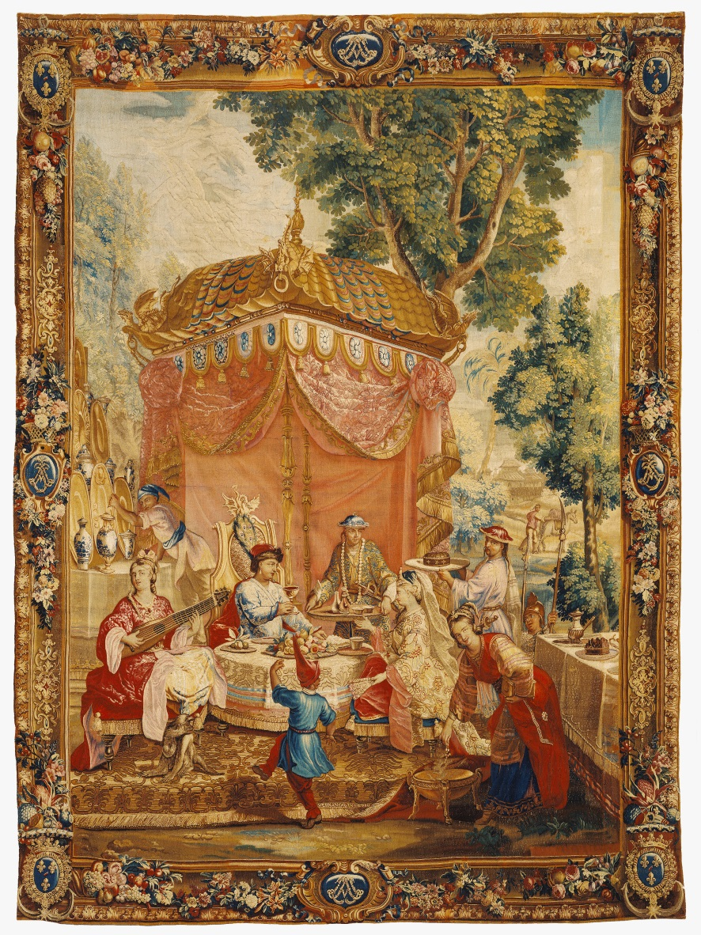
Figure forty eight. The collation. From a ten piece tapestry set the Story of the Emperor of China, Beauvais, Paris, c.1686-90 (423x310cm) © The J. Paul Getty Museum (83.DD.336).

