Appendix.
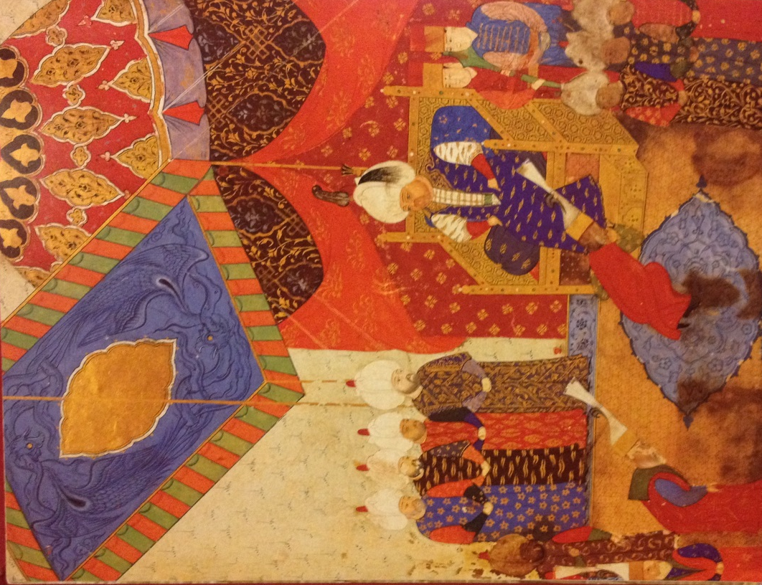
Figure one. The enthronement of Selim II, from the Nuzhet el-Esrar el-Ehbar der sefer-I Sigetvar, fol. 110b, 1568. ©The Topkapi Palace library, Istanbul. MS.H.1339.

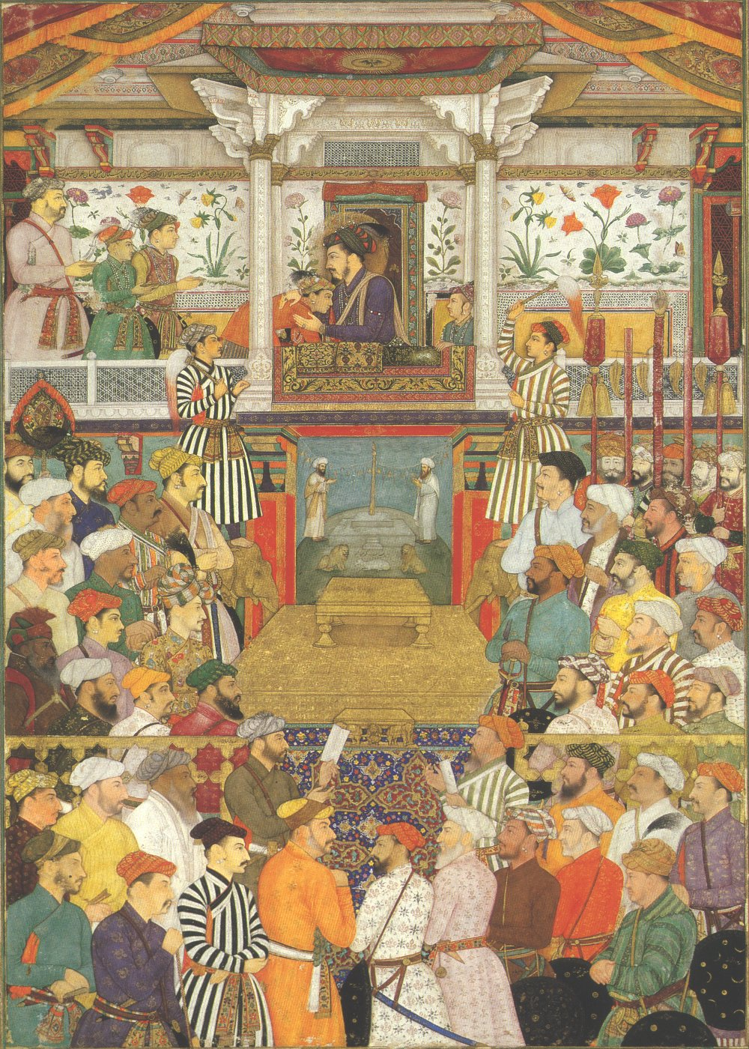
Figure two. Shah Jahan receives his three eldest sons and Asaf Khan during his accession ceremonies. Opaque watercolor and gold on paper. From the Padshahnama (the book of kings) manuscript (f.50b.) Mughal ca.1630. The royal collection, Windsor castle. © Her majesty Queen Elizabeth II

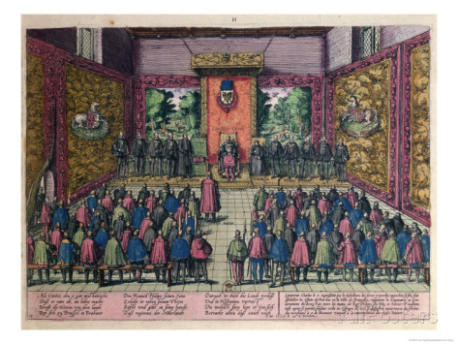
Figure three. The abdication of Charles V from Events in the history of the Netherlands, France, Germany, and England between 1535 and 1608. Later impression of an engraving by Frans Hogenberg, ca 1558. 19.8 x 27.3 cm. ©The metropolitan museum of art, New York; The Elisha Whittelsey Fund, 1959 (59.570.200[11])

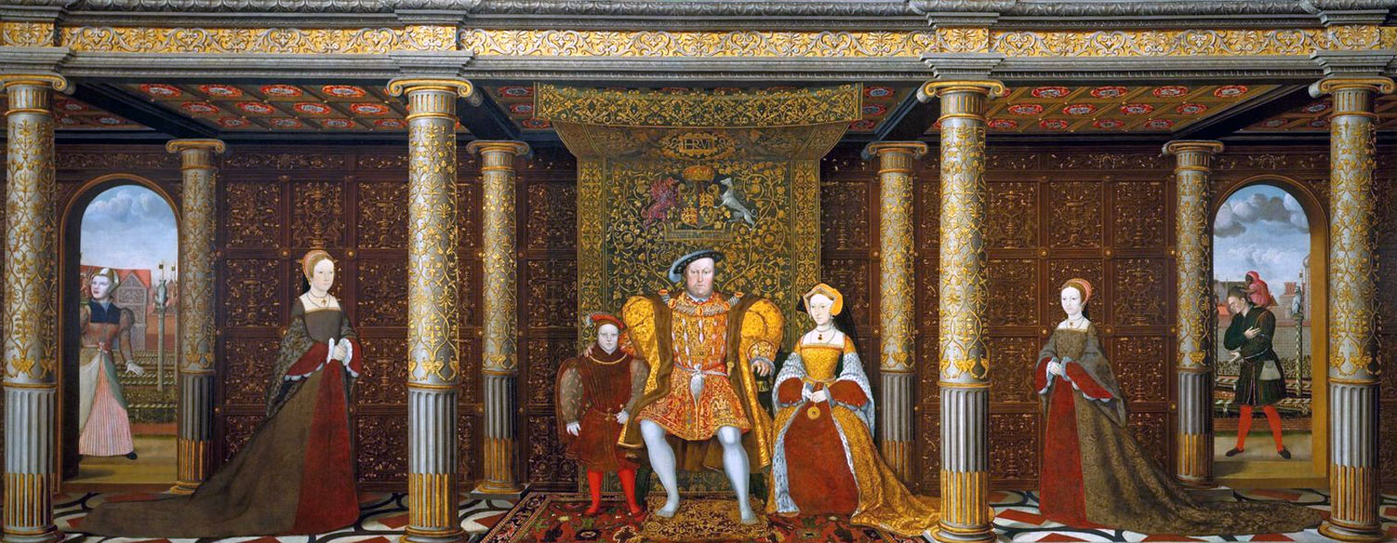
Figure four. The family of King Henry VIII c. 1543-1547. Unknown artist, after Holbein.
Hampton Court Palace. © The Royal Collection.
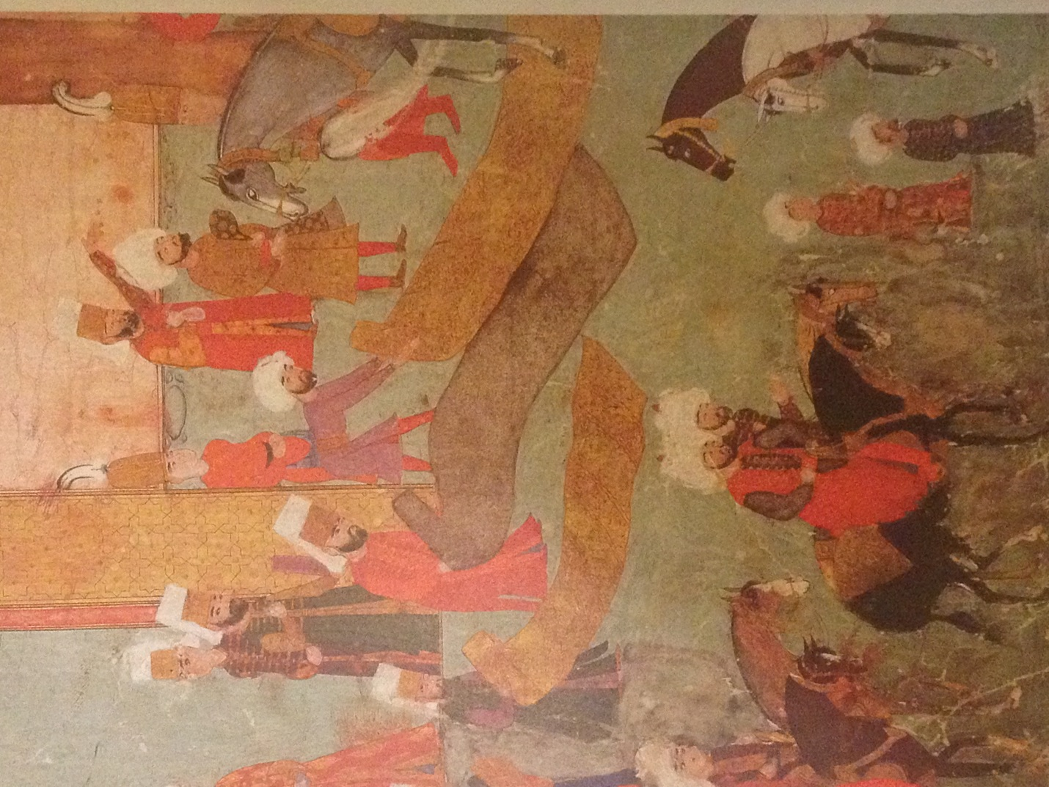
Figure five. Prince Mehmed arriving at the palace of Ibrahim Pasa in the Hippodrome, from the Surname c. 1582, folio 12a. ©Topkapi Palace library Istanbul. MS.H.1244.

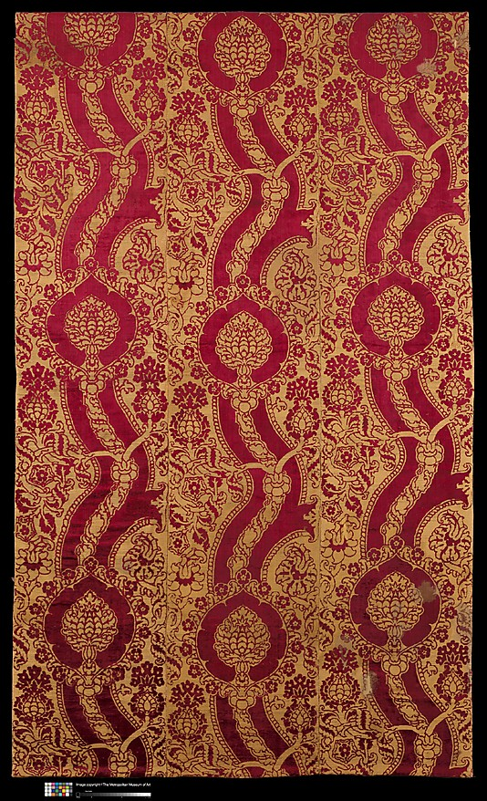
Figure six. Cloth of gold with pattern of palmettes and roses, Italy or Spain c.1500. Velvet with silk and metal thread (279.4 x 167.6 cm), ©The Metropolitan museum of art, New York. Bequest of Susan Dwight Bliss, 1966, (67.55.101).
This is an example of the kind of textile that dominated at the 1520 meeting between Kings Henry VIII and Francis I.

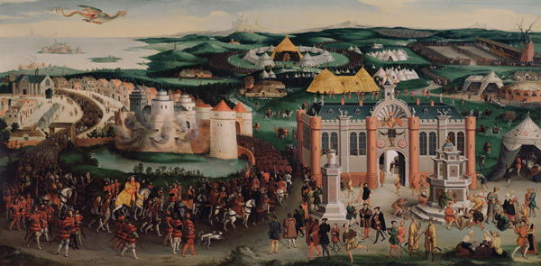
Figure seven. Friedrich August Bouterwek, Meeting at the field of the cloth of gold, oil on canvas c.1820, © The Royal Collection, Windsor.

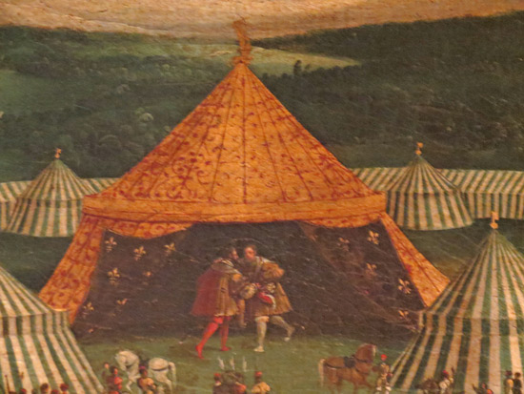
Figure seven-b. Detail of tents from figure seven. Hampton Court Palace. © The Royal Collection

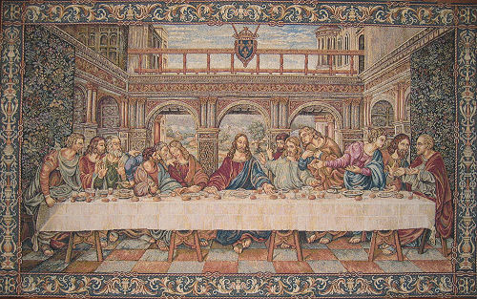
Figure eight, The Last Supper, c.1514, tapestry, wool, silk and gilt metal wrapped thread (490x915cm), woven in the southern Netherlands © Vatican museums, Vatican city.

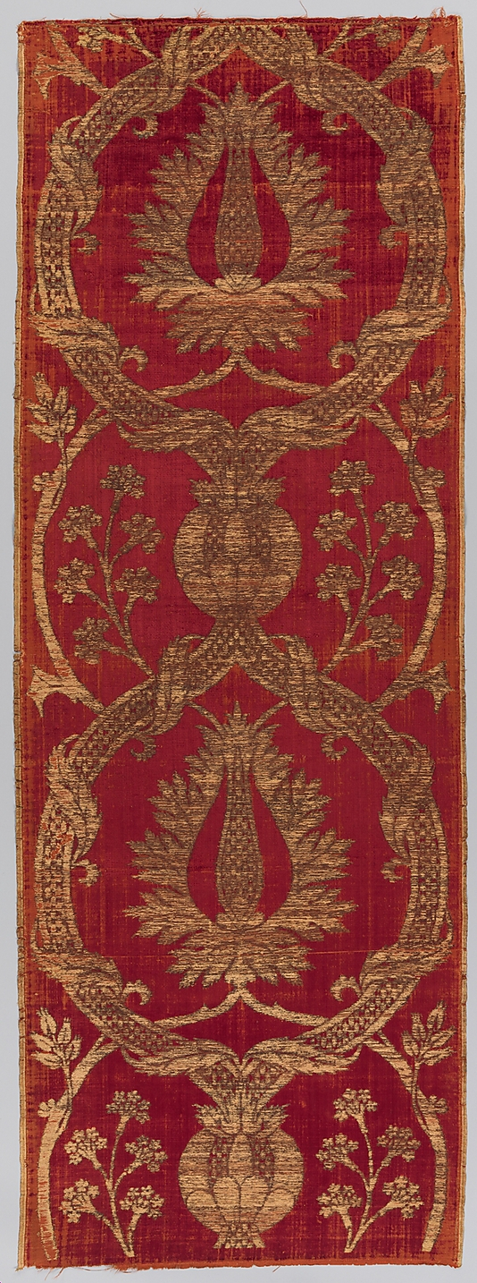
Figure nine. Length of velvet (cloth of gold), silk and metal-wrapped thread (186.7x 66 cm,) Turkey late C16 ©The Metropolitan museum of art, New York. Rogers Fund, 1917 (17.22.8b).

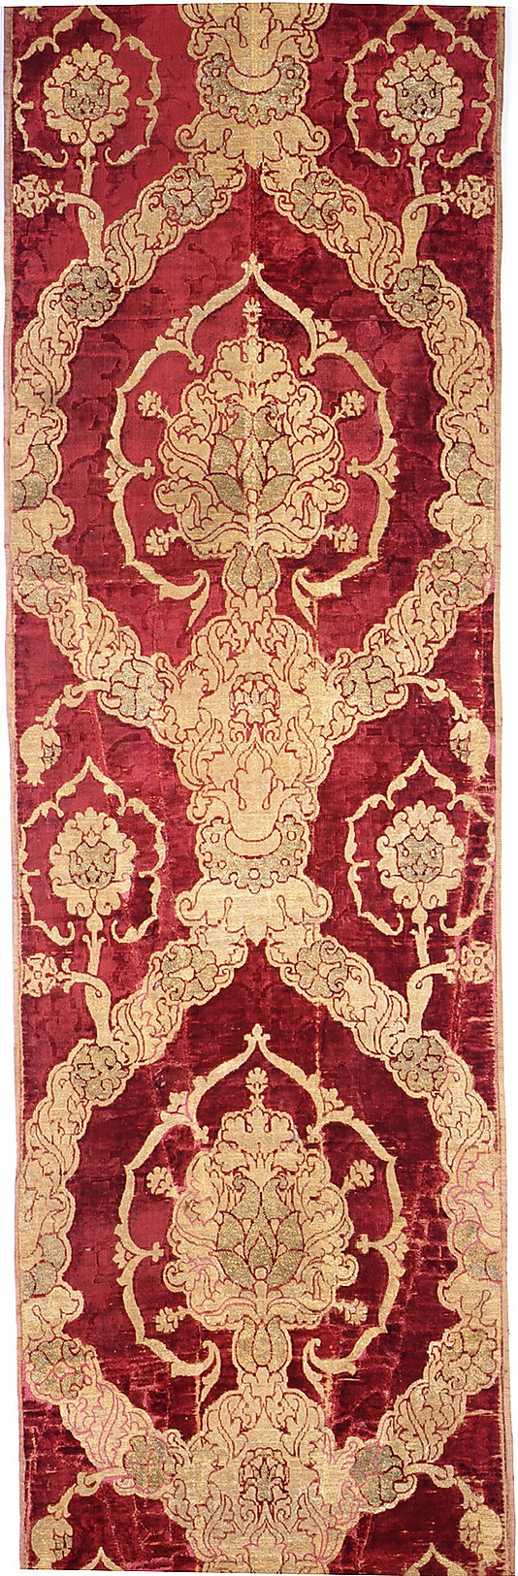
Figure ten. Length of velvet (cloth of gold), silk and metal wrapped thread (374.7x59.1cm), Italy 16th century ©The Metropolitan museum of art, New York. Rogers Fund, 1912 (12.49.8).

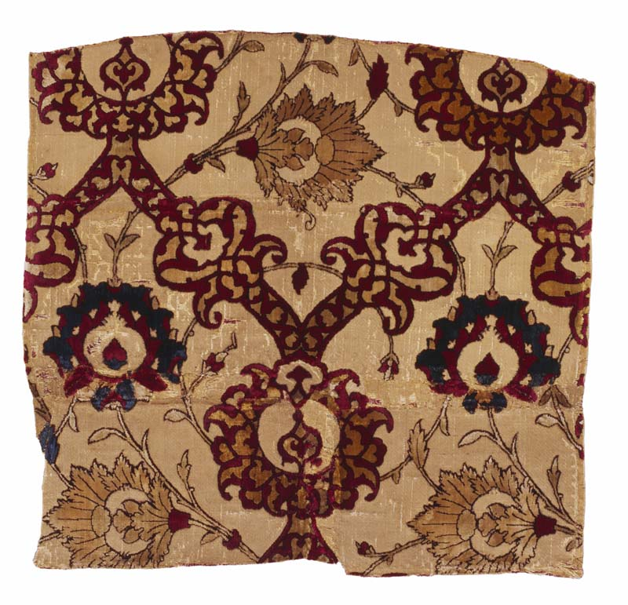
Figure eleven. Velvet hanging (cloth of gold), Velvet with narrow strips of metal foil (49cm x 51.7cm), Iran C16 ©The textile museum, Washington DC. Acquired by George Hewitt Myers in 1929 (3.224).

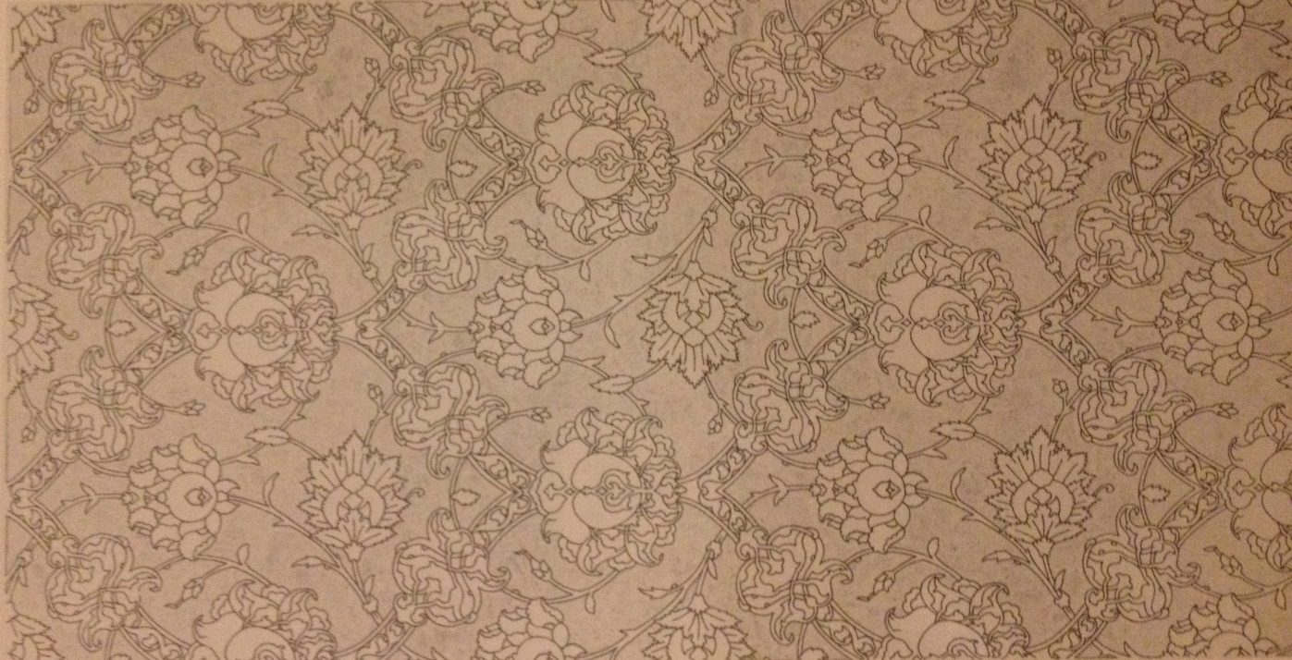
Figure eleven-b, reconstruction of figure 11 by Milton Sonday 1987. ©The textile museum, Washington DC.
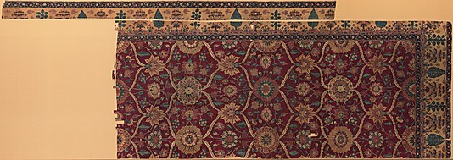
Figure twelve. Fragments of a pashmina carpet with pattern of lattice and blossoms. Northern India c.1650 ©The metropolitan museum of art, New York, bequest of Benjamin Altman, 1913 (14.40.723).
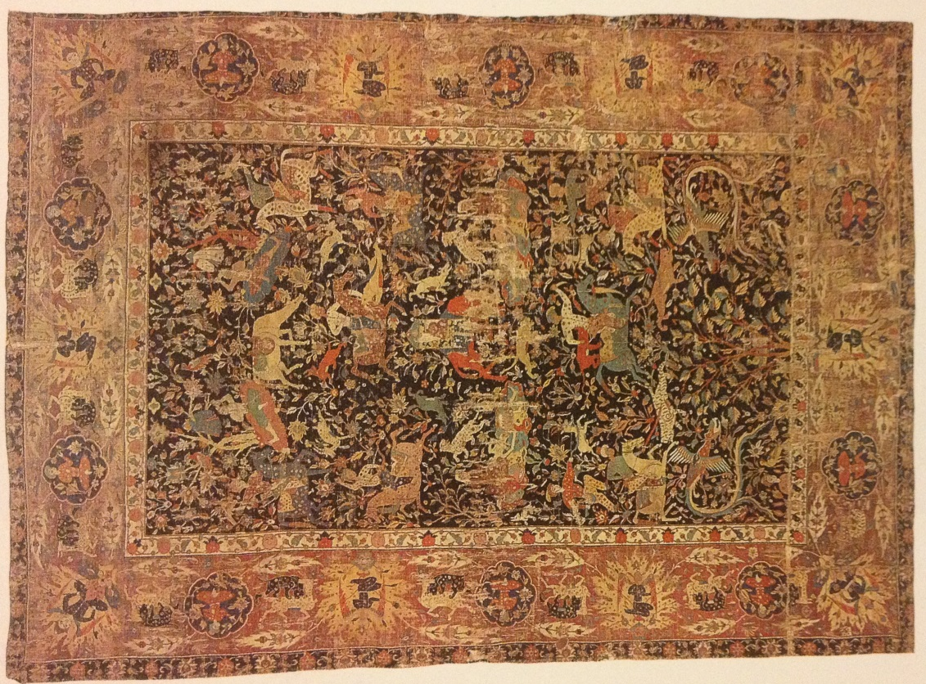
Figure thirteen. Carpet with pictorial design of animals and wildlife. Iran late sixteenth/early seventeenth century. Wool pile on cotton, wool and silk foundation (375x269cm.) ©Musee des arts Decoratifs, Paris inv.no.10615).
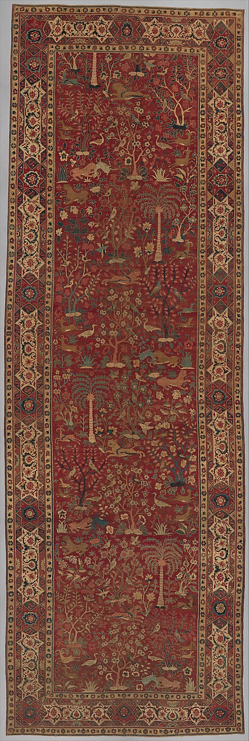
Figure fourteen. Carpet with pictorial design of animals and wildlife. Northern India late sixteenth/early seventeenth century. ©The Metropolitan museum of art, New York, gift of J. Pierpont Morgan, 1917 (17.190.858).
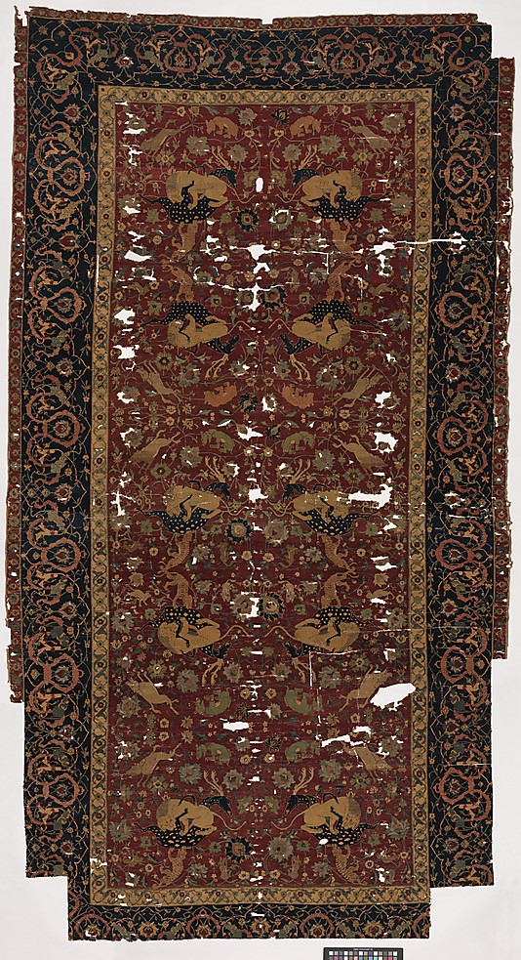
Figure fifteen. Carpet with pattern of scrolling vines and animals. Iran, sixteenth century. Silk and wool (355.6 cmx181cm.) ©The metropolitan museum of art, New York, Frederick C. Hewitt Fund, 1910 (10.61.2).

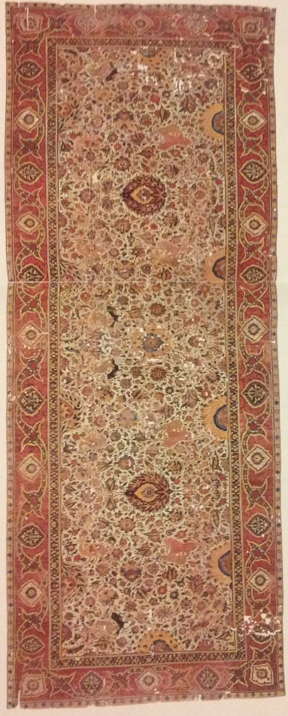
Figure sixteen. Carpet with pattern of scrolling vines and animals. Northern India c.1610. ©Museum fur Islamishe Kunst, Staatliche Museen zu Berlin-Preussischer Kulturbesitz (1.6/74).

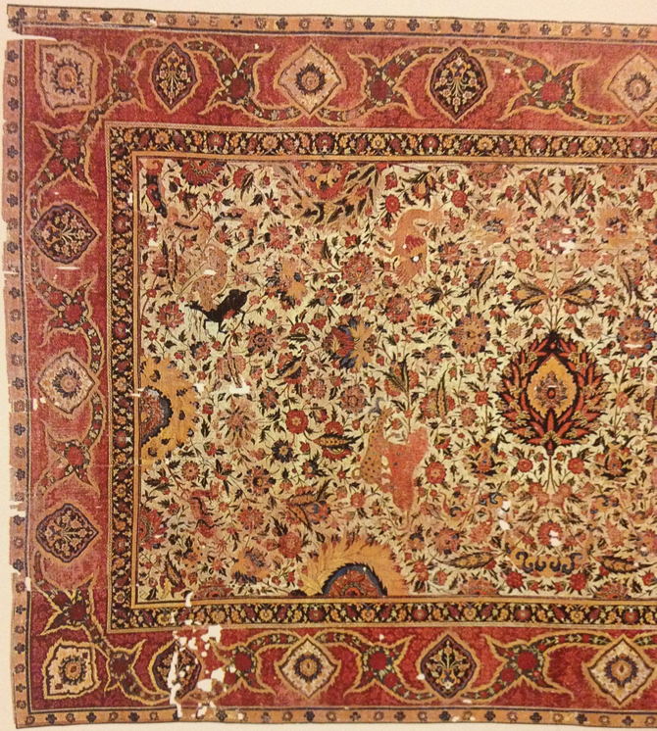
Figure sixteen-b. Detail of carpet. ©Museum fur Islamishe Kunst, Staatliche Museen zu Berlin-Preussischer Kulturbesitz (1.6/74).

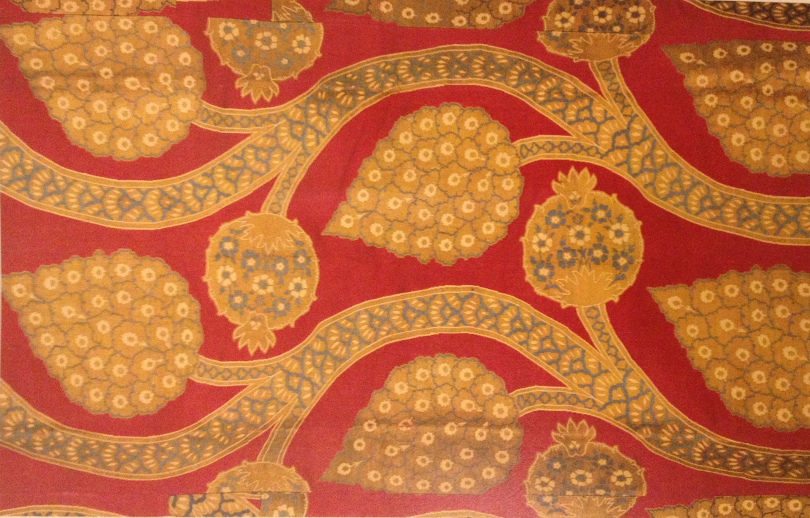

Figure seventeen. Short sleeved Kaftan with a pattern of vegetal motifs on an undulating vine (detail). Second half of sixteenth century (73x67cm.) ©Topkapi palace Museum, Istanbul (13/584).
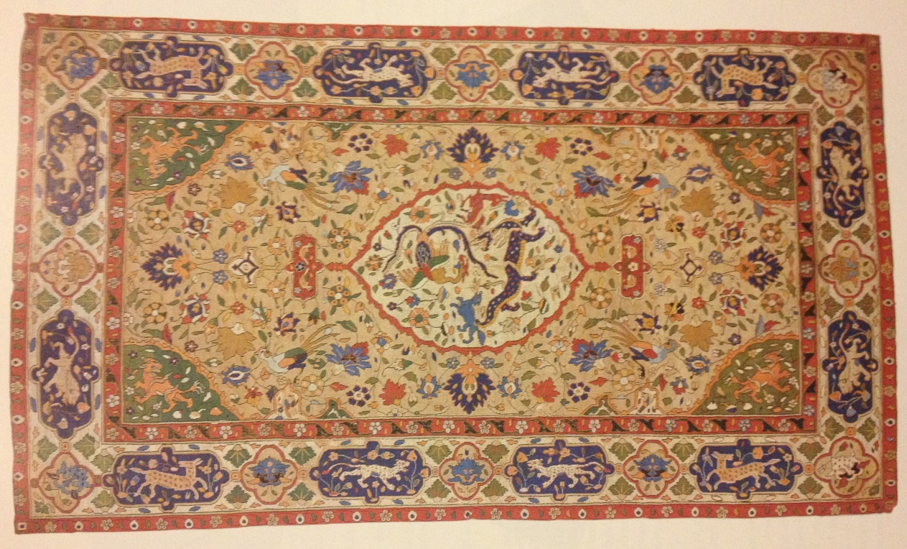
Figure eighteen. Tapestry with central medallion, dragon and phoenix. Iran, late sixteenth/early seventeenth century (227cmx131cm.) ©The textile museum, Washington DC. Acquired by George Hewitt Myers in 1926 (R33.28.1).
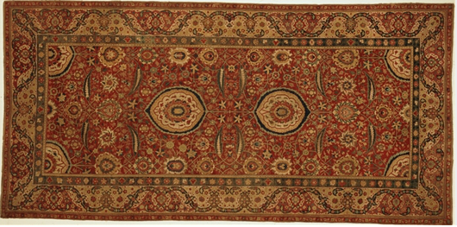
Figure nineteen. Carpet with medallion design. Northern India ca.1620-30. ©The Detroit Institute of Arts, Gift of Mr. and Mrs. Esdel B. Ford (29.242).

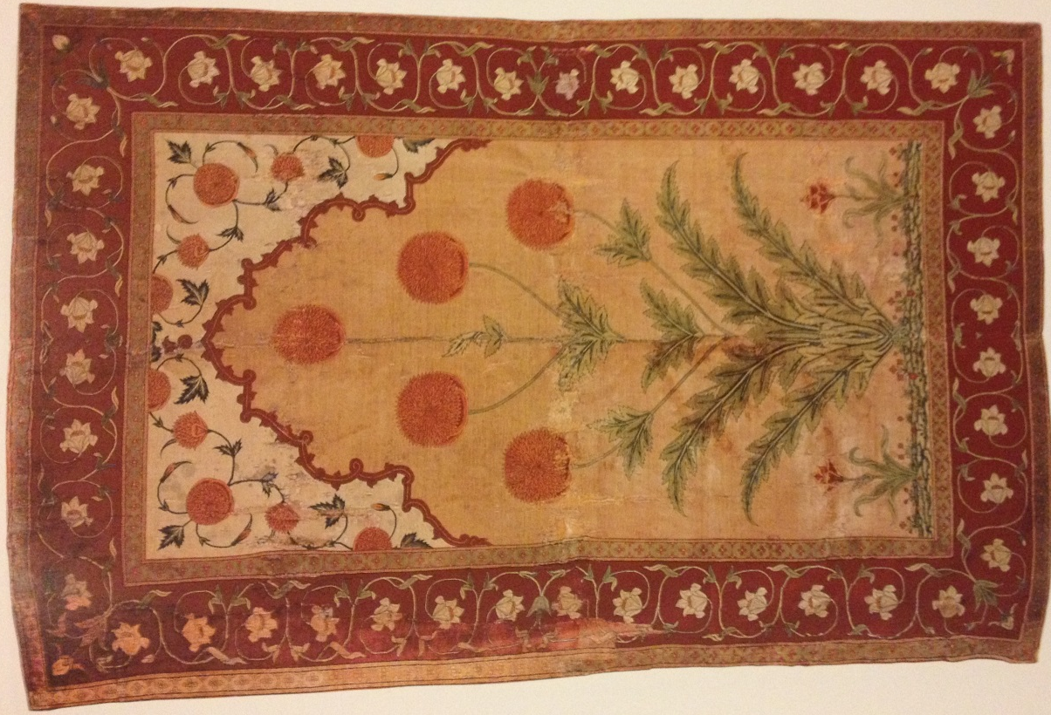
Figure twenty. Pashmina carpet with flower design. Northern India c.1630-40. ©Private collection

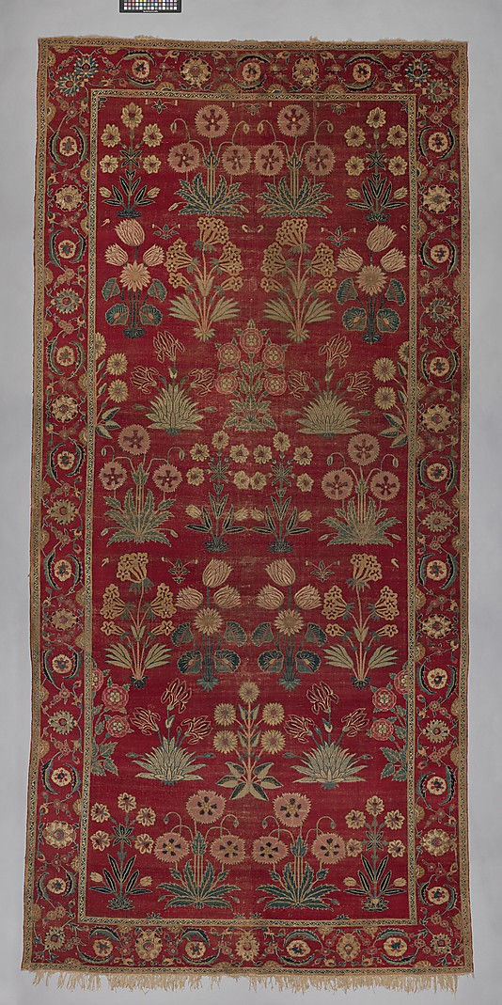
Figure twenty one. Carpet with repeat flower pattern. Northern India ca.1650. ©The Metropolitan museum of Art, New York. Purchase, Florance Waterbury Bequest and Rogers Fund, 1970 (1970.321).

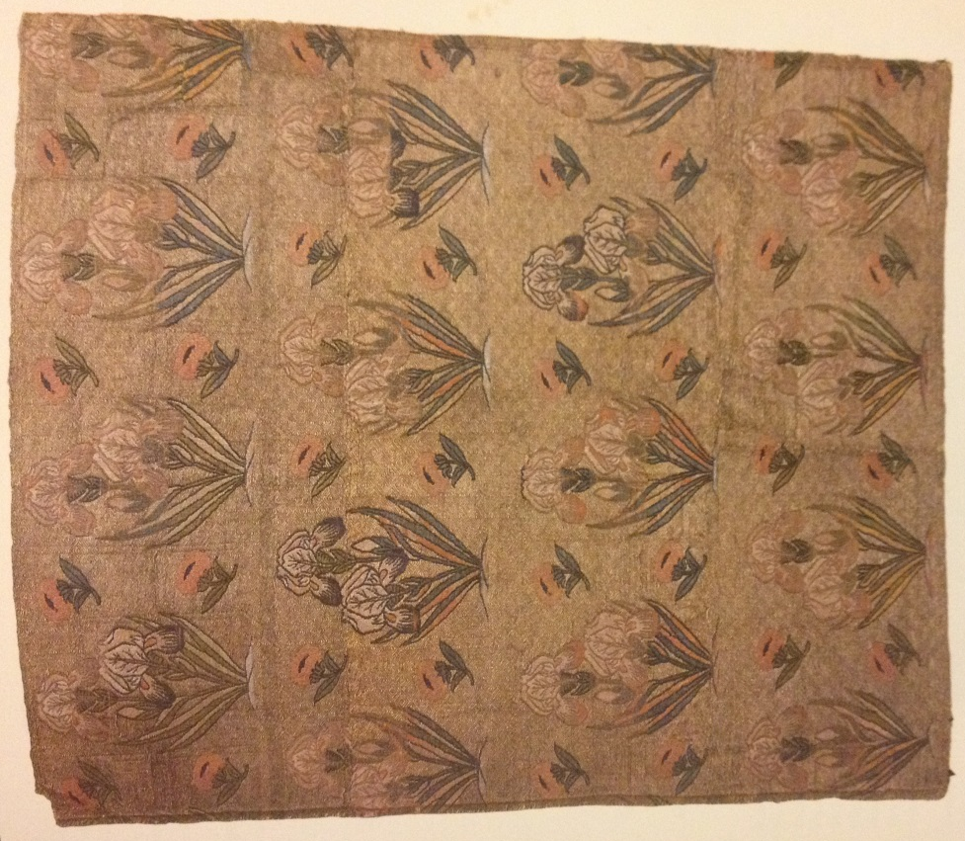
Figure twenty two. Metal ground textile with repeat power detail. Iran seventeenth/eighteenth century (50.4cmx42.1cm.) © The textile Museum, Washington D.C, Acquired by George Hewitt Myers in 1928 (3.118).

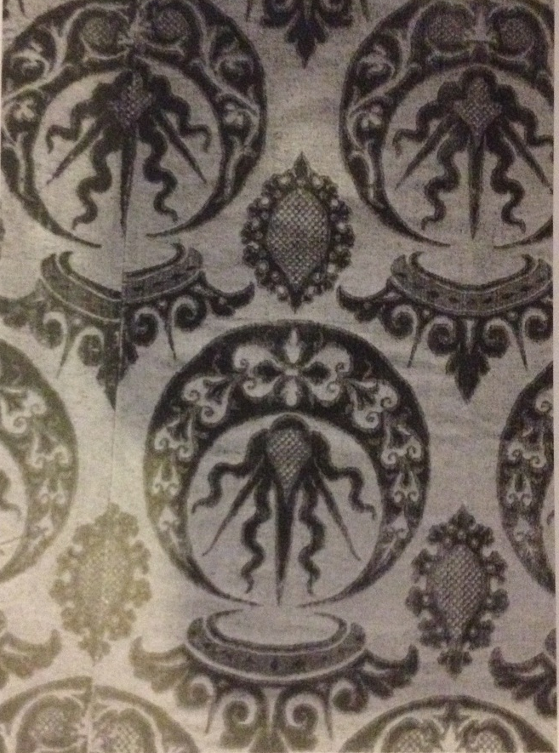
Figure twenty three. Kaftan of Italian velvet with crown and crescent motifs. Italy, early seventeenth century ©Topkapi Palace Museum (13/297).

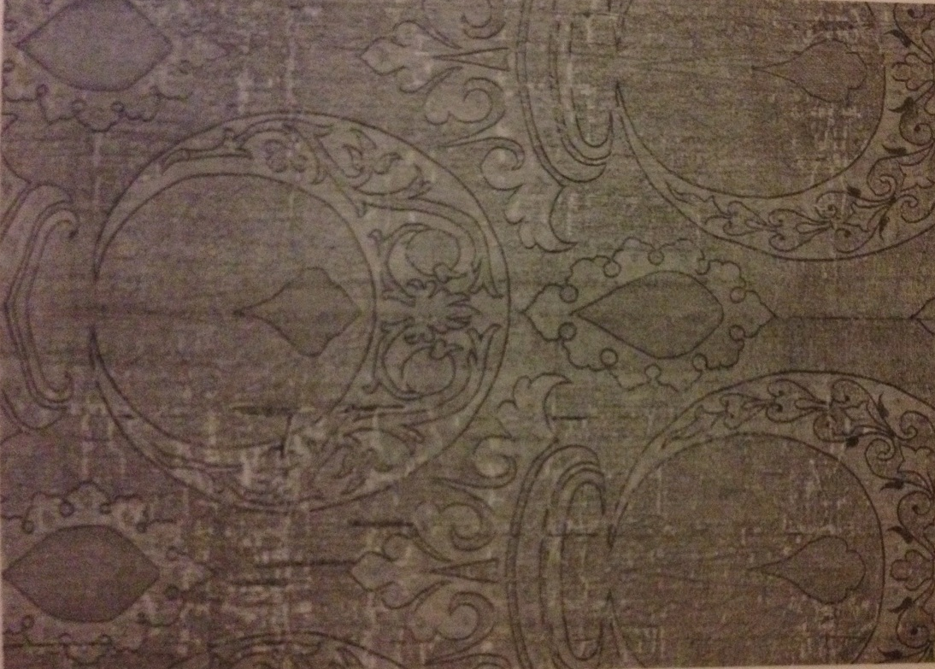
Figure twenty four. Fragment of Ottoman seraser with crown and crescent motifs. Turkey, early seventeenth century ©Kremlin armory museum (TK-2399).

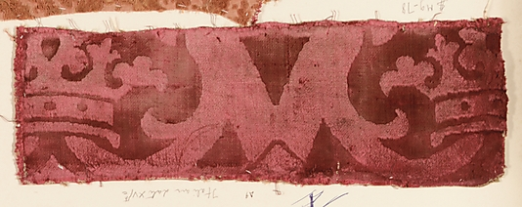
Figure twenty five. Silk fragment with crowns. Italy, late sixteenth century. ©The Metropolitan Museum of Art Gift of Nanette B. Kelekian, in honor of Olga Raggio, 2002 (2002.494.135).
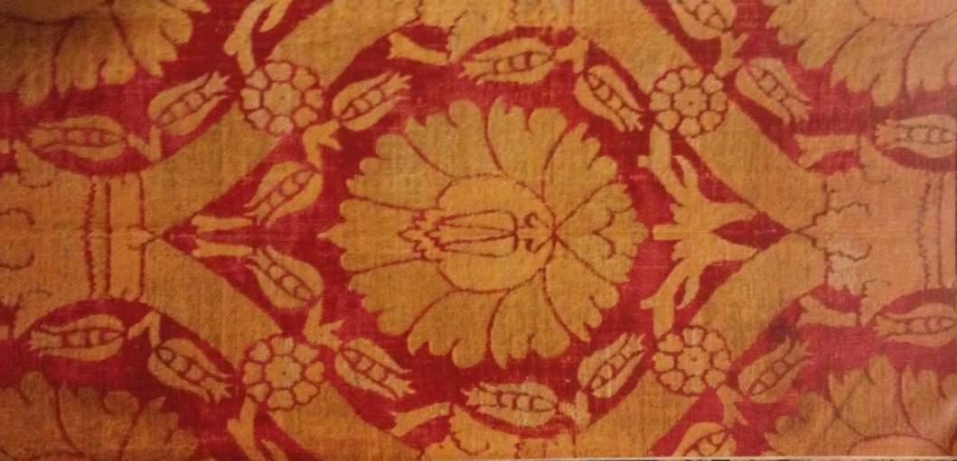

Figure twenty six. Ceremonial kaftan with an ogival lattice bearing crowns, detail. Turkey, first half of seventeenth century (152cm long.) ©Topkapi palace museum (13/1909).
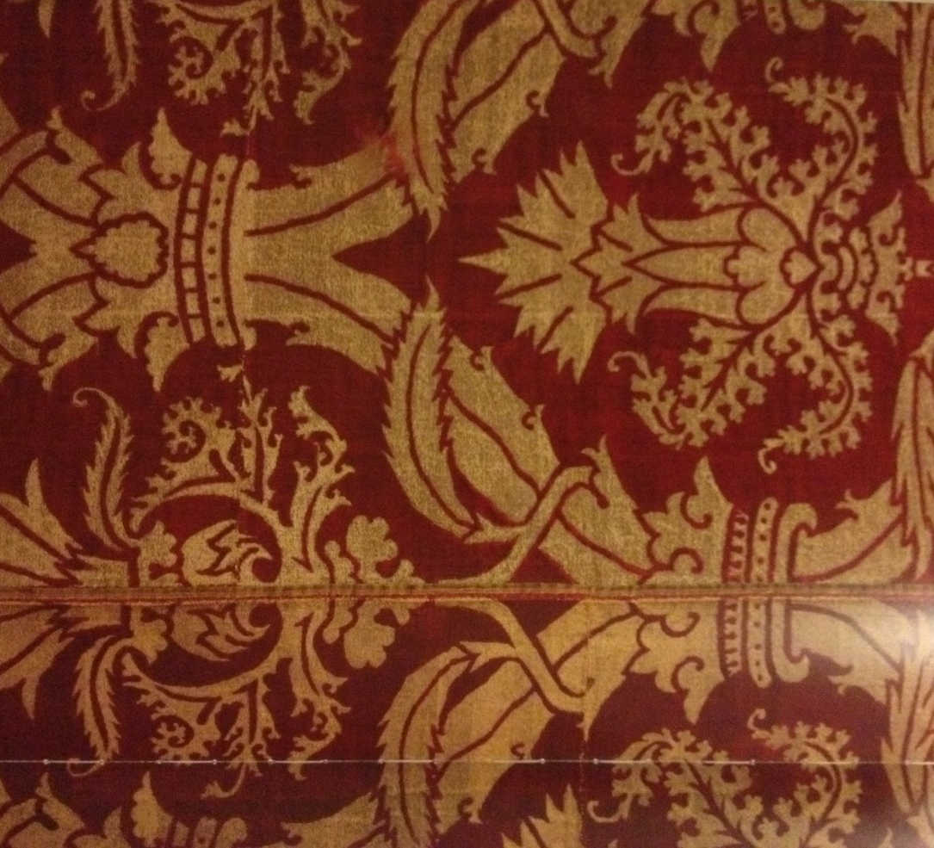

Figure twenty seven. Cloth of gold with ogival lattice bearing crowns, detail. Turkey, second half of the sixteenth century (63.4cm wide.) ©Musees royaux d’art et d’histoire, Brussels (1200 1/2).

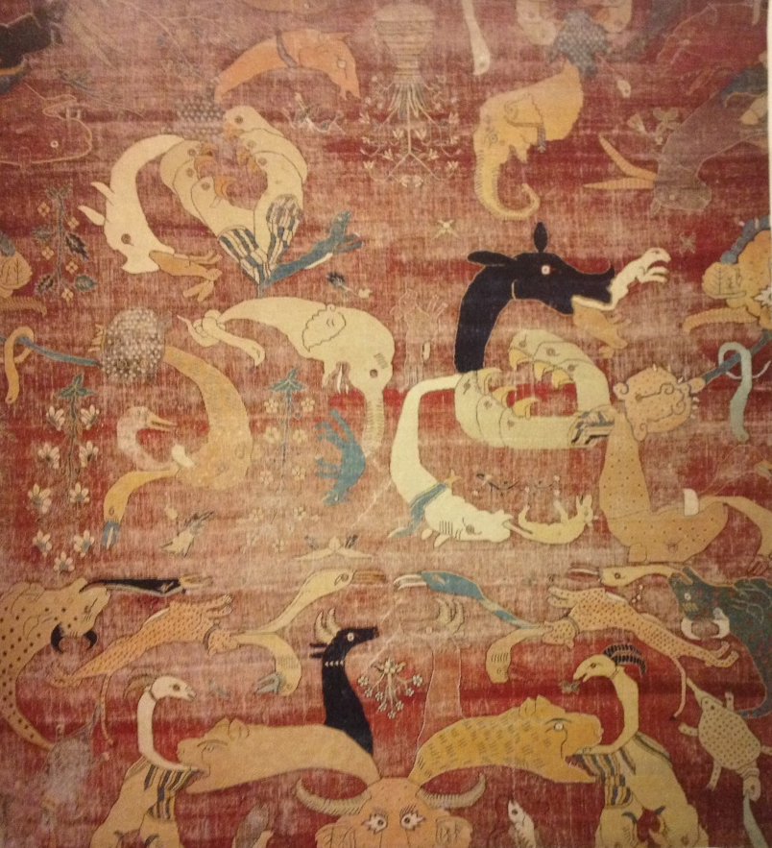
Figure twenty eight. Grotesque animal carpet, fragment. Northern India ca.1580-8. ©The Detroit Institute of arts, founder’s society purchase, Esdel B. Ford fund (31.64).

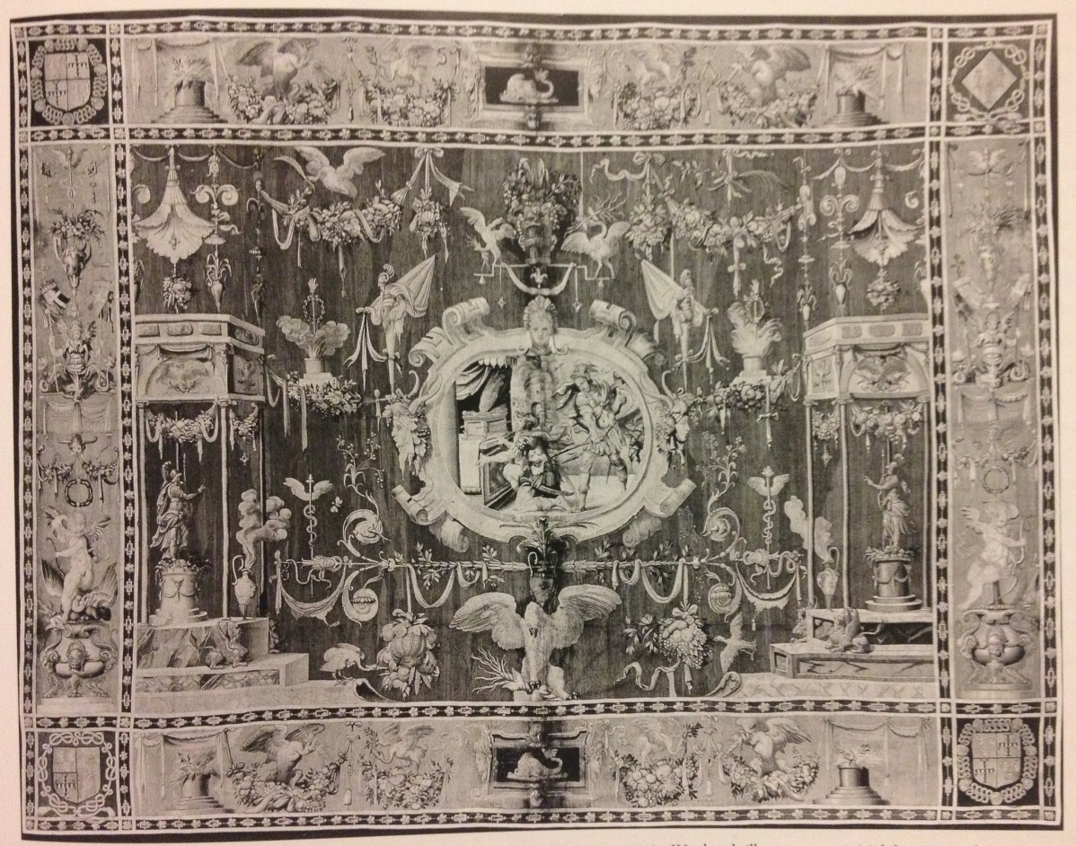

Figure twenty nine. Grotesque tapestry. Paris, c.1556-85 (417x527 cm.) ©Mobilier National, Paris

