Appendix:
A.)
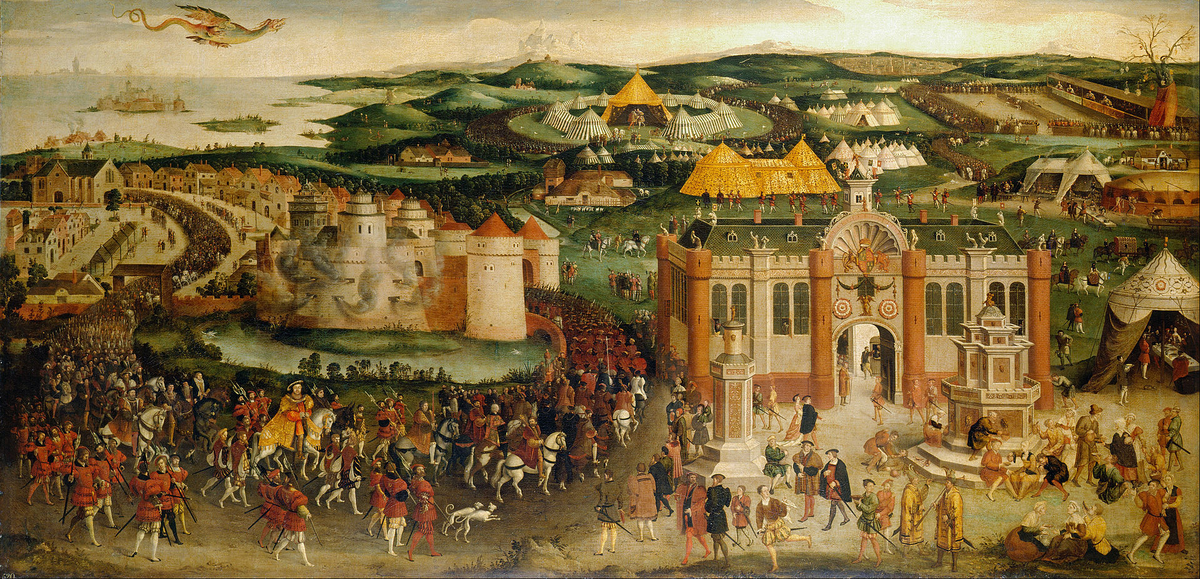
The Field of Cloth of Gold, British school, c.1545, painting, The Royal Collection, Hampton court palace.

B.)
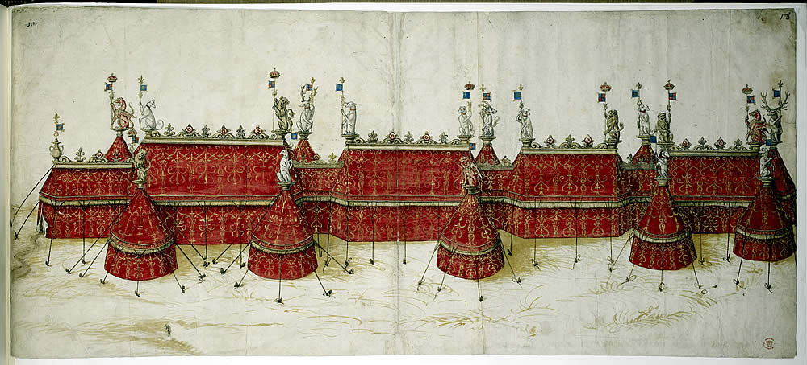
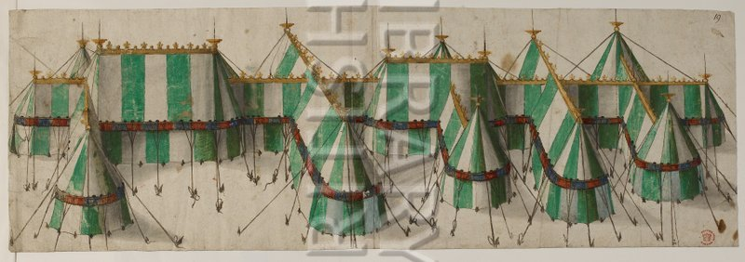
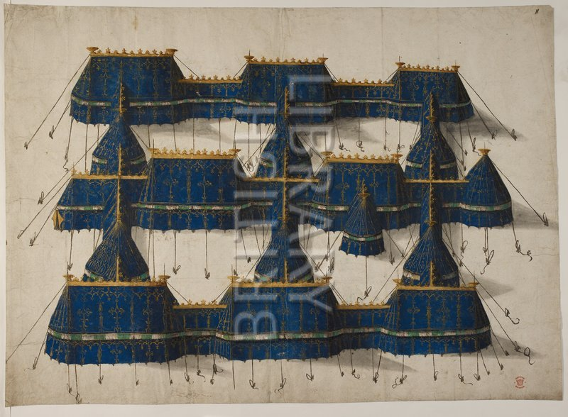
Tent designs believed to be for The Field of Cloth of Gold, 1520, The British Library, Ms, Augustus 111.18

C.)
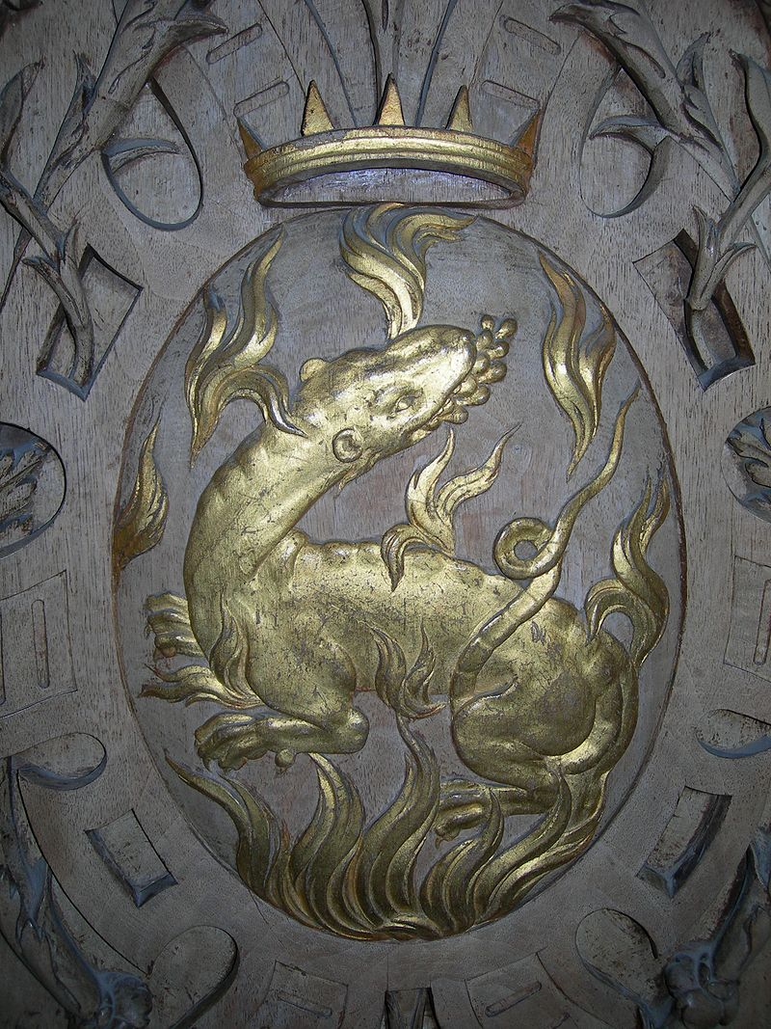

Francis I Salamander in flame motif, engraved medallion, Royal Château de Fontainebleau, Paris.

D.)
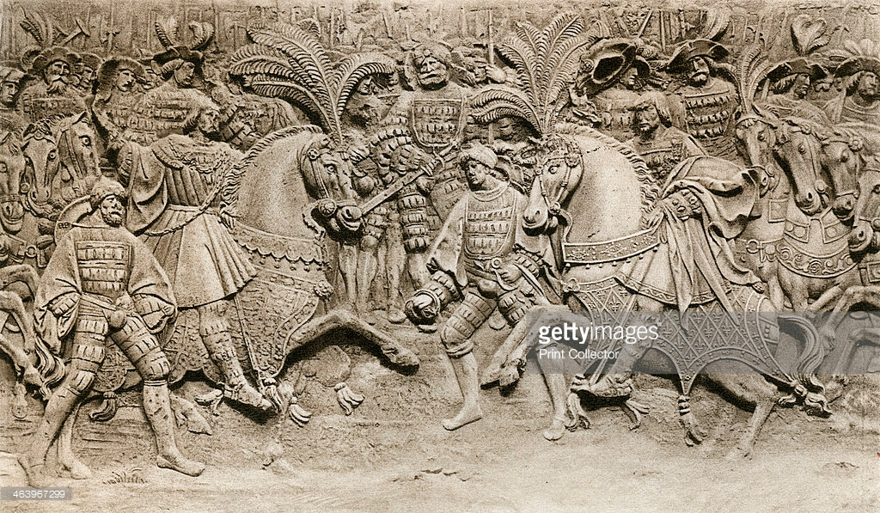
Section of the Bas relief at The Hotel de Bourgtheroude depicting Henry and Francis first meeting at The Field of Cloth of Gold, Getty images, 1520

E.) 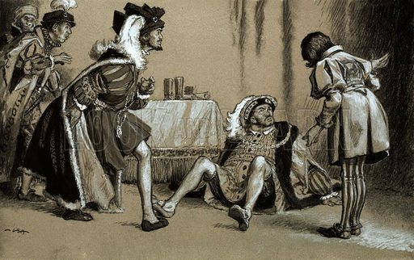
This humorous image shows an artist’s interpretation of the wrestling match story.
“Francis and Henry after Wrestling,” The Bridgeman Art Library.

