Introduction
The overall objective of this study is to explore the construction and dissemination of an image of ‘godly kingship’ in the reign of Edward VI and its inherent connection with the unique political context of Edward’s short reign. It is argued that a specific royal image was consciously created by the young monarch and his government, modelled and re-modelled between 1547-1553, and ‘sold’ to an ever expanding public through various modes of visual, written and verbal representation. Due to this specific goal only official representations and the domestic royal image will be explored even though significant discussion exists on the Edwardian regime’s links with the protestant international.
Edward VI was king of England for only six years (1547-1553) and as a minor throughout never ruled in his own right. The defining feature of his reign, as traditionally understood, is the introduction of the first truly Protestant church in England. Scholarship on the period is usually dominated by, and split between, the characters and policies of the two dukes Somerset (Feb. 1547-Oct. 1549) and Northumberland (Oct.1549- July 1553) who headed up the regime during the minority. For a long time historiographically Edward’s reign was viewed as part of a ‘mid-Tudor’ crisis, a period of decline and stagnation for England, dwarfed by the ‘golden’ Tudor regimes of his father Henry VIII and half sister Elizabeth I. This theory is now largely discredited with a wealth of studies re-emphasizing the importance of the reign and the role of the young monarch. In terms of the royal image, there has been a shift in the way historians are viewing this in the Tudor period. Most survey books now recognize the concept as a viable area for historical research, if not explicitly exploring the idea. Nonetheless whilst the political potency of Henry and Elizabeth’s royal image is being recognized this remains little explored for Edward, a fact that is particularly frustrating in light of the aforementioned reassessments and the unique challenges Edward faced to his authority.
Chapter one will place the study within its historiographical context discussing arguments over the value/nature of royal representations and ideals of Tudor kingship. The value of a representational approach to Edward’s reign in particular will be emphasized. Chapter two will deal with the royal image under Somerset, highlighting the dominant images of Edward’s ‘godly’ kingship and how they relate to the political context of the early reign. Chapter three will continue this exploration into the Northumberland years, looking for any evolution, continues and changes in Edward’s royal image and how these may relate to politics. Paul Binski has argued that the value of representations of royalty is in “the potential of any artefact not only to shape our understanding of a culture but actually substantially to form that culture.” Therefore through an exploration of Edward’s image as a ‘godly king’, a unique understanding of the values, mentalities and concerns of Edward and his government can be reached.

Chapter one

The royal image and notions of kingship in early Tudor England.

‘I, anunlyent trewth, which long time was suppressed with hethen rites and detestable idolatrye,
have in thy realme been in great part refreshed by god’s servent my defender King Henry,
...wherefore if you will me likewise embrace, as did your father, most loving Kynge Edward...Then shall England, committed to your gard, rejoice in God, which hath govern her nation,
After old David, a younge Kynge Salomon’

- Speech presented to Edward VI by a boy dressed as ‘truth’ - part of pageant proceedings during the coronation procession on 19th February 1547
At just 9 years old Edward VI was introduced to his public in a spectacle of great majesty and opulence. The only son of the bombastic Henry VIII, he had just inherited a polity wrought with confessional divisions. At Fleet Street, he was met in a pageant by three boys representing the notions of ‘truth,’ ‘faith’ and ‘justice,’ a projection of the kingship he was destined to embody. To the people of England Edward was presented as a new king Solomon, the “godly, just, and wise” King of Jerusalem who, following in the footsteps of his father King David, had helped rebuild the temple of Judah. Just as Solomon had before him, Edward was envisaged to take the lead from his father and embark on rebuilding the ‘true’ Protestant Church in England. The message of the procession was clear; a new ‘godly’ reforming monarch had arrived.
The ideals of kingship, expressed through the royal image of a particular monarch, were a conscious concern of rulers as far back as antiquity. As Franklin Le Van Baumer has argued, in the Renaissance these ideals took on particular dominance, with the arts of successful rule articulated in writings such as Machiavelli’s The Prince, (1532) and Castiglione’s The courtier (1528). From birth, a future ruler was schooled in the arts of good kingship and understood that to be a well loved prince it was essential to be, amongst other traits, just, pious, strong and wise. Humanist theorists stressed the importance of education not only in theological texts but the arts of human rule. A successful monarch should be skilled in “poetry, oratory and rhetoric…the arts of political persuasion by speaking and writing.” Theorists such as John Fortesque also stressed the importance of magnificence in securing power. In The Governance of England, printed in the reign of Henry VIII, Fortesque “explained the political value in maintaining a splendid royal establishment and impressing foreign ambassadors.” Edward VI was no exception to this schooling; in fact W.K Jordan has argued that he was perhaps the monarch best equipped for the task of rule. The idea of political persuasion held particular currency in the Tudor monarchies as in early Tudor political thought the relationship between monarch and subject, ruler and ruled, was conceptualized as reciprocal. The primary model for a harmonious society was that of the godly commonwealth, a “vision of a hierarchical and ordered society, working efficiently and effectively.” In appealing to the ‘common good’ commonwealth rhetoric was seen as an effective way of enjoining popular obedience to the monarch. Within this structure everyone had a station prescribed by God, with the monarch at the top. If the prince performed his role properly, provided protection and faith for his polity, in return he could expect loyalty and obedience. The centrality of obedience, deference and co-operation in this model suggests significant repercussions for the royal image, as in order to attain the harmonious ideal a king had to be ‘seen’ as fulfilling his role and duties. Despite this, whilst studies exist on the power of the royal image in the Tudor period, the idea of this as part of a deliberate government construction, a programme consisting of visual, verbal and written images, created as a foundation for authority, has been little explored. Discussion, such as that by Roy Strong, tends to centre on the material construction and iconography of visual representations only. This is an argument Kevin Sharpe has recently developed. Sharpe recognises the wealth of discussion that exists around the Tudor royal image but argues that studies overwhelmingly fail to explore the inherent connection between images of royalty and politics.
The revisionist consensus on the role of Tudor royal representations is to view expressions of majesty as examples of top down propaganda only, overlooking the centrality of image in shaping the policy and character of a reign. This paradigm is best exemplified in the works of Sydney Anglo and Theodore K. Rabb who argue that events, words and images, which present the royal persona, should be viewed as reflections of an inherent power only, not as part of a concerted attempt to secure authority. According to Anglo expressions of the ‘royal image’ during proceedings such as the coronation procession are examples of “play not politics;” a-political displays of power for the purposes of “entertainment and recreation” only. By exploring what he sees as the conscious formulation and political role of the Tudor royal image Sharpe has formulated an argument which challenges this secondary manifestation idea. Understanding “the verbal and visual representations of rulers as arts essential to their authority in dangerous and divided times” he argues that for the first time the Tudor monarchs were consciously harnessing the power of representation and actively cultivating and ‘selling’ depictions of self in an attempt to enforce stability and win the acceptance of their public.. Sharpe’s conception of the Tudor monarchs governing in ways similar to modern day ‘spin,’ by ‘selling’ a consciously constructed image of royalty, forms the primary historiographical viewpoint in which my study of the ‘politics of representation’ in the reign of Edward VI operates.
Sharpe’s use of modern conceptions to explain what he believes to be the political role of the royal image has unsurprisingly been accused by some, such as Lucy Woodling, as anachronistic. He argues, however, that the unique circumstances of the Tudor period, the turbulent context of Reformation and the rise of the printing press, provided the critical circumstances in which the construction of a politically minded image of the monarch was both useful and viable. Harking back to the renaissance pedigree on Kingship, which highlighted the reciprocal nature of monarchical rule, Sharpe suggests that from the reign of Henry VIII, largely as a result of his reformation, there was “a need not just to state authority but to argue it: through words images and spectacle.” As a number of historians, including Alec Ryrie and Karl Gunther have noted, though technically heads of an absolute monarchy, unlike their counterparts on the continent, “the absence of a paid bureaucracy, police force, or standing army” in England meant that the “Tudor Monarchs needed the consent of their subjects in order to rule effectively.” Ryrie has recently argued that in the Tudor period “royal legitimacy was less a matter of who inherited the throne than of who could seize and hold it.” Power could not be achieved simply through hard forms such as persecution, especially considering that the means for physical coercion were simply not there. Soft forms, such as the dissemination of a successful royal image, were therefore vital in gaining consent. Furthermore as a result of the Reformation a direct challenge to the foundations of monarchical authority had been made possible. The Reformation had a complicated effect in terms of the royal image. It undoubtedly led to questions about the nature of monarchical authority, particularly in light of the ‘sacralisation’ of the monarch which resulted from the royal supremacy, but this sacred image could also be used as a way to harness and further strengthen monarchical power through a successful portrayal of ‘godly kingship.’ As J.P.D Cooper has argued the rhetoric of ‘godly kings’ did not start with the break from Rome. Indeed monarchy was at its heart a biblical institution. However “the Henrican reformation both demanded and made possible a sanctification of Tudor kingship,” the monarch was now responsible for the souls of the English nation, a new authority which the royal image, it will be illustrated, would be exploited to argue.
Since Henry VIII then, representations of the royal image were far more than expressions of an inherited power. Sharpe attests that “regal images were not the outward signs of an established and secure authority but part of the anxious and contentious process of constructing and sustaining that authority in the face of animadversion and contest.” When viewed as a form of ‘damage control,’ the exploration of royal images can therefore provide unparalleled insights into the political anxieties and major concerns in one of the most dramatic periods of English history. This study will explore the forms of ‘damage control’ employed by the government of Edward VI through an exploration of his royal image. Henry’s legacy in royal representation is particularly important when looking at Edward’s image because a key part of his kingship was built around being Henry’s son. Not only did Edward inherit the intensified need to argue monarchical authority from Henry, but the personal legacy left by his father was one which would be hard to follow. Sharpe describes Henry VIII as the monarch who, “perhaps more than any other ruler appeared to personify personal monarchy – adult, male, strong, brave, decisive and authoritarian.” Henry’s overtly masculine brand of kingship was a legacy which must have seemed impractical for a boy of just 9 to live up to. Henry had used expressions of his majesty to argue for the support of his polity in times of unrivalled change. However Henry’s need to ‘publicize’ himself, principally to the effect of securing the success of the break from Rome, created further difficulties for Edward’s image. By publicizing himself, Henry had subsequently made the royal image a focus of public concern and the very nature of monarchical authority open to questioning.
Edward, therefore, came to the throne in a polity already attuned to the royal image of the monarch. Subsequently, perhaps more than any other Tudor sovereign, Edward needed to legitimize his authority right from his accession, and as a result is a particularly interesting monarch for an exploration into the political role of the royal image. Edward not only inherited problems from his father but a number of aspects unique to him provided further challenges for his royal image. Edward was only 9 years old when Henry died. Too young to rule in his own right, England therefore came to be ruled by a protectorate under the young king’s uncle Edward Seymour. The reality of having a minor on the throne caused obvious problems for royal representation. In order to be accepted by his subjects Edward had to be seen as possessing all the traits of effective kingship, yet the reality was he was physically unable to rule. The new king had to reassert his role as head of state, reassuring his court and subjects that under a minority the country could remain strong, but perhaps more importantly he also had to justify his new position as head of the Church of England. England in 1547 was a country riddled with religious division and Edward faced threats to his position both internally and externally. Many Catholics refused to accept Edward’s position as King, as they saw Henry’s divorce from Catherine of Aragon as illegal, thus making Edward a ‘bastard’ with no legitimate claim to the throne. In light of this, his rightful place as the temporal and ‘godly King’ of the English Commonwealth needed to be underlined. Edward was also bought up to be a staunch Protestant. His fervent Protestantism caused further problems in terms of the need for a specific image of godly Kingship. If a radical re-adjustment of the church was to be accepted, without serious opposition, the consent, or at least conformity, of the public was essential.
Consequently on becoming King, Edward’s authority was already under extreme pressure and it can be argued, a ‘crisis’ of image beckoned. The task of his advisors was to create and disseminate a royal image which could successfully deal with the unique demands of the reign and enforce stability in obviously uncertain times. This study argues that Edward’s government consciously created an image of the young monarch as a ‘godly king’ in relation to the political context of his reign. The appropriation of Edward as a ‘godly king’ is one which has been discussed in a number of studies. Nonetheless the key studies on Edward’s reign by Diarmaid MacCulloch, W.K Jordan and Jennifer Loach, whilst noting that Edward was seen as a godly monarch, (most commonly as a second Josiah) lack an exploration into the conscious decisions behind this image of godly kingship and fail to recognize its connection with the politics of the reign. To my knowledge, Sharpe’s fairly brief chapter in Selling the Tudor monarchy is the only exploration to explicitly link the discourses of image and politics in Edward’s rule. This study therefore allows for a new understanding of the relationship between politics and image in the Tudor period by exposing the conscious construction behind the dominant image of the young monarch as a ‘godly King’, an image with obvious connections to the political context of Protestant Reformation.
Within the last twenty years or so, conceptions of the Edwardian regime have undergone somewhat of a revolution. This study aims to contribute to this expanding historiography. Released from the idea of a ‘mid-Tudor crisis’, scholars including Jennifer Loach, Diarmaid MacCulloch and Stephen Alford have begun to view “Edward’s reign on its own terms.” The years 1547-1553 are now viewed as some of the most politically dramatic of the whole Tudor period, where a new Protestant church was developed in a confessionally divided polity, in spite of significant opposition both internally and externally. Edward’s personal importance has undergone particular re-assessment. Edward is no longer seen as the sickly, ineffectual child of legend but an intelligent, vivacious prince who was beginning to show every possibility of ruling with all the grandeur and power of his father before his untimely death in 1553. This reassessment of the significance of Edward’s reign makes the study of his royal image an all the more pertinent enterprise.
The study which follows forms part of what Helen Hackett discerns as the current trend towards a more ‘representational’ view of the past and needs to be viewed and appropriated as an addition to this wider historical trend. This trend has seen a number of studies on the representation of authority, whose quest “is not to identify the real person behind the public facade, but to analyse that highly wrought facade itself, and the processes that went into its construction.” Recent studies by Adrienne Munich and Thomas N. King, on Queen Victoria and Charles I respectively, seem less concerned with discovering the ‘reality’ of their subjects but more the nature of their representations. In light of postmodernism, a new interest has developed in exploring the meaning and value of representations of monarchy, over the search for objective facts. This new representational approach has clear foundations in the idea of ‘the history of mentalities’, as if it is understood that visual and textual representations are the result of conscious aims, they can be analysed to provide vital insights into the ‘mentalities’ of a particular era or institution. As Maurice Howard has argued “the range of forms taken by (the monarch’s image) are an important barometer of changing and evolving ideas of what the country itself represented.”
It has already been argued that Sharpe’s study constitutes the first authoritative exploration of the Tudor royal image to synthesize the relationship between politics and culture. The importance of visual and verbal representations of power in past cultures, however, is by no means a new idea. Traditionally left to the concerns of scholars from other disciplines, such as Art History and Anthropology, Sharpe notes how these scholars “over the last two or three decades, have theorized, and led to an insistence on the porous connections of culture and politics, representations and authority, in the present and the past.” Therefore the work of academics, including Stephen Orgel, Michael Baxandall, Clifford Geertz and Michel Foucault, provide a strong conceptual framework on which studies into royal representation can build. It is perhaps this traditional insistence within other disciplines of the connection between culture and politics, which led to the rejection of the thesis by Sydney Anglo and Theodore K. Rabb. A key part of their argument is based around what they see as the practical inability to disseminate and ‘sell’ ‘images of rule,’to the Tudor public. They ask how can representations of royalty be viewed as deliberate political constructions if they were not to be seen by large sections of the polity? Their limitations argument, however, needs reassessment. J.P.D Cooper has recently gone some way in this. He argues how in light of the Reformation and the incorporation of church within state the image of monarchy in the localities was greatly expanded. The pulpit effectively became “a mouthpiece for crown policy” and the visual reminder that the monarch was now head of the church was reflected in the erection of the royal arms often in place of traditional Catholic images of the saints. Moreover Anglo’s argument overlooks the intentions behind representations of royalty even if the means of dissemination were sometimes lacking. He himself recognizes the existence of a contemporary theory on ‘the political potency of the royal image’ by Clement Urmerston, but argues its rejection by Henry VIII’s government as evidence that they were not seeing the royal image in this way. This study argues, however, that as testament to the existence of such theories, Urmerston’s work is instead evidence of the possibility that governments were already, or would soon begin, to understand the vital role image could play in politics. Anglo also argues the limited nature of the Tudor printing press to discredit the effectiveness of the medium as a political tool. This is a fair assessment with regards to its early existence. However, its value as a disseminator of the royal image should not be discredited. This is especially true with regards to Edward’s reign for as Diarmaid MacCulloch has argued the medium began to flourish from 1546 when Charles V’s expulsion of Protestants resulted in an influx of foreign experts into the English Market.
To conclude this study aims to contribute to wider historiographical research on the value of a representational view of the past which highlights the inherent connection between politics and culture. Peter Burke suggests that “abstract concepts have been represented through personification from ancient Greek times if not before.” Edward’s royal image then, should not only personify the specific conceptualizations of his kingship, but illustrate the unique concerns of his government by linking his ‘godly image’ to the period’s political context.

Chapter two
The early royal image – Edward’s image from birth and under Somerset (February 1547- 11 October 1549)
“Woe to thee, O land, when thy king is a child…”
“Blessed is the land where there is a noble king…”
- Ecclesiastes 10:16 and 10:17
After thirty eight years on the English throne Henry VIII died on 6th January 1549 bequeathing his authority and kingship to his infant son. Edward was only 9 years old, causing much anxiety over the future of the Tudor dynasty. Precedents of minority rule provided little solace: the last ‘boy’ king Edward V disposed, most likely by his own uncle, long before he reached maturity. Even the Bible which would form such a central part of Edward’s kingship and authority seemed to prophesy disaster, the proverb from Ecclesiastes becoming a gift to all those who opposed Edward and his Protestant regime. For Edward’s government, Diarmaid MacCulloch argues, “the best way out...was to redefine the text as referring to childish kings, rather than kings who were children.” The creation and dissemination of an effective royal image which embodied this maturity and argued Edward’s right to rule had perhaps never been so necessary.
The challenge of Edward’s royal image was unique. On his father’s death Edward was undoubtedly the rightful king of England but as a minor could not rule in his own name. Edward therefore had to be ‘sold’ to his subjects as embodying all the authority and character of a ‘godly’ Tudor King without being able to enact this power. To gain the consent of his subjects Edward needed to be seen as ‘ready for rule’ without actually ruling. Edward’s task was unprecedented, as Chris Skidmore argues: “he was the first King to be born with the title defender of the faith, and the first to be crowned with the powers that the royal supremacy brought with it; no king before or since, was ever given such an unequivocal mandate for absolute rule.” Yet ironically it was one he could not practice. Henry’s break from Rome meant that Edward not only needed to be seen as the protector and embodiment of his subject’s secular bodies, but under the act of supremacy, he was now legally a ‘godly’ king, in charge of their souls. This chapter will explore the ways in which Edward’s royal image was created and sold to his polity in Somerset’s protectorship (February 1547- October 1549.) It will explain how these images related to the specific political agendas of the period and a regime which first introduced England to an explicitly Protestant church and has been characterized as one of surprising tolerance and clemency. It will show how Edward’s royal image was used to make him the psychological centre of the nation and the embodiment of policies, which as a minor, he could not ‘officially’ sanction.
Before conducting a more detailed exploration into his royal image it is necessary to further emphasize the political importance of the royal image under Edward. It has already been noted that the Henrican Reformation fundamentally altered the nature of kingship, creating a new role for Edward to embody as supreme head of the Church of England and officially making him a ‘godly king’. The primary goal of the Edwardian regime, to introduce a Protestant re-ordering of the church, was to also have a significant effect on the nature of royal representation. J.P.D Cooper has argued how the 1549 Book of Common Prayer brought the royal image directly into the lives of even the parish polity. It was the first prayer book to include prayers to the monarch which, by law, were to be read every Sunday. The monarch’s place in the new liturgy saw that ‘the godly king’ became not only a spiritual but a political image. The pulpit effectively became a tool of crown policy and as will be shown was used to command obedience to Edward in an attempt to strengthen his rule. The iconoclasm of Edwardian Protestantism further saw the royal image permeate the lives of Edward’s subjects. With the removal of the visual fabric which so defined Catholicism the royal arms were often literally put up in place of the traditional rood. An allegory of these visual changes under Edward can be seen in a woodcut in Foxe’s Acts and Monuments (appendix one.)
From 1549 when entering church the parishioners were directly confronted with Edward’s royal image and the new political reality of his ‘godly kingship.’ Further evidence of the centrality of the royal image in Edward’s reign was the practice of royal proclamations as a way of inducting government policy. This style of government was to become a hallmark of Somerset’s protectorate, with an average of nineteen royal proclamations per year opposed to only six in Henry VIII’s reign. Proclamations provided a viable solution to the ambiguity over Edward’s kingship. In allowing the regime to speak in the guise of the monarch, Edward’s image, as expressed in these proclamations, could be engineered to embody political decisions; giving royal authority to policies which as a minor he was lawfully unable to sanction.
The historiography of Edward’s image emphasizes the idea of a pious, precocious, and above all ‘godly king,’ as illustrated in another woodcut in Acts and Monuments which shows the monarch listening intently to a sermon being preached by Hugh Latimer (appendix two.) Edward is commonly identified as ‘Josiah,’ the Old Testament iconoclast boy king of Judah. The parallels between Edward and Josiah are obvious: both were boy kings, both brought the word of God to their people and, to Protestants, were seen to resuscitate the ‘true’ religion in their polities by purifying it of its perceived corruptions. Edward as ‘Josiah’ has therefore traditionally dominated historical thinking on his royal image. This characterization is seen as central to Edward’s royal image from the start of the young king’s reign, largely as a result of a sermon apparently preached by Thomas Cranmer at his coronation. In this sermon the Archbishop of Canterbury was said to have directly compared the two boy kings and urged Edward to emulate Josiah in bringing the ‘true’ faith to England. However, recent research by Diarmaid MacCulloch has thrown this dominant portrayal into question. On exploring what he saw to be the suspicious nature of Cranmer’s coronation sermon (indeed no contemporary record exists) MacCulloch has found that it was in fact a falsification, created in the seventeenth century by the Protestant scholar Robert Ware. In light of this a reassessment of Edward’s royal image, particularly at the start of his reign, is more important than ever. In the course of this chapter it will become clear that the ‘godly king’ image was at the centre of Edward’s kingship, indeed through political reality it had to be. However, it will be argued that Edward was not exclusively or zealously presented as Josiah in Somerset’s protectorship. For the first tentative years of the reign a more multifaceted, pliable royal image was created which linked directly to the precarious political situation of the minority. Edward was a ‘godly king’ but within this he was also portrayed as a Tudor Renaissance prince in the model of his father, a ‘learned prince’ wise beyond his years (and therefore ‘fit to rule’) and a clement leader of the English commonwealth.
From birth the ‘godly king’ was an image Edward was destined to embody. Indeed his birth was seen as sanctification from God of Henry’s break from Rome; at news of his birth Bishop Latimer gave thanks to God for his gift of “an English God. ” Edward needed to be represented as a ‘godly prince’ to set himself up for the role he was to inherit as supreme head of the English church. However he was not only destined to be a spiritual leader. Edward was Henry VIII’s legitimate heir and his dynastic legitimacy therefore characterizes much of the early images of Edward. This is particularly the case with portraiture. Edward’s early image in portraiture is indicative of the importance of his image as a Tudor Renaissance prince, carrying on the mantle from his father. For example the 1545 painting ‘The Family of King Henry VIII’ (appendix 3) stresses Edward’s legitimacy. Dressed in the finery so emblematic of Henry, Edward is depicted under the arm of his father whilst his two half sisters remain detached. As Chris Skidmore argues “its effect is one of both power and solidarity, a reinforcement of the bond between father and son.” As Henry’s health began to deteriorate the importance of stating Edward’s legitimacy in portraiture increased. What was more important, however, in light of the fact that Edward would probably succeed as a minor, was the need to show him as strong enough to take on his father’s authority. This was done by painting Edward almost as a carbon copy of Henry. For example a portrait by an unknown artist painted in the year of his accession (appendix 4) depicts him in all the regalia and an almost identical pose of Henry in Holbein’s famous Whitehall mural (1537) (appendix 5.) Edward’s pose is authorative and masculine. He is depicted as a fine Tudor prince with none of the immaturity of youth, in his hand a dagger to symbolise strength. Portraits such as these quite clearly attempted to transfer some of Henry’s authority onto the young monarch and gloss over anxieties concerning the king’s age.
On his accession the political importance of Edward’s royal image was illustrated in the proclamation issued to mark the event. This not only proclaimed the nature of Edward’s authority as king but also evidenced the reciprocal character of early modern rule, stating that “like as we or our part shall...show ourselves a most gracious and benign sovereign lord to all our good subjects...so we mistrust not that they and every one of them will again....show themselves unto us most faithful, loving and obedient subjects.” In tones similar to his father the proclamation also reflected the persistence of commonwealth rhetoric in understanding and illustrating the nature of monarchical authority. Ethan Shagan has recently argued the political potency of this representation of kingship. He suggests that Edward’s government used the image of the commonwealth king in a conscious attempt to enjoin popular support for the monarch and his reformation, as a way of finding common ground with the polity. This portrayal was particularly viable for Edward as the reformation, through sacralisation of the monarch, had effectively made the commonwealth ‘godly.’ Thus Edward could be sold as a ‘godly commonwealth king’ who to rebel against was technically a sin. Edward’s portrayal as this was therefore a key way to argue for consent.
From the outset another important way of arguing Edward’s ability to rule was through his portrayal as a ‘learned prince.’ Edward’s education both instilled in the young monarch the ideals of kingship believed to constitute effective rule and the ‘learned prince’ image itself became a key way of showing Edward as ‘ready to rule.’ Edward was schooled in a number of ideals which would come to embody his kingship. Most important was for Edward to be schooled in the values of a ‘godly’ protestant King. W.K. Jordan argues that Henry VIII had realised that “Edward’s very legitimacy and title were safe and unsullied only in a Protestant settlement of faith and ecclesiastical constitution.” The appointment of Protestants Richard Cox and John Cheke as Edward’s principle tutors was thus a deliberate politically minded one. Edward was bought up reading the scriptures and contemporary comments reflect his perceived capacity for ‘godly’ learning. Martin Bucer, in a reflective testimony to Edward’s early scholarship, writes in 1550 how “no study delights him more than that of the Holy Scriptures, of which he daily reads about 10 chapters with the greatest attention.” Particularly important for his image as a ‘godly king,’ Edward was taught to read the stories of Old Testament kings, undoubtedly as precedents for ‘godly’ rule; Cox reported in a letter to William Paget as early as 1544 that Edward had been reading Solomon’s proverbs. It was not uncommon for Tudor monarchs to look for models of kingship in the Old Testament; Henry VIII had often visualised and sold himself as King David. For example the illuminations in Henrys Latin Psalter of 1542 clearly depict him as such (appendix 6. ) Biblical precedents were an effective way for a monarch to clearly express the nature of his kingship to a public attuned to biblical imagery. Nicholas Udall, in a dedication to Edward in 1548, attests to these comparisons being appropriated for Edward. Udall presented Edward as “the embodiment of humanist learning and godly piety...after a David, the Solomon to build in England a house of god, another Ezekias or Josiah to secure the word.”
Edward’s education clearly helped foster the image of a godly king; however he was not here exclusively viewed as a new Josiah. Nor was he just in possession of a godly education. Edward was taught as much in languages and the classics as he was scripture; an education for a Renaissance prince. As Jennifer Loach attests, on his accession he could speak French and Latin and was learning Greek and Italian. From the classics of Isocrates and Cicero he learnt the value of mercy, mildness and clemency, traits which would prove vital in a reign open to much criticism and always in fear of rebellion. For the first part of Edward’s reign then, the ‘learned prince’ was a vital image in overcoming concerns over his minority. Edward may not have been strong physically but as the ‘learned prince’ he was held to possess wisdom beyond his years and was strong in both mind and faith.
But of course being an anointed King, Edward had to be seen. During his first public outing, the coronation procession (19th February 1547), it was vital to show the king in a way that was both impressive and reflective of his authority to soothe any doubts concerning the future of the country under a minor. The imagery invoked in the procession, and in the service itself, argued the two central fundamentals of Edward’s early kingship, Edward as godly king (the spiritual leader) and Edward as Tudor Renaissance prince (the secular monarch.) Edward, “richly apparelled with a gown of cloth of silver, all over embroidered with damask gold...garnished with precious stones,” was visually the paradigm of a Tudor prince. Edward’s ‘godly’ authority was expressed in the majority of the pageants put on for the King by the London authorities. The pageants provide an interesting source as not technically being official representations they remind us of the two way construction of kingship. The character of the pageants suggests that the authorities were re-iterating the official images of Edward’s godly kinship whilst further expressing the fundamentals they wanted him to embody. The biblical precedent of Solomon was commonly invoked, in a total of five of the pageants. The image of Solomon was particularly symbolic as his main attribute was wisdom. Moreover this image can be seen as underlining the city’s support of their monarch as a Renaissance Tudor prince and Henry’s legitimate heir; Edward as Solomon was the rightful successor to Henry as David. This support was also clear in a pageant which involved “a Phoenix – the emblem of the Seymour family – making friendly with a crowned lion, and producing a young cub, who was himself then crowned by angels.” The ‘crowning by angels,’ moreover, represented the dual nature of Edward’s kingship as godly king and Tudor prince.
The foremost political expression of Edward’s godly kingship came in 1549 with the implementation of the Book of Common Prayer. The introduction of this Protestant liturgy would ironically challenge the whole basis of Edward’s authority and provide a new test for his royal image. Largely in reaction to the prayer book, the west rebelled. In his chronicle Edward notes how widespread the disturbances were. As a result Edward’s authority seemed weaker than ever; if the regime was ever in crisis it was now. In their demands the western rebels explicitly stated that they would not accept the changes to religion on the grounds that they were introduced by a protectorship and therefore not legally Edward’s wishes or recognized as such. This direct challenge to Edward's authority was answered through a royal proclamation on July 8th, known as ‘the King’s answer.’ This printed and public message provides evidence of the value of the royal image as a form of political ‘damage control’ in the way in which it portrayed Edward as the force behind religious change. Through the proclamation Edward asserted his divinely ordained position and his kingly authority arguing: “be we of less authority for our age....as a king, we have no difference of years or time...we are your rightful king, your liege lord, your king anointed, your king crowned, the sovereign king of England, not by our age but by god’s ordinance; not only when we shall be of twenty-one years, but when we are of ten years.” The royal image being ‘sold’ was clear, Edward was a strong, godly anointed king, who was fully behind the changes of his government and to challenge him was to challenge god himself.
In demanding the obedience of subject’s the rhetoric of ‘The kings answer’ is also further indicative of the political importance of Edward’s representation as a godly ‘commonwealth king.’ The government’s response to the 1549 rebellions more generally provides evidence of the kind of representations involved in this portrayal. The reciprocal nature of the commonwealth model encouraged a representation of the monarch as clement and reasonable. ‘Clemency’ was an important part of Edward’s early kingship which had specific political value. In ‘the Kings answer’ Edward explains how “we have condescended of love to write rather than to war against you as rebels.” Ethan Shagan has recently explored the political thinking behind this magnanimous policy, questioning with regards to Somerset how “in his delicate position and without the reflexive support of the nation upon which early modern monarchs relied, could he afford a policy of repression?” His conclusions are ultimately no. Although he is talking about Somerset his arguments undoubtedly ring true for Edward’s image and stability also. Indeed it is not unlikely that the limitations of Edward’s position as a minor almost forced a portrayal of ‘clement’ kingship. A more dogmatic image was risky as Edward’s ability both legally and physically to embody policies of repression was questionable. The regime could not afford to create martyrs. This tenet of Edward’s image may provide some understanding to the often baffling reality that whilst this was a time of significant religious tension no one between 1547 and 1549 was executed for their faith alone. It is also indicative of the politically conscious nature of representations of Edward.
In conclusion this exploration into Edward’s royal image under Somerset has stressed the centrality of the ‘godly King’ image but has suggested that Edward was never this exclusively and that other dominant features existed within the godly ideal. Moreover, the ‘godly kingship’ invoked in the early reign is not that which history traditionally proscribes him of Josiah but far more Solomon; an image which had as much value in arguing the young monarch’s secular authority as Davidic Henry’s heir as in selling a ‘godly pedigree.’ Edward the ‘godly King’ exists amongst a number of equally important images each with their own political value: Edward ‘the learned prince,’ which argued his mental maturity and attempted to show the king as ready to rule; Edward ‘the Renaissance Tudor prince’ designed to impress and highlight his right to the throne, in the hope of transferring some of Henry’s authority onto the young monarch, and finally Edward ‘the commonwealth king’ which fostered obedience to the monarch and attempted to limit the risk of attacks against his government and person. The dominant ‘royal images’ under Somerset suggest that the major concern in the first tentative years of Edward’s reign was not to introduce a dramatic break with the religious past and uncompromisingly enforce Protestantism, but to continue in a way which would both strengthen and stabilize Edward’s reign, setting him up to rule in his own right. The following chapter will explore if these images, and the ideas behind them, still rang true in the new political regime under the Duke of Northumberland.

Chapter 3
The later royal image – Edward’s image under Northumberland (11 October 1549- 6 July 1553)
“We understand…how yow have been procured once to go a pilgrimage…hereafter if any such chance happen..with safe conscience you cannot do any such thing, being brought up with me, and bound to obey my laws…apply yourself to riding, shooting or tennis…not forgetting… your learning, chiefly reading of the scripture”
- Extract from a letter from King Edward VI to his favorite Barnaby Fitzpatrick circa December 1551.
At the fall of Protector Somerset in October 1549 Edward had been on the throne for just under three years and along with his government had established an image for himself as a Tudor renaissance prince and the Godly King of the English Commonwealth. Writing to his favorite Barnaby Fitzpatrick in 1551, (who was Edward’s envoy at the French court and therefore effectively tasked with representing the young king and his regime to Henry II), the above letter reveals much about the young monarch’s self image as well as a growing sense of personal authority. The dominant image of the early reign is clear, Edward is a godly king devoted to the ‘word of god.’ Within this overarching godly ideal however, the letter also suggests another element of the royal image, that of a Tudor martial prince incumbent in the arts of ‘riding’ and ‘shooting.’ Moreover, as a minor still technically unable to rule, Edward is stating his authority in uncharacteristically explicit terms: the laws of England are his and as such must be obeyed. This letter then, suggests that by 1551 Edward had not only matured physically but authoritatively. In suggesting a renewed presence in the governance of the realm, perhaps a matured royal image was also being created, and sold, to fit alongside this new political reality.
This chapter will explore Edward’s royal image under the Duke of Northumberland, looking for possible continuities, changes or additions, and will investigate the repercussions of a new regime for Edward’s godly kingship. Northumberland became lord ‘president’ in February 1550. Along with him came a more evangelical episcopate and a new Prayer Book. Revisionist consensus has been to emphasize continuities over changes in the religious aims of the two dukes. Nonetheless leading authorities on Edward’s reign including MacCulloch, Alford and Loach maintain that whilst the aims may be comparable, the pace of religious change was greatly accelerated from 1550. If Somerset’s fall did not cause an evangelical revolution, there was certainly an evolution in religious policy. As Eamon Duffy has argued, the 1549 Prayer Book could easily be manipulated to fit traditional modes of Catholic worship. By 1550, with the episcopate behind them, “the council was now determined that the time for any compromise with the catholic past had gone.” The task for Edward’s royal image then was to appropriate the ‘godly king’ representation within this more zealous drive towards an unambiguously protestant settlement, alongside other elements of the royal image which would continue to convey and argue Edward’s authority.
An exploration into the royal image under Northumberland cannot be attempted without reference to the fact that Edward was physically maturing and, as a result, growing into his ‘kingship’ in this period. It is largely recognized that from 1550 Edward was perceived to have a greater understanding and involvement in running the country. This is illustrated especially in the young king’s writings, which become far more detailed and numerous in the later part of the reign. Edward’s writings are therefore vital to an exploration of how he is conceiving his royal image and presenting himself, to his government and realm, under Northumberland. Edward’s foremost written form of self expression comes in the form of his chronicle. This unique piece of historical evidence, best viewed as part private journal and part state diary, Kevin Sharpe argues, “presented Edward as a boy fit to reign as King.” He states that the chronicle should be viewed as “a principle agent of Edward’s claim to rule and an essential act of self representation.” The royal arms which adorn the chronicle indicate that it was always seen as more than a mere school exercise. Though the chronicle starts in 1547, for the current study it is most enlightening for the later part of the reign. The entries from 1550-1552, in light of Edward’s growing maturity, are authorative, written in the possessive first person, and can clearly be seen as the expressions of a monarch who had grasped the nature of his authority and was learning how best to express it. In comparison, the first few years of the reign are covered more as a narrative written in hindsight. Small lexical differences from 1550, such as the fact that references to ‘the council’ become ‘my council’ reinforce Edward’s growing maturity and illustrate a firmer grasp of his kingship. This can also be seen in numerous, ‘position papers,’ in the king’s hand under Northumberland, which show Edward “proposing policy (and) not just as a passive auditor. ”
The repercussions of this shift for the royal image, it will be argued, were that a much more personal sense of Edwardian kingship developed. This royal image was more attuned to Edward’s individual qualities as a king, as opposed to his association with Henrican ideals of rule: it could be seen as the beginnings of Edwards ‘personal monarchy.’ Edward may not have been ruling under Northumberland but was portrayed as increasingly capable of this task, and in some cases was actually involved in structuring policy. As his reign progressed Edward was no longer predominantly sold as a ‘learned prince,’ a kind of ‘godly king’ in training, but was increasingly represented as the epitome of his godly and temporal kingship.
The continuity of Edward’s image as a ‘godly king’ was imperative in assuring the consolidation and character of the new regime. We can clearly see this element of the royal image being used as a form of ‘damage control’ not long after Somerset’s fall in a royal proclamation on the 30th October 1549. The proclamation attested that because Edward was still a minor when his uncle fell, “certain lewd and seditious persons…” had suggested that “the good laws made for religion should be now altered and abolished, and the old Romish services…renewed and revived.” The King and government’s answer was to show that it was Edward the ‘godly king’ incarnate who embodied these laws and to ‘sell’ an image which provided a clear message for the future of religious policy. The King, it was stated, “will continue and maintain the good laws…and further do in all things…whatsoever may lend to the glory of god and the advancement of his most holy word.” The proclamation therefore not only reinforced the potential instability of rule in a minority but the continued recognition that an effective royal image was fundamental in gaining popular support and compliance. Edward’s reply clearly presented himself as a ‘godly King’ and the centre of authority, in a voice much stronger than the clement tones of ‘the king’s answer’ just a few months earlier. The representation of Edwards ‘godly kingship’ then, continued to be a key buttress in arguing the legality of religious policy and also set the tone for continued protestant reformation under Northumberland.
In chapter two it was argued that the commonplace of invoking Old Testament kings as biblical precedents for rule formed an important part of Edward’s royal image. This continued to be an effective way of selling the king, especially as the precedents chosen were argued to show God’s divine approval for religious reformation. However, under Northumberland there is a distinct shift in the type of precedents applied for the young monarch which link directly to the political agenda of the regime. In April 1550 it was ruled that sermons should be preached every Sunday in the public preaching area at Whitehall. This act not only displayed Edward as the ‘godly king’ incarnate, whose regime was through law spreading the word of God to the people of London: sermons were also used as a way of suggesting models for Edward’s ‘godly kingship.’ These models, while not officially coming from royal channels, were clearly associated with the reign as it was the regime who appointed the preachers. Evangelicals such as Hugh Latimer and John Hooper used this opportunity to construct a more individualized godly image of Edward as one in a long line of biblical iconoclast kings. For example in a Lentern sermon in 1550, Hooper preached to the monarch that it was the duty of the prince to bring the true word of God to his people and remove all idolatry. He invoked the Old Testament Kings Moses, Joshua, David, Jehosophat and Josiah as precedents. All were “noble princes of god’s people,” significantly they were also all iconoclasts. Edward’s primary biblical precedent was no longer Solomon, an image which had inherently connected him to the religious reforms of his father. Instead he was now an iconoclast ‘godly King.’ He was not, however, in this guise exclusively Josiah. The iconoclast image, which provided Edward with a more personal model of ‘godly kingship,’ also had significant political currency. Just as the iconoclasts of the Old Testament had purged the temple of Judah and restored it to its true purpose of worship, with the implementation of the unambiguously protestant Second Book of Common Prayer in November 1552, the Edwardian regime would appear to do the same for the Christian church. It is clear that a more zealous image of godly kingship evolved in this period alongside an accelerated programme for religious reform. This was perhaps most apparent in Edward’s hardening attitude towards his half sister Mary. His reinforced godly image would not stand for the degree of religious toleration she had received in the early reign. The young King recalls in his chronicle that in March 1551 “she was called with my council into a chamber where was declared how long I had suffered her mass in hope of her reconciliation and how, being no hope, which I perceived by her letters…I could not bear it.”
It has been shown that under Somerset, in line with his godly kingship, Edward was also depicted as ‘a Tudor renaissance prince’ and head of the English commonwealth. The continuity of the commonwealth image can be seen in a 1551 position paper entitled ‘Discourse on the reform of abuses in church and state.’ In this piece Edward writes his authority as a commonwealth king. He starts by arguing that “the temporal regime consists in well ordering, enriching and defending the whole body politic of the commonwealth, and every part of the whole, so one hurt not the other.’ He continues by suggesting his ‘royal medicines’ to bring the country in line with this harmonious ideal, citing the example of kings as one of these. The commonwealth element of the royal image was an important continuity as it reiterated an ideal of society which depended on obedience to a godly ordained monarch and clarified Edward’s place at the top of this society in the new political establishment.
In terms of Edward’s image as a Tudor renaissance prince the Northumberland years mark a significant evolution and intensification. In her recent biography of Edward, Jennifer Loach has gone some way to illustrate that this courtly side of Edward’s royal image has been long overshadowed by the ‘godly imp’ ideal. The court had always been seen as a centre of kingship and magnificence for the Tudor monarchs and it would be naïve to suggest that Edward’s court was ever any different. However, it is apparent that from 1550 the magnificence of the court expanded and Edward’s presence within this world became more visible; thus resulting in an amplification of the Renaissance prince representation. John N. King argues that during his time as lord president Northumberland “exploited ceremonial pomp as an important anchor of kingship.” Northumberland significantly increased expenditure on revels at court and even revived the office of master of the king’s pastimes which had been in disuse for almost fifteen years. Under Northumberland the court became a true centre for displaying Edward’s personal authority through the dissemination of an idealized image of renaissance Kingship. A visit from the French bureaucrat St André in March 1551 illustrates this. In his chronicle Edward describes how “he (St André) saw me shoot...he dined with me, heard me play on the lute, ride, came to me in my study and supped with me.” St André was clearly given the impression that Edward was the nucleus of his court and the activities he witnessed consciously designed to ‘sell’ the specific image of a renaissance prince.
In light of his growing physical maturity it is clear that under Northumberland a more visual selling of Edward’s image was conducted. This visual representation of Edward’s kingship was not just restricted to his court. In the summer of 1552, Edward embarked on his first cross country royal progress. The Royal Progress was an established form of royal propaganda principally intended as a show of monarchical power but at the same time it reinforced the necessity for a monarch to foster the relationship between ruler and ruled. This visual representation of Edward was important not only as a display of power but the physical presence of the king was an effective way of reiterating his authority. Edward and his government seem to have grasped the political importance of the progress as the royal procession was conducted only a few months after Edward had been ill with smallpox. Moreover he visited some of the country’s most powerful subjects as well as showing himself “in five of the counties of England in which as recently as 1549 there had been overt manifestations of malaise and dissatisfaction.” The physical presence of the king in these areas is clearly suggestive that the progress was in part designed to allay any suggestions of weakness in a minority government as Edward was conveyed as physically strong, powerful, in control and wanting to see his subjects. The royal progress also ‘sold’ Edward as an archetypal Tudor prince, who “rode his progress with greater magnificence than ever before...his whole train about the number of 4,000 horses.” It was imperative, however, that this magnificence did not alienate the polity. Sharpe argues that the progress can clearly be seen as a ‘public relations’ exercise when it was decided, at the second stop in Petworth, that the king’s train should be significantly reduced as the horses were enough to “eat up the country.” Selling the right image was essential. Edward was a ‘renaissance prince’ but he was also a ‘commonwealth king.’ To effectively represent him as such “Edward’s progress, as he had appreciated, had to combine magnificent display with a minimum burden on the country through which the court travelled.”
Alongside this intensified visual image of Edward at court and in the country a new element of Edward’s godly kingship developed under Northumberland: Edward as ‘martial prince.’ An account from the Venetian ambassador Soranzo, written in 1554, after Edward’s death, attests to the significance of this shift in royal representation. He recalls how:
“He attended his studies with marvelous success, learning not only Latin but Greek likewise, though when the government was changed and Somerset replaced by the duke of Northumberland, he changed the king’s studies accordingly and had him taught how to ride and handle weapons…. Edward soon commenced arming and tilting, managing horses and delighting in every sort of exercise, drawing the bow, playing rackets, hunting and so forth indefatigably.”
Edward as ‘martial prince’ was presented as brave and strong and conveyed a monarch beginning to embody the ideals of adult male kingship. It was an image Edward was himself keen to portray. His chronicle includes several notes on proposals for military fortifications and documents his participation in a number of activities (such as those mentioned above), which were associated with the martial ideal. This suggests that the martial prince would have become a key bastion of power had he reached majority.
The representation of Edward as ‘martial prince’ had significant repercussions for Edward as ‘godly king.’ It is interesting that current consensus, framed predominantly by Jennifer Loach’s research, sees this image as one which went alongside the godly king, but had little connection to it. This interpretation needs to be reassessed and the mutually reinforcing nature of these two parts of the royal image identified. The relationship between ‘godly king’ and ‘martial prince’ is best illustrated in Edward’s proposed reforms for the chivalric Order of the Garter, for which he composed three drafts between 1550 and 1553. As Diarmaid MacCulloch has argued, the knights of the garter had long been a prime concern of English monarchs. But in a kingdom were the monarch was now head of church and state the chivalric order took on new importance as reforms could express what the reformation (and therefore Edward’s Godly Kingship) was about. In his guise as a godly iconoclast king Edward was reforming a ‘popish order’ and ‘purging’ it of any reference to the saintly figure of Saint George. He was also portraying himself as the head of the godly commonwealth by proposing a more social function for the order to promote religion, learning and the general improvement of the country: an image which reiterated both his temporal and spiritual authority. What is particularly significant and reflective of the influence of aforementioned iconoclast precedents of rule is the kind of godly kingship being articulated in these reforms. Edward is not selling himself as the learned ‘pious’ imp which was so central to his godly kingship under Somerset but instead as a ‘militant’ godly leader. The new insignia of the order was to be an armed Knight on horseback wielding in one hand a sword inscribed ‘protectio,’ piercing a book emblazoned with ‘Verbum Dei,’ and a ‘shield of faith’ in the other. Edward is clearly configuring his knights and himself as their patron, as militant ‘defenders of the faith’. Just like Moses or Josiah before him Edward is taking a martial outlook to religious reform by enforcing a bold break on the past. Understanding this image in this way illustrates how the seemingly less pious sides of the royal persona did indeed fit within the godly ideal. The ‘militant’ image did not contradict the godly model but was used to complement and reinforce the iconoclast godly precedent which had become dominant under Northumberland.
To conclude, the continuity of Edward as a ‘godly’ king was imperative in maintaining support for the new regime. Under both Dukes Edward was above all sold as a ‘godly king’ but he also continued to be a ‘Tudor renaissance prince’ and a ‘Commonwealth King.’ In the Northumberland years these images mutated, and were bolstered with the addition of the ‘martial prince,’ in conjunction with Edward’s growing personal authority and changing pace of religious policy. Altogether a more individualized, zealous image of Edward’s godly kingship was manifested over this period. By recognizing the dominance of the ‘militant’ representation of Edward’s godly kingship under Northumberland we can gain an understanding into the evolution of the godly royal image alongside the political circumstances of the new protectorate. Unlike Somerset, Northumberland clearly sought to firmly and uncompromisingly establish the Edwardian Protestant church. This chapter has shown that representations of Edward’s godly kingship were consciously developed and ‘sold’ to fit alongside this political agenda.

Conclusion
“O almighty and merciful lorde...look down with thy pitiful eyes upon thy servant Edward our king...and as thou didst most faithfully deliver King Ezekias from extreme sickness…so we most entirely appeal to thy great mercy…to restore the health…of thy servant, Edward…”
Edward VI went to his deathbed on the 6th July 1553 as a godly king, this time in the guise of the Old Testament king Ezekiah. This study has emphasized the centrality of an image of godly kingship throughout the young monarch’s reign. It has also argued that this was an image with fundamental political importance and is therefore illustrative of the conscious construction of royal representations in the period. The study therefore fits with current historiography on the royal image in the early modern period which argues against Sydney Anglo’s ‘play not politics’ thesis and reasserts the validity of royal representations as a form of political ‘damage control;’ particularly the work of Kevin Sharpe, who has recently emphasized the inherent connection between Tudor politics and culture and has called for a more representational view of the period.
The major challenge of Edward’s royal image was to assert his authority to rule and suppress any fears over him being a minor. In ‘selling’ Edward as a godly king his lawfully ordained position as head of both the temporal and spiritual state in England was argued. It has been emphasized however that within this godly ideal other equally politically important images of Tudor kingship existed. Edward’s royal image was a multifaceted, pliable construction. He was also sold as a ‘Tudor Renaissance prince’ both in terms of learned ability and martial prowess and a clement ‘Commonwealth King;’ images which themselves evolved and found dominance depending on their perceived political importance. It has also been shown that the nature of Edward’s godly kingship evolved between the two dukedoms, from pious giver of God’s Word (a godly king in training) to militant godly prince (a godly king incarnate,) a discovery which has illustrated the different nature of religious change in both regimes as well as the growing individualism of Edward’s Kingship.
A re-assessment of the historiographical legacy of Edward’s royal image as Josiah has also been achieved. It has been shown that he was never this exclusively. On the contrary this is an image which seems to have been confirmed posthumously in light of the appropriation of the iconoclast boy king, by important figures such as John Foxe, as an allegory of Edward’s rule. Moreover, this image appears to have found its place in historiography due to Robert Ware’s falsification.
In exploring the royal image of Edward VI, a monarch with a unique ‘identity crisis,’ the reciprocal nature of Tudor Rule is re-asserted, and a new understanding of the achievements and challenges of his reign is reached. In terms of current understanding on Edward’s reign this study fits alongside the work of Diarmaid MacCulloch and Jennifer Loach who have re-emphasized its importance and the importance of Edward himself. The Edwardian period was one of significant change and therefore of vital importance in Reformation history. An image of a boy king, just beginning to embody the kingship he had been trained for permeates this exploration. If he had lived longer the findings of this study suggest that Edward may have gone on to be one of the most personal and memorable monarchs of the entire dynasty!
Final word count: 11,007

Bibliography:
Primary Sources in Print
Bonnet, Jules (ed.), Letters of John Calvin, 2 volumes, (Edinburgh: Thomas Constable, 1857)
Brown, Rawden (ed.) Calendar of State Papers Relating to English Affairs in the Archives of Venice, Volume 5 1534-1554, (1873) URL: http://www.british-history.ac.uk/report.aspx

Foxe, John, The acts and monuments of the Christian Church: Being a complete History of the lives, sufferings and deaths of the Christian martyrs from the commencement of Christianity to the present period, (London: Nabu public domain reprints, 2011)
Hughes, Paul N., and Larkin, James F. (ed.), Tudor Royal Proclamations volume 1: The Early Tudors 1485-1553, (London: New Haven, 1964)
Hume M. and Tyler Royall (ed.), Calendar of State Papers Spain Volume 9 - 1547-1549, 1912
Jordan, W.K, The chronicle and political papers of King Edward VI, (London: Allen and Unwin, 1966)
King Edward VI of England, Copies of seven original letters from King Edward VI to Barnaby Fitz-Patrick, (London: Ecco print editions, 2010)
Latimer, Hugh, Sermons and remains of Hugh Latimer, (Cambridge: Cambridge University Press, 1845) (ed.) The Parker society

Lemon Robert (ed.) Calendar of state papers, domestic series, of the reigns of Edward VI, Mary, Elizabeth preserved in the State Paper Department of Her Majesty's Public Record Office, 1547-1580 (London: H.M.S.O, 1856)

Nichols, John G. (ed.), Literary remains of King Edward the Sixth, vol 1, (London: The Roxburghe Club, 1857)
Nichols, John G. (ed.), Literary remains of King Edward the Sixth, vol 2, (London: General Books, 2009)
Secondary Sources:
Adamson, John, The princely courts of Europe: Ritual, politics and culture under the Ancien regime 1500-1750, (London: Seven Dials, 2000)
Alford, Stephen, Kingship and politics in the reign of Edward VI, (Cambridge: Cambridge University Press, 2002)
Anglo, Sydney, Images of Tudor Kingship, (Guildford: Seaby, 1992)
Anglo, Sydney, Spectacle, Pageantry and Early Tudor Policy, (Oxford: Oxford University Press, 1969)
Aston, Margaret, The Kings Bedpost: Reformation and Iconography in a Tudor Group Portrait, (Cambridge: Cambridge University Press, 1993)
Auerbach, Erna, Tudor Artists: a study of painters in the Royal service and of portraiture on illuminated documents from the accession of Henry VIII to the death of Elizabeth I, (London: Athlone press, 1954)
Baumer, Franklin Le Van, The Early Tudor theory of Kingship, (New York: Russell and Russell, 1966)
Baxandall, Michael, Patterns of intention: on the historical explanation of pictures, (London: Yale University Press, 1985)
Bernard, G.W and Gunn, S.J, Authority and consent in Tudor England, (Hants: Ashgate, 2002)
Binski, Paul, Westminster Abbey and the Plantagenets: Kingship and representation of power 1200-1400, (London: Yale University Press, 1995)
Brigden, Susan, New worlds/lost worlds: the rule of the Tudors 1485-1603, (London: Penguin Books, 2000)
Burke, Eye-witnessing: the use of image as historical evidence, (London: Reaktion, 2001)
Clark, Peter, Smith, Alan and Tyacke Nicholas (ed.), The English Commonwealth 1547-1640, (Leicester: Leicester University Press)
Cooper, J.P.D, Propaganda and the Tudor State: political culture in the Westcountry, (Oxford: Oxford University Press, 2002)
Davies, Catherine, A Religion of the Word: the defence of the reformation in the reign of Edward VI, (Manchester: Manchester University press, 2002)
Deploige, Jeroen and Denakene. G, Mystifying the Monarch: Studies on discourse, power and history, (Amsterdam: Amsterdam University Press, 2006)
Duffy, The stripping of the Altars: Traditional religion in England c.1400-1580, second edition, (London: Newhaven, 2005[first edition 1992])
Early Modern Research Group, ‘Commonwealth: The social, cultural and contextual contexts of an early modern keyword,’ The Historical Journal, 54, 2011, pp.659-687
Fletcher, Anthony and MacCulloch, Diarmaid, Tudor Rebellions, fifth edition, (London: Pearson Longman, 2008[first edition 1968])
Foucault, Michel, The Archaeology of Knowledge, (London: Tavistock Publications, 1972)

Foucault, Michel, Power: Essential works of Foucault Vol 3, (London: Penguin, 2002), (ed.) James D. Faubion.

Geertz, Clifford, The Interpretation of cultures, (New York: Basic Books, 1973)
Gittings, Clare The National Portrait Gallery of the Tudors, (London: Scala, 2006)

Gordon, Bruce. (ed.), Protestant history and identity in sixteenth-century Europe: the later reformation, Vol 2., (Aldershot: Scolar Press, 1996)
Gunther, Karl, 'Review : Kevin Sharpe Selling the Tudor Monarchy: authority and image in sixteenth century England', The Journal of Modern History, vol.83, 2011, pp. p.158-160
Haigh, Christopher, English Reformations: Religion, Politics and society under the Tudors, (Oxford: Clarendon Press, 1993)
Hackett, Helen, ‘Dreams or designs, cults or constructions? The study of images of monarchs’, The Historical Journal, (2001) pp.811-823
Hayward, John, The life and raigne of King Edward the Sixth, (Ohio: The Kent state university press, 1993[first published 1630]), (ed.) Beer, Barrett L.
Heal, Felicity, Reformation in Britain and Ireland, (Oxford: Oxford University Press, 2003)
Hearn, Karen, Dynasties: painting in Tudor and Jacobean England 1530-1630, (New York: Rizzoli, 1996)
Hoak, Dale (ed.), Tudor political culture, (Cambridge: Cambridge University Press, 2002)
Howard, Maurice, The Tudor Image, (London: Tate Publishing, 1996)
Howarth, David, Images of Rule: Art and politics in the English Renaissance 1485-1649, (Basingstoke: Palgrave Macmillian, 1997)
Hunt, The drama of coronation: medieval ceremony in early modern England (Cambridge: Cambridge University Press, 2008)
Jones, Whitney R. D., The Tudor Commonwealth, 1529-1559: a study of the impact of the social and economic developments of mid-Tudor England upon contemporary concepts of the nature and duties of the commonwealth, (London: Athlone Press, 1970)
Jordan, W.K, Edward VI The Young King: The protectorship of the Duke of Somerset, (London: Allen and Unwin, 1968)
Jordan, W.K, Edward VI: The Threshold of Power, the dominance of the Duke of Northumberland, (London: Allen and Unwin, 1970)
King James Holy Bible, (Massachusetts: Hendrickson Bible, 2001)
King, John, M., English Reformation literature: the Tudor origins of the Protestant tradition (New Jersey: Princeton University Press, 1982)
King, John.N, Tudor Royal Iconography, (Guildford: Princeton University Press, 1989)
Loach, Jennifer, Edward VI, (London: Yale University Press, 1999), (ed.) Bernard, George and Williams, Penry
Loades, David, The Tudors: History of a Dynasty, (London: Continuum, 2012)
MacCulloch, Diarmaid, Tudor Church Militant: Edward VI and the Protestant Reformation, (London: Allen Lane, 1999)
MacCulloch, ‘Foxes, Firebrands and Forgery: Robert Wares pollution of Reformation History’, The Historical Journal, 2011, pp.307-346.

MacCulloch, Diarmaid, Reformation: Europe’s Houses Divided 1490-1700, (London: Penguin Books, 2003)
Marshall, Peter and Ryrie, Alec, The beginnings of English Protestantism, (Cambridge: Cambridge University Press, 2002)
Mortimer, Richard and Knighton, Chares (ed.), Westminster abbey reformed 1540-1640, (London: Ashgate, 2003)

Murdock, Graeme, ‘The importance of being Josiah: an image of Calvinist identity’, Sixteenth Century Journal, 1998, pp. 1043–59
Orgel, Stephen, The Illusion of Power: Political theatre in the English Renaissance, (London: University of California Press, 1975)
Rabb, Theodore K., ‘Play not politics: who really understood the symbolism of renaissance art?,’ Times literary supplement, 1995, pp.18-20.
Rex, Richard, ‘Review: Selling the Tudor Monarchy, authority and image in sixteenth century England’, Renaissance Quarterly, vol. 63, 2010, pp.293-295
Rose, Jacqueline, ‘Kingship and council in Early Modern England’, The Historical Journal, 2011, pp.47-71.
Rose-Troup, Frances, The Western Rebellion of 1549, (London: Smith Elder, 1913)
Rowlands, John, Holbein: The paintings of Hans Holbein the younger, (Oxford: Phaidon, 1985)
Ryrie, Alec, The age of reformation: The Tudor and Stuart realms 1485-1603, (Harlow: Pearson Longman, 2009)
Scott, Jennifer, The Royal Portrait: Image and Impact, (London: The Royal Collection, 2010)
Scribner, Robert, For the sake of simple folk: popular propaganda for the German reformation, (Cambridge: Cambridge University press, 1981)
Shagan, ‘Protector Somerset and the 1549 Rebellions: New sources and New perspectives’, English Historical Review, 1999, pp.34-63
Shagan, Ethan, Popular politics and the English Reformation, (Cambridge: Cambridge University Press, 2003)
Sharpe, Kevin, Selling the Tudor Monarchy: Authority and image in sixteenth-century England, (London: Yale University press, 2009)
Skidmore, Chris, Edward VI: The lost King of England, (London: Orion Books, 2007)
Smith, Nicola, The Royal Image and the English people, (Surrey: Ashgate publishing limited, 2001)
Smith, Alan, The emergence of a nation state: the commonwealth of England 1529-1660, second edition, (London: Longman 1997[first edition 1984])
Strong, Roy, Tudor and Jacobean Portraits vol. 1: Text, (London: Her majesty stationary office, 1969)
Strong, Roy, Tudor and Jacobean Portraits vol. 2: Plates, (London: Her majesty stationary office, 1969)
Taylor, Phillip M., Munitions of the mind: A history of propaganda from the ancient world to the present era, Third edition, (Manchester: Manchester University Press, 2003[first edition 1995])
Thomas, Paul, Authority and disorder in Tudor Times 1485-1603, (Cambridge: Cambridge University Press, 1999)
Thompson, E.M, ‘The revision of the statutes of the Order of the Garter by King Edward VI’, Archaeologia, 54, 1894, pp.173-198
Walzer, Michael, ‘On the role of symbolism in political thought,’ Political Science Quarterly, 1967, pp.191-204
Wood, Andy, The 1549 rebellions and the making of early modern England, (Cambridge: Cambridge University Press, 2007)
Woodling, Lucy, ‘Review of Selling the Tudor Monarchy: Authority and Image in Sixteenth-Century England’, (review no. 852), URL: http://www.history.ac.uk/reviews/review/852, Date accessed: Tue 6 September 2011 1:11:41
Woychuk. N.A, The British Josiah, (St Louis: Smf press, 2001)
Yates, Francis, The Art of Memory, (London: Pimlico, 1966)
Electronic sources:
Foxe, John, The acts and monuments of the Christian Church: Being a complete History of the lives, sufferings and deaths of the Christian martyrs from the commencement of Christianity to the present period, (1570) URL: http://www.johnfoxe.org/index.php.

Appendix 1.
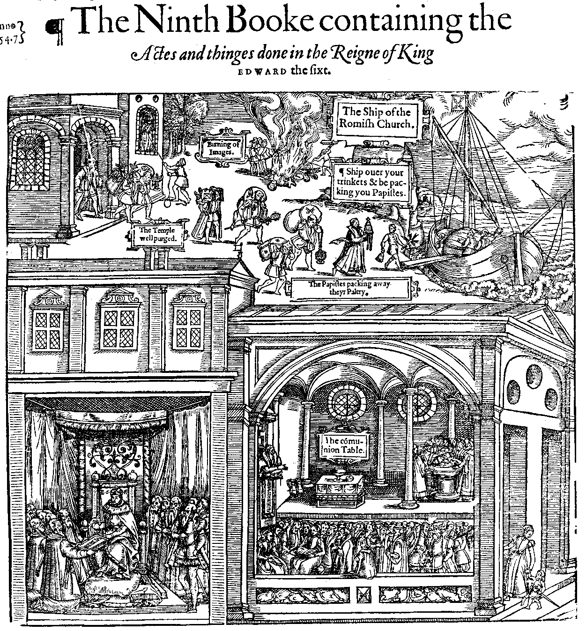
An allegory of the reign of Edward VI from John Foxe Acts and monuments, 1570 edition, p.1521. Accessed from http://www.johnfoxe.org/index.php. The scene shows the pulling down of Catholic idolatry and Edward giving the word of God in its place.
Appendix 2.
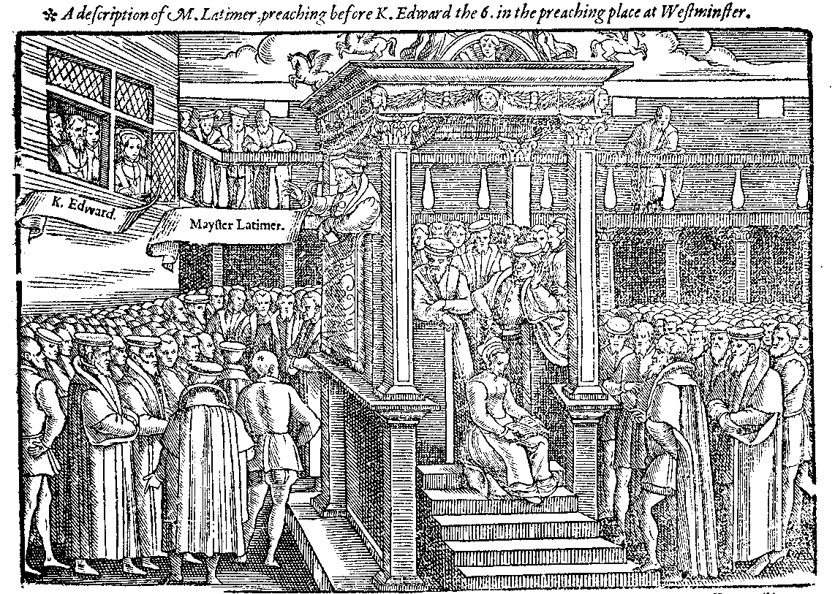
Edward listening to a sermon preached by Hugh Latimer, in Foxes Acts and Monuments, 1570 Edition. . Accessed from http://www.johnfoxe.org/index.php.

Appendix 3.
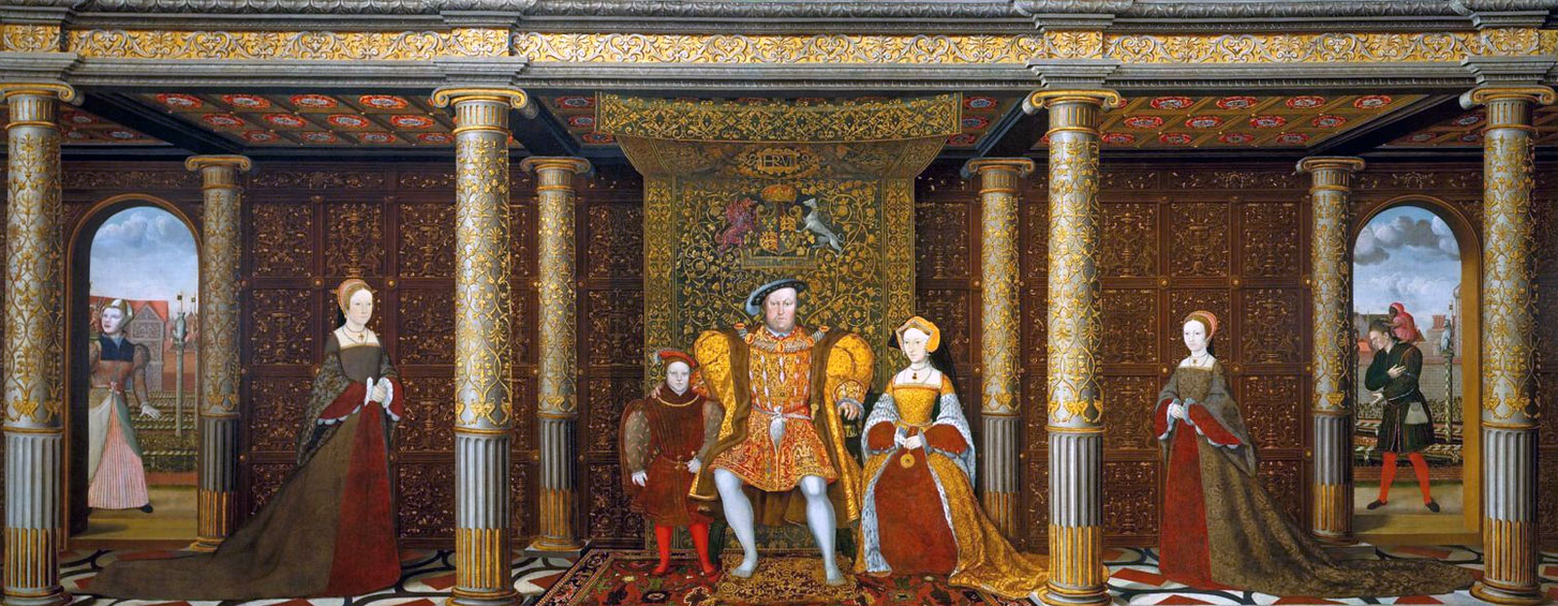
The Family of King Henry VIII, C.1545 Unknown artist, after Holbein.
Hampton Court Palace. © The Royal Collection.
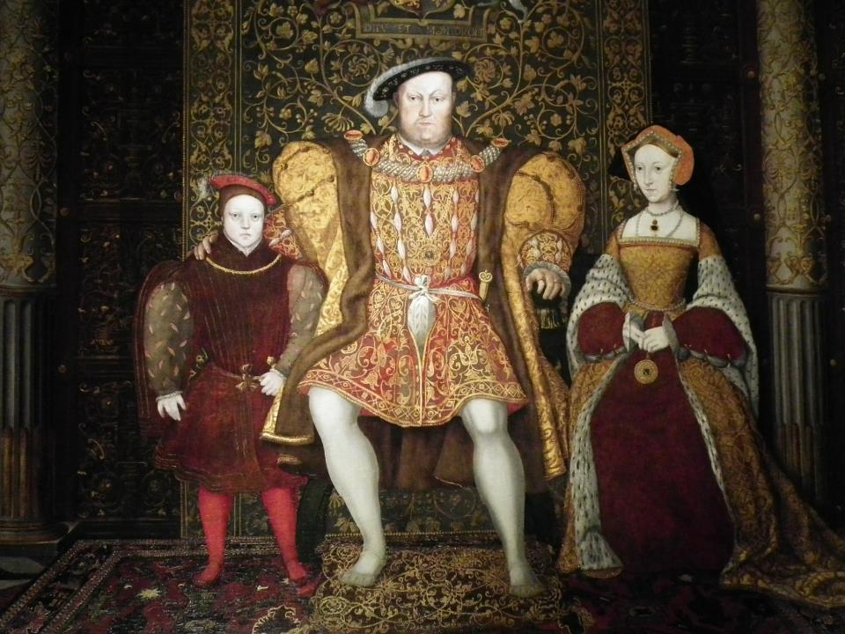
Detail from The Family of King Henry VIII, C.1545 Unknown artist, after Holbein.
Hampton Court Palace. © The Royal Collection. The similarities between Edward and Henry are clear.

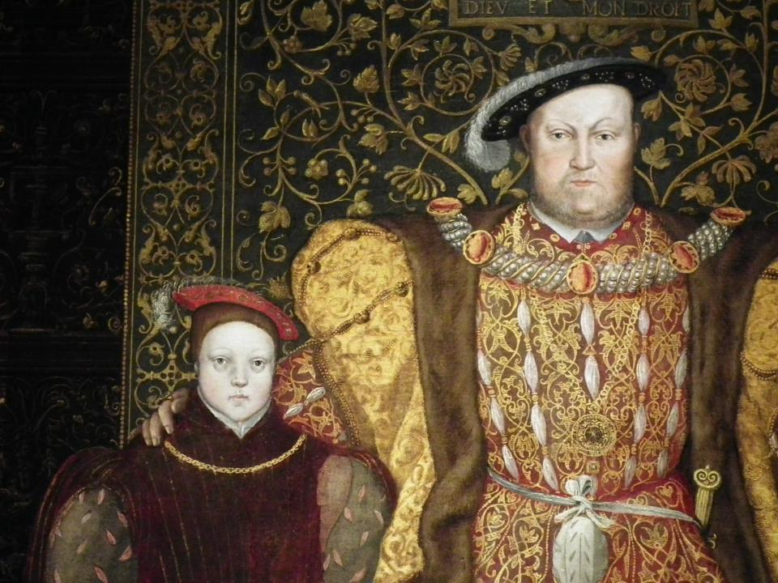
Further detail highlighting the similarities in the pose/composition of images of Edward and Henry. The Family of King Henry VIII, C.1545 Unknown artist, after Holbein.
Hampton Court Palace. © The Royal Collection.

Appendix 4.
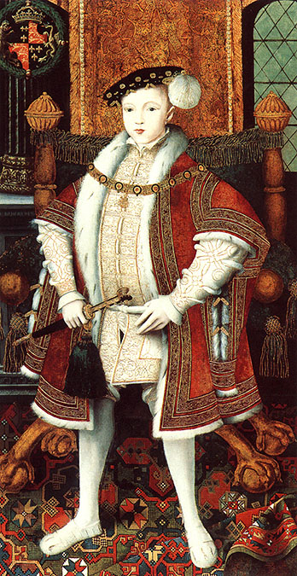

King Edward VI
by Unknown artist
oil on panel, circa 1547
On display at the National Portrait Gallery
This portrait was to become the prototype for visual depictions of Edward.

Appendix 5.
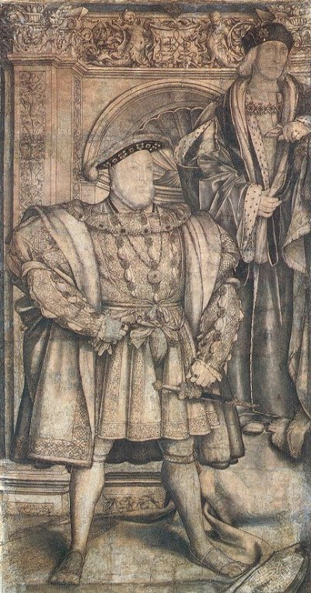
Henry VIII, Hans Holbein, cartoon for the Whitehall Mural, 1537, on display at the National Portrait Gallery
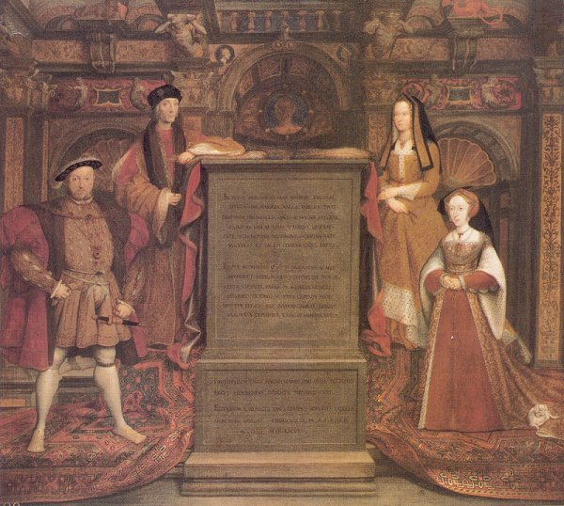
The Whitehall Mural, c.1537, after Holbein Unknown artist.

Appendix 6.
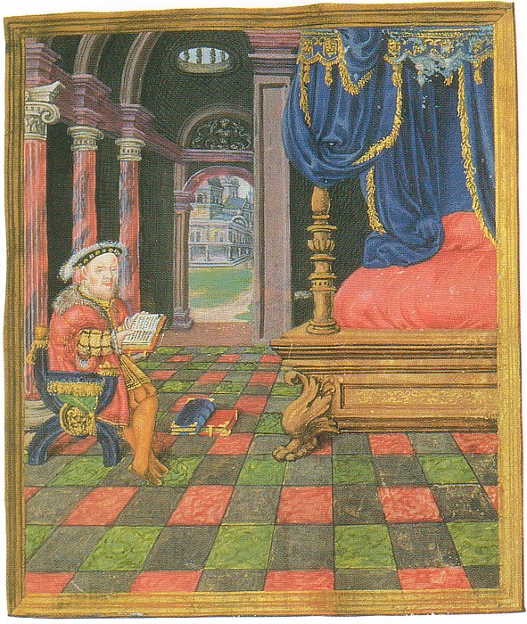
Henry VIII as the biblical king David from his Latin Psalter, 1542

These forms of representation include sermons, proclamations, speeches, portraiture and woodcuts.
The literature on this is huge. For the classic interpretation see, Whitney Jones, The Mid-Tudor crisis 1539-1563, (London: Macmillan, 1973)
For example David Loades recent survey text on the Tudor dynasty includes a chapter entitled ‘The selling of the monarchy.’ See David Loades The Tudors: History of a Dynasty, (London: Continuum, 2012); pp.169-188.
Paul Binski, Westminster Abbey and the Plantagenets: Kingship and representation of power 1200-1400, (London: Yale University Press, 1995); p.8.
John G. Nichols (ed.), Literary remains of King Edward the Sixth vol 1., (London: The Roxburghe Club, 1857); p. ccxcvii.
Nichols, Literary remains vol 1.,p. ccxcvii.
Susan Brigden, New worlds/lost worlds: the rule of the Tudors 1485-1603, (London: Penguin Books, 2000); p.112.
Franklin Le Van Baumer, The early Tudor theory of kingship, (New York: Russell and Russell, 1966); p.154.
Diarmaid MacCulloch, Reformation: Europe’s Houses Divided 1490-1700, (London: Penguin Books, 2003); p.77.
MacCulloch, Reformation, p.77.
J.P.D Cooper, Propaganda and the Tudor State: political culture in the Westcountry, (Oxford: Oxford University Press, 2002); p.210.
W.K Jordan, Edward VI: The threshold of power: the dominance of the Duke of Northumberland, (London: George Allen and Unwin, 1970); p.21. Edward’s kingly education was overseen, overwhelmingly, by humanist, protestant scholars including John Cheke, Roger Ascham and Peter Cooke. The impact of these scholars, and there teaching, on Edward’s royal image will be explored in the second chapter of this study but for a brief introduction see the entry on Edward VI in The Oxford dictionary of National Biography
Stephen Alford, Kingship and politics in the reign of Edward VI (Cambridge: Cambridge University Press, 2002); p.38. The importance of the commonwealth as a conceptual field in the early modern period has been recently argued by historians. For some examples see Early Modern Research Group, ‘Commonwealth: The social, cultural and contextual contexts of an early modern keyword,’ The Historical Journal, 54, 2011, pp.659-687 and Ethan Shagan, ‘The English people and the Edwardian Reformation’ in Ethan Shagan, Popular politics and the English Reformation, (Cambridge: Cambridge University Press, 2003), pp.270-304.
Early Modern Research Group, ‘Commonwealth: The social, cultural and contextual contexts of an early modern keyword,’ The Historical Journal, 54, 2011, p.663. This of course became an increased concern of rulers after the schismatic effect of reformation.
In the commonwealth model the monarch was conveyed as on top temporally, but was understood as God’s representative and was therefore always under God’s authority and expected to act in a godly manner. The commonwealth ideal then did not provided a mandate for absolute despotic rule.
Anthony Fletcher and Diarmaid MacCulloch, Tudor Rebellions, fifth edition, (London: Pearson Longman, 2008[first edition 1968]); p.14.
Furthermore existing discussion on the royal image tends to centre on the two ‘great’ Tudor monarchs Henry VIII and Elizabeth I only.
Strong is arguably the leading figure on the history of the Tudor royal portrait and royal iconography. For examples of his work which deal with the Tudor royal image in this way see: Roy Strong, The cult of Elizabeth, (London: Pimlico, 1999), Roy Strong, Portraits of Elizabeth I, (Oxford: Clarendon Press, 1963), Roy Strong, Holbein and Henry VIII, (London: Routledge and Kegan Paul, 1967)
The idea of the deliberate political construction of royal representations forms the central argument in his 2010 study, Selling the Tudor Monarchy: Authority and image in sixteenth-century England, (London: Yale University press, 2009)
Sharpe, Selling, pp.xiii-xxix.
Sydney Anglo, Images of Tudor Kingship, (Guildford: Seaby, 1992), Theodore K. Rabb, ‘Play not politics: who really understood the symbolism of renaissance art?,’ Times literary supplement, 1995, pp.18-20.
David Howarth, Images of Rule: Art and politics in the English renaissance 1485-1649, (Basingstoke: Palgrave Macmillan, 1997); p.6.
Anglo, Images of Tudor Kingship, p.107.
Sharpe, Selling, p.xxiii.
Sharpe, Selling, pp.xiii-xxix. Quote, p.xiii.
Sharpe, Selling, pp.xviii-xxvi.
Sharpe, Selling, p.7.
Lucy Woodling, ‘Review of Selling the Tudor Monarchy: Authority and Image in Sixteenth-Century England’, (review no. 852), URL: http://www.history.ac.uk/reviews/review/852, Date accessed: Tue 6 September 2011 1:11:41
Sharpe, Selling, pp.33-34, p.55
Sharpe, Selling, p.xvii. Of course Henry’s break from Rome provided fervent Catholics with valid reason to question his authority to rule.
Karl Gunther, ‘Review: Kevin Sharpe Selling the Tudor Monarchy: authority and image in sixteenth century England’, The Journal of Modern History, vol.83, 2011, pp. p.158-160; p.58. , Alec Ryrie, The age of reformation: The Tudor and Stuart realms 1485-1603, (Harlow: Pearson Longman, 2009); p.34.
Ryrie, The age of Reformation, p.34. This is of course a reality which had been illustrated to contemporaries in the founding of the Tudor dynasty, by usurpation, on Bosworth Field.
Sharpe argues that the value of using the royal image as a way of gaining consent may go some way to explaining the enduring legacy of the Tudor monarchs (particularly Henry VIII and Elizabeth I) even in the modern day. Sharpe, Selling, pp.xxiii-xxix.
Cooper, Propaganda, p.213.
Cooper, Propaganda, p.214.
Cooper, Propaganda, p.214.
Furthermore the reformation saw an expansion of the social responsibilities of the crown. The monarch as head of the church effectively took on the social functions which were originally the concern of the clerical establishment, such as provision of charity and care for the poor. The state was also now directly responsible for spreading the Protestant message. A royal image which portrayed these new roles was therefore also of much political importance. This image had strong connections with the rhetoric of the godly commonwealth which portrayed the monarch as both religious and temporal ruler, working in the ‘common good’ of his subjects. See Whitney Jones, The Tudor Commonwealth, 1529-1559: a study of the impact of the social and economic developments of mid-Tudor England upon contemporary concepts of the nature and duties of the commonwealth, (London: Athlone Press, 1970)
Sharpe, Selling, p.47.
David Loades has recently re-emphasized this point arguing how “even before his accession Edward had been presented as the heir to his father’s virtues, as well as to his throne.” David Loades, The Tudors: History of a Dynasty, (London: Continuum, 2012); p.176).
Sharpe, Selling, p.189.
This was a task undertaken through the advertisement of his kingship in a number of publications, such as ‘A glass of the truth’ (1532) and ‘A necessary doctrine’ (1543). Kevin Sharpe, ‘Sacralisation and demystification. The publicization of monarchy in early modern England,’ in Jeroen Deploige and Gita Deneckere (ed.), Mystifying the Monarch: studies on discourse, power and history, (Amsterdam: Amsterdam University press, 2007), pp.99-116; p.103.
This is a reality which Karen Hearn argues can be seen in the “diverse range of his surviving portraits (which) bears witness to intense contemporary interest in this male heir to the throne.” Karen Hearn, Dynasties: painting in Tudor and Jacobean England 1530-1630, (New York: Rizzoli, 1996); p.49.
Recent scholarship actually suggests that Edward would have reached maturity before the usual age of 21 and taken personal control of government at the age of 16. This may be a testament to the success of his ‘mature’ royal image which was ‘sold’ from birth (an idea explored in chapter one.) For a current exploration into this idea see Jennifer Loach, Edward VI, (London; Yale University Press, 1999) (ed.) George Bernard and Penry Williams
This need for ‘popular’ support of the Edwardian reformation and the way in which a specific royal image was portrayed to enjoin this will be explored in chapters two and three predominantly with regards to Edward’s image as a godly commonwealth king.
An image which it will be argued was also consciously adopted and portrayed by Edward himself as the reign progressed. This is an argument put forward in chapter three.
For example see sections on Edward in Susan Brigden, New worlds/lost worlds, (London: Penguin Books, 2000), Alec Ryrie, The age of Reformation: the Tudor and Stuart Realms 1485-1603, (Harlow: Pearson Longman, 2009) Felicity Heal, Reformation in Britain and Ireland, (Oxford: Oxford University Press, 2003), also see chapter ‘Propaganda’ in J.P.D Cooper, Propaganda and the Tudor state, pp.210-247, for a more general exposition of the godly king image in political thought.
The image of Edward as Josiah and the subsequent effect of this association for thinking about Edward’s royal image and reign more generally is discussed in chapters two and three.
These studies are Diarmaid MacCulloch, Tudor Church Militant: Edward VI and the Protestant Reformation, (London: Allen Lane, 1999), W.K Jordan, Edward VI The Young King: The protectorship of the Duke of Somerset, (London: Allen and Unwin, 1968), W.K Jordan, Edward VI: The Threshold of Power, the dominance of the Duke of Northumberland, (London: Allen and Unwin, 1970), Jennifer Loach, Edward VI, (London: Yale University Press, 1999) (ed.) George Bernard and Penry Williams.
Loach, Edward VI, p.1., Diarmaid MacCulloch, Tudor Church Militant, Stephen Alford, Kingship and politics in the reign of Edward VI, (Cambridge: Cambridge University Press, 2002.) The study builds on Alford’s work in particular as whilst not looking through the angle of royal image, in Kingship and politics in the reign of Edward VI Alford provides the first serious study of the practical and conceptual ideals of Edwardian Kingship.
Moreover, revisionist consensus on the nature of change in the reformation, which sees this more as a result of reluctant compliance opposed to religious fervour, suggests that compliance was something which needed to be gained; perhaps an important way of gaining this was through the selling of an effective royal image. For an important study which views the Reformation in this way see Eamon Duffy The stripping of the Altars: Traditional religion in England c.1400-1580, second edition, (London: Newhaven, 2005[first edition 1992])
Helen Hackett, ‘Dreams or Designs? Cults or constructions? The study of images on Monarchs’, The Historical Journal, 2001, pp. 811-823; p.811.
Hackett, ‘Dreams or Designs,’ The Historical Journal, p.811. These studies being, Adrian Munich, Queen Victoria’s Secrets, (London: Columbia University Press, 1996) and Thomas N. Corn (ed.), The Royal image: representations of Charles I, (Cambridge: Cambridge University Press, 1999)
Maurice Howard, The Tudor Image, (London: Tate Publishing, 1996) p.62.
Sharpe, Selling, p.4.
For examples of their work see Stephen Orgel, The Illusion of Power: Political theatre in the English Renaissance, (London: University of California Press, 1975), Michael Baxandall, Patterns of intention: on the historical explanation of pictures, (London: Yale University Press, 1985), Clifford Geertz, The Interpretation of cultures, (New York: Basic Books, 1973), Michel Foucault, The Archaeology of Knowledge, (London: Tavistock Publications, 1972), Michel Foucault, Power: Essential works of Foucault Vol 3, (London: Penguin, 2002), (ed.) James D. Faubion.
See Anglo, Images of Tudor kingship, and Rabb, ‘Play not politics,’ Times literary supplement
Howarth, Images of Rule, p.1.
Anglo, Images of Tudor Kingship, p.107.
It is an interesting point that in Images of Tudor Kingship Anglo, through questioning the value in exploring images of this kind, actually doubts the very validity of his previous scholarly work which was devoted to the spectacle and pageantry of Tudor monarchy. See Sharpe, Selling, pp.48-49
In Propaganda and the Tudor State: political culture in the Westcountry, (Oxford: Oxford University Press, 2002)
Cooper, Propaganda, p.216. Cooper looks at church warden’s accounts to assess the extent to which the image of monarchy had infiltrated the parishes of Devon and Cornwall by looking at examples such as the possession of prayer books and presence of royal arms as evidence. He argues that the view of these parishes as detached and with little exposition to the institution of monarchy needs to be reassessed.
Cooper, Propaganda, p.11.
See Sharpe, Selling, pp.48-49 for his criticism of Anglo’s theories. For a further study on the ‘intentions’ of images as disseminators of messages and values more generally see Michael Baxandall, Patterns of Intention: on the historical explanation of pictures, (London: Yale University Press, 1985)
Anglo, Images of Tudor Kingship, p.107.
See Anglo, Images of Tudor Kingship, pp.120-123.
Dairmaid MacCulloch, Reformation, p.256. Moreover the print industry was central to a Protestant regime as it was a religion based around the word of God. As a protestant king therefore, whose duty was to bring the word to his people, Edward obviously required printed books!
For some more examples of studies which link culture and politics see: J. Plunkett, Queen Victoria: First Media Monarch, (Oxford: Oxford University Press, 2003), David Howarth, Images of rule: art and politics in the English renaissance 1485-1649, (Basingstoke: Palgrave Macmiilian, 1997), Peter Burke, Eye witnessing: the use of images as historical evidence, (London: Reaktion, 2001), C.S Knighton and Richard Mortimer (ed.), Westminster abbey reformed 1540-1640, (London: Ashgate, 2003) , Margaret Aston, The Kings Bedpost: Reformation and Iconography in a Tudor Group Portrait, (Cambridge: Cambridge University Press, 1993)
Peter Burke, Eye-witnessing: the use of image as historical evidence, (London: Reaktion, 2001); p.61.
A different study to this one would be an exploration into public representations of monarchy in the Tudor period; this is an area which I feel is in need of more research. Due to word constraints I am unable to look at this in my study. Furthermore it is the ‘royal representations’ of the monarch which, it is argued, reflect the main argument of my dissertation, that of the connection between the royal image and Tudor politics.
King James Holy Bible, (Massachusetts: Hendrickson Bible, 2001); Ecclesiastes 10:16 10:17
Nichols (ed.), Literary remains of King Edward the Sixth vol 1, vol 1, p.lxxxvi.
Prominent opposition to Edward’s authority, due to him being a minor, came from Stephen Gardiner and also the King’s half sister Mary. Gardiner would prove to be a thorn in Somerset’s side throughout his protectorship, trying at all times to de-rail the move towards Protestantism. See Diarmaid MacCulloch, Tudor Church Militant: Edward VI and the Protestant Reformation, (London: Allen Lane, 1999); p.61., W.K Jordan, Edward VI The Young King: The protectorship of the Duke of Somerset, (London: Allen and Unwin, 1968); p.440., J.P.D, Cooper, Propaganda and the Tudor State, (Oxford: Oxford University Press, 2002); p.161.
MacCulloch, Tudor Church Militant, p.20.
Sharpe, Selling, p.193.
Sharpe, Selling, p.193.
Chris Skidmore, Edward VI: The lost King of England, (London: Orion Books, 2007); p.62.
Skidmore, The lost king, p.2. Of course it has already been argued that monarchy, even in medieval times, had always been seen as a godly institution. Nonetheless the Act of Supremacy intensified the godly nature of Tudor Kingship by legally sacralising the monarch.
For historians who have characterized Somerset’s protectorship in this way see Ethan Shagan, ‘Protector Somerset and the 1549 Rebellions: New sources and New perspectives’, English Historical Review, 1999, pp.34-63 , Alec Ryrie, The age of reformation the Tudor and Stuart realms 1485-1603, (London: Pearson Longman, 2009) , Susan Brigden, New Worlds Lost Worlds: The Rule of the Tudors 1485-1603, (London: Penguin, 2000), Paul Thomas, Authority and Disorder in Tudor Times 1485-1603, (Cambridge: Cambridge University Press, 1999)
Sharpe, Selling, p.74.
Cooper, Propaganda, p.11. Cooper has argued that the records of churchwarden’s accounts provide evidence that the parishes in the West Country were purchasing and enforcing the new liturgy (most importantly the Book of Common Prayer) which was at the centre of the regime. He has discovered that the impact of the Book of Common Prayer and other Protestant writings was much more widespread than is often thought. For a study in royal image, therefore, his findings suggest that familiarity with the monarch was becoming a part of everyday life and the pulpit had become a key way to ‘sell’ the monarch.
Cooper, Propaganda, p.11.
Cooper, Propaganda, p.11.
Cooper, Propaganda, p.35.
Jordan, The young King, p.349.
Jennifer Loach, Edward VI, p.135.
This sermon has had a significant effect on characterizations of Edward. In chronological order here is a list of key texts which explicitly refer to the sermon and Edward as ‘Josiah.’ John M. King, English Reformation literature: the Tudor origins of the Protestant tradition (New Jersey: Princeton University Press, 1982), p. 167, C. Bradshaw, ‘David or Josiah? Old Testament kings as exemplars in Edwardian religious polemic’, in B. Gordon, ed., Protestant history and identity in sixteenth-century Europe (Aldershot: Ashgate, 1996), vol II, pp. 77–90, Graeme Murdock, ‘The importance of being Josiah: an image of Calvinist identity’, Sixteenth Century Journal, 1998, pp.1043–59, at p. 1048 , J. Loach, Edward VI (London: New Haven, 1999), pp. 37, 48–9 , Dairmaid, MacCulloch, Tudor church militant : Edward VI and the Protestant Reformation, (London: Allen Lane, 1999), pp. 62 and 231, Stephen Alford, Kingship and politics in the reign of Edward VI, (Cambridge: Cambridge University Press, 2002), p. 52, Felicity Heal, Reformation in Britain and Ireland (Oxford: Oxford University Press, 2003), pp. 157–8 , Chris Skidmore, Edward VI: the lost king of England (London: Orian books, 2007), pp. 61–62, Alice Hunt, The drama of coronation : medieval ceremony in early modern England (Cambridge: Cambridge University Press, 2008), pp. 78–98 , Kevin Sharpe, Selling the Tudor monarchy: authority and image in sixteenth-century England (London: New Haven, 2009), pp. 212, 236. From Diarmaid MacCulloch, ‘Foxes, Firebrands and Forgery: Robert Ware’s pollution of Reformation History’, The Historical Journal, 2011, pp.307-346, p.343
Diarmaid MacCulloch, ‘Foxes, Firebrands and Forgery: Robert Ware’s pollution of Reformation History’, The Historical Journal, 2011, pp.307-346.
MacCulloch, ‘Foxes Firebrands’, The Historical Journal, p.318, 328. MacCulloch has traced the origins of this forgery back to Robert Ware’s 1682 publication Foxes and Firebrands and believes that it entered into historiography largely as a result of its inclusion in John Strype’s, The Memorials of Thomas Cranmer Archbishop of Canterbury, in 1694.
It is interesting to note that in the first historical bibliography of Edward’s reign by John Hayward, which was published in 1630 before Ware’s forgery, Edward is not characterized as a new Josiah. Instead Hayward emphasizes the unique nature of Edward’s learning abilities and his preference to ‘sell’ himself as a clement, wise king. This is suggestive of the unrealistic perceptions Wares forgery may have had on historical thinking on Edward’s royal image. See John Hayward, The life and raigne of King Edward the Sixth, (Ohio: The Kent state university press, 1993[first published 1630]) (ed.) Barrett L. Beer, pp.1-25. pp.36-37.
Skidmore, The lost king, p.18 quoting Latimer, Calendar of State papers of Henry VIII, p.571
Portraiture was a key way of selling ideals of kingship to foreign courts and the nobility, who were vital in securing Edward’s rule.
Skidmore, The lost king, p.29.
Research at The National Portrait Gallery highlights the deliberate use of symbolism in this portrait. It has been discovered that Edward’s stance had to be made smaller than was originally intended. It appears that the stance which was meant to be the same as that of his father’s portraits did not look correct on an image of a boy of just nine. This of course highlights the difficulties Edward and his government had over his image, especially when trying to transfer the symbolism (and therefore authority) of Henry onto his young son. See Clare Gittings, The National Portrait Gallery of the Tudors, (London: Scala, 2006)
Sharpe, Selling, p.208, quoting Paul. L Hughes and James Francis Larkin, Tudor Royal Proclamations vol 1: The Early Tudors 1485-1553, (London: Yale University Press, 1964); no.275, p.381.
After the reformation the image of Henry as a commonwealth king helped bolster his position as head of state ruling for the good of his people. Moreover the continuity of the royal image here is also an important way of arguing authority in transferring it from Henry as commonwealth king to Edward in the same guise. For some examples of Henry using the commonwealth rhetoric see Sharpe, Selling, pp.96-100.
See Ethan Shagan, ‘The English people and the Edwardian Reformation,’ Popular politics and the English Reformation, (Cambridge: Cambridge University Press, 2003), pp.270-304.
Shagan, Popular politics, p.275. This political image which had obvious value in a minority was first widely introduced in this proclamation of Edward’s accession and again in the 1547 ‘Book of Homilies.’ Cooper, Propaganda, p.220. The homilies were an effective way of getting Edward’s image across as they were in the voice of the monarch and through royal injunction were to be read in church every Sunday. This commonwealth representation of godly kingship is most explicit in ‘The homily of obedience’ which not only conveyed Edward as a Commonwealth King but almost threatened those who dared challenge the theory: “Take awaye kynges, princes, rulers...and such states of gods ordre, no man shal ride or go by the high waie unrobed...and there must nedes follow all mischief and utter destruction, both of soules, bodies, goodes and common wealthes.” Cooper, Propaganda, p.161-62, p.221-223 quoting from ‘An exhortion concerning good order and obedience to rulers and magistrates’ from the Book of Homilies.
Of course this ‘popular’ image of Edward’s godly kingship would not succeed in stopping rebellion. In fact in 1549 the portrayal backfired when rebels in the west and East Anglia began to adopt the commonwealth rhetoric as a way of arguing that the king and his government should protect the rights that they believed this image showed they acknowledged. This is an idea explored in depth later in the chapter.
Jordan, The young King, p.41.
For further explorations into this idea see Christopher, Haigh, English Reformations: Religion, Politics and society under the Tudors, (Oxford: Clarendon Press, 1993) and Richard Rex, Henry VII and the English reformation, (Basingstoke: Palgrave Macmillian, 2006)
Nichols, (ed.), Literary remains Vol 1, p.cxliv.
Jordan, The young King, p.43.
Cooper, Propaganda, p.214.
See John N. King, English Reformation literature: the Tudor origins of the Protestant tradition, (New Jersey: Princeton University Press, 1982); p.161. Moreover they highlighted the ‘godly’ pedigree of monarchy as further justification of a king’s authority, especially in religious matters.
Sharpe, Selling, p.214. quoting the dedicatory from Nicholas Udall in, The Final tome or volume of the Paraphrase of Erasmus vpon the newe testament, 1548
Loach. Edward VI, p.13. An interesting remark on Edward's linguistic ability which is suggestive that this was an image deliberately exaggerated as opposed to an accurate reflection of reality comes from the correspondence of the imperial Ambassador at Edward's coronation proceedings, Van der Deflt. In his writings to the emperor Van de Deflt recalls how during Edward's coronation procession he greeted the young monarch in French but was promptly asked by Somerset to continue in Latin as Edward understood this better. The ambassador sharply recalls ‘the truth to tell he seemed to understand one just as little as the other.’ See Jordan, The Young King, p.69.
Sharpe, Selling, p.194. The image of the ‘clement king’ would be much utilized as a way of attempting to secure compliance in the rebellions of 1549: see Shagan, ‘Protector Somerset and the 1549 Rebellions: New sources and new perspectives’, English historical review, for a good example of this policy in action. In her biography on Edward Jennifer Loach also provides evidence of the non-academic side of his schooling and discusses how the prince much enjoyed watching and both taking part in physical activities and tournaments. This physical side to Edward’s kingly education, and it’s repercussions for his royal image, will be explored in the next chapter of this dissertation which deals with the later part of the reign. This is because from 1550-1553 in light of his growing physical maturity an image of Edward as a martial prince in both mind and stature was increasingly ‘sold’ to the polity. See Loach, Edward VI.
A letter written to Somerset in 1547 illustrates some of the fundamentals of Kingship instilled in Edward through his education. The young monarch highlights the importance of “equity and justice...faith and true religion, courage and valour” as kingly virtues. Nichols, (ed.), Literary remains vol.1., p.47. It was common for the young king to express his kingship through his pen, which of course only added to the ideal of a ‘learned prince’. Indeed in light of Edward’s tentative authority the pen and the pulpit were primary modes of royal representation. These forms were important as they could ‘sell’ Edward’s godly kingship without having to deal with the physical un-impressiveness of his youth and the anxieties this caused. This is an idea which is explored in depth in chapter three as it was under Northumberland, and in light of Edward’s growing maturity, that he began to fully utilize the craft as a way of selling written expressions of kingship.
Sharpe, Selling, p.223.
For a full contemporary account of coronation proceedings see Nichols (ed.) Literary remains vol.1., pp.cclxxviii-cccii.
Nichols (ed.), Literary remains Vol 1., p.xcv.
Nichols (ed.), Literary remains Vol 1., pp. cclxxviii-cccii
Loach, Edward VI, p.34 and Nichols (ed.), Literary remains Vol 1., p.cclxxxvi. Edward representation as Henrys legitimate heir was also clear in a pageant in which Edward was addressed by a boy dressed as ‘truth’ (which in itself was another reflection of an idealised royal image,) the boy predicted that ,“Then shall England, committed to your gard, rejoice in God, which hath govern her nation, After old David, a younge Kynge Salomon.” Nichols (ed.), Literary remains vol 1., p. ccxcvii.
The coronation medal struck to celebrate this occasion further ‘sold’ some of the images dominant at the coronation. Edward is shown in armour reminiscent of his father on horseback wielding the sword of faith: with inscriptions in Latin, Greek and Hebrew stressing his supremacy. See Skidmore, The lost king, p.62. The coronation medal is illustrative of the way in which the royal image was used to portray the dual authority of Edward’s kingship; ‘the sword and the book.’ The importance of the imagery of the sword and book is argued in two works by John N. King: English Reformation literature: the Tudor origins of the Protestant tradition (New Jersey: Princeton University Press, 1982) and King, John.N, Tudor Royal Iconography, (Guildford: Princeton University Press, 1989). In Images of Tudor Kingship, Sydney Anglo has argued that the images of Edward at this event should not be seen as politically conscious as the intricate symbolism of many of the displays would not be understood by the lay majority. Nonetheless they were aimed at the king and his government and the image of the renaissance prince coming from official channels was clearly designed to impress and state the king’s authority, in terms which would have been clear to all who saw him pass by. Moreover the obvious biblical imagery in the pageants, of angels for example, would have also been understood in the religious world view of the sixteenth century regardless of whether some of the more specific messages were missed. Another key element with regards to the royal image the authorities appropriated for Edward suggested that his monarchical authority went back even further than the foundations of his grandfather’s dynasty. Sydney Anglo has noted how the pageants put on for Edward were actually adapted from an earlier procession put on for the boy king of England and France, Henry VI ,for his return from France in 1432. See Sydney Anglo, Spectacle Pageantry and Early Tudor Policy, (Oxford: Clarendon Press, 1969); p.284. Anglo, however, fails to recognise the repercussions of this choice for Edward’s royal image. Kevin Sharpe and Diarmaid MacCulloch have argued how the choice of adapting the pageants for Henry VI was a deliberate one because it invoked a distinct brand of kingship which was suitable to Edward’s position. See MacCulloch, Tudor Church, p.63. and Sharpe, Selling, p.225. Henry VI was a boy king who had gone on to rule as an adult. He had a reputation for piety and in 1547 he was viewed by contemporaries as a royal saint. The legacy of Henry VI’s Kingship, the ‘pious’ boy king, was clearly a powerful and politically charged image for Edward to be seen to embody. For a detailed exploration into the early modern cult of ‘saint’ Henry VI see Sydney Anglo, Images of Tudor Kingship, pp.61-73.
Edward talks about risings in Wilshire, Sussex, Hampshire, Kent, Gloucestershire, Suffolk, Warwickshire, Essex, Hertfordshire, a piece of Leicestershire, Worcestershire and Rutlandshire, W.K,. Jordan The chronicle and political papers of King Edward VI, (London: Allen and Unwin, 1966); p.12. The value of Edward’s chronicle as a source for this study is discussed in the following chapter as it is of far more value for the Northumberland years.
This challenge to the Kings authority was also espoused in the demands of Ketts rebellion despite the fact that its causes had much more to do with economic than religious factors. Ketts rebellion was particularly alarming because in their demands the rebels used the commonwealth rhetoric popular with the government (particularly Somerset) to call for the ‘justice’ they believed this language promised them. This therefore highlights the dangers which could arise from the popular publicization of the royal image. This is an argument which would be later used to engineer Somerset’s downfall. For a good introduction to Kett’s rebellion and also the Western rebellion of 1549 see Anthony Fletcher and Diarmaid MacCulloch, Tudor Rebellions, fifth edition, (London: Pearson Longman, 2008[first edition 1968])
Frances Rose-Troup, The Western Rebellion of 1549, (London: Smith Elder, 1913); p.214. The full title is “a message sent by the Kings Majestie, to certain of his people, assembled in Devonshire”.
Sharpe, Selling, p.207.
Cooper, Propaganda, p.243 quoting from John Foxe, The acts and monuments of the Christian Church: Being a complete History of the lives, sufferings and deaths of the Christian martyrs from the commencement of Christianity to the present period , book four, pp.743-5, (ed.) J. Pratt (8 volumes, 1870)
Edward had already ‘written’ his authority on religious change to Somerset in his 1548 ‘Treaty against the supremacy of the pope.’ This treatise without doubt expressed him as a protestant godly king and depicted the pope as ‘the true son of the devil, a bad man, an antichrist and abominable tyrant’. See Nichols (ed.) Literary remains Vol 1., p.173 and MacCulloch, Tudor Church Militant, p.26.
A contemporary record of the Western Rebellion and the siege at Exeter by John Hooker suggests that the image of the commonwealth King was particularly effective in securing public support for the reign. Hooker argues that the city of Exeter held out against the rebels dues to their loyalty to Edward as the head of the English Commonwealth even though they were unsure about the religious policies taking place under him. For a description of Hookers account see Fletcher and MacCulloch, Tudor Rebellions, p.58.
Rose-Troup, Western Rebellion, p.215. quoting ‘A message sent by the Kings Majestie, to certain of his people, assembled in Devonshire.’ The rebels did eventually have to be suppressed through force but this was despite the regime’s best efforts at a peaceful conciliation (though even then this was only the fate of the ringleaders.) See Shagan, ‘Protector Somerset and the 1549 rebellions’, English historical review, for the way in which the regime tried to deal with the rebels through offering pardon.
Shagan, ‘Protector Somerset and the 1549 rebellions,’ English historical review, p.48.
Shagan, ‘Protector Somerset and the 1549 rebellions,’ English Historical review, pp.34-63.
Indeed even after 1549 only two people lost their lives for their religious beliefs: Joan Butcher and George ‘a Dutchman.’ Hayward, Life and raigne, p.37. Shagan also argues that it was in part down to the successful portrayal of Edward as a commonwealth king which enabled the Edwardian religious settlement to be implemented without nationwide resistance. He argues that the commonwealth rhetoric was “a site of popular convergence with the regime.” Shagan, Popular politics, p.267.
King of England Edward VI, Copies of seven original letters from King Edward VI to Barnaby Fitz-Patrick, (London: Ecco Print Editions, 2010); p.2. This extract comes from a series of letters written by the King to his favourite who was at the French court from October 1551- September 1552. Edward VI, Seven original letters, p.vi.
Christopher Haigh, English Reformations: Religion, Politics and society under the Tudors, (Oxford: Clarendon Press, 1993); p.176. Under the regime conservative bishops such as Bonner, Heath and Gardiner who had proved troublesome in the Somerset years were removed and replaced with evangelical preachers including Hugh Latimer and John Hooper. This would have a significant impact on the pace of religious change under Northumberland who no longer had to contend with the stalling attempts of the traditionally conservative episcopate. Gardiner was put on trial between December 1550-Feb 1551 which resulted in him losing his see. See Christopher Haigh, English reformations, p.178 and W.K Jordan, The chronicle and political papers of King Edward VI, (London: George Allen and Unwin, 1966); p.53 for King Edward’s recording of this event.
See Diarmaid MacCulloch, Tudor Church Militant, p.57
See MacCulloch, Tudor Church, p57. , Jennifer Loach, Edward VI, p.121., Stephen Alford, Kingship and politics p.121, p.153.
This is an argument put forward in Eamon Duffy, The stripping of the Altars: Traditional religion in England c.1400-1580, second edition, (London: Newhaven, 2005[first edition 1992])
Duffy, The stripping of the Altars, p.470.
Hayward, Life and raigne, p.18 , Alford, Kingship and Politics, p.136, and Felicity Heal, Reformation in Britain and Ireland, p.164.
Kevin Sharpe, Selling, p.195.
Sharpe, Selling, pp.194-5
Sharpe, Selling, pp.194-5
Skidmore, The lost King, p.230, Jordan, Chronicle, pp.113-14
Jordan, Chronicle, p.ix.
Sharpe, Selling, p.199. These ‘position papers’ are re-printed in Jordan, Chronicle, pp.157-190
A royal image with explicit reference to Henry may not have been as overt under Northumberland as it had been under Somerset. Nonetheless Edward was a Tudor Monarch and his royal image was always reflective of this, connecting him to Henry in the fact that they were both sold as Tudor renaissance princes. From 1550 however this was done with more specific personal nuances.
For example in the three schemes he proposed for the reform of the chivalric order of St George (which he would rename to the order of the garter.) The importance of these reforms as a disseminator of a politically minded royal image is explored later in the chapter.
‘A proclamation ordering arrest of persons spreading seditious rumors,’ Paul L. Hughes and James F. Larkin (ed.), Tudor Royal Proclamations volume 1: The Early Tudors 1485-1553, (London: New Haven, 1964); no.352, p.484.
Hughes and Larkin (ed.), Tudor Royal Proclamations, no.352; p.484.
Hughes and Larkin (ed.), Tudor Royal Proclamations, no.352; p.484.There was a further proclamation in December 1549 which directly mentions how Somerset’s fall led to questioning of the new regimes authority, being still in a minority, to enact religious change. This proclamation entitled ‘Ordering Bishops to destroy old service books clearly stated that the Book of Common Prayer was Edward’s idea for reform and also ensured that for many throughout the country the new regime opened with public burning/destruction of catholic texts as a clear reinforcement of the nature of Edward’s godly kingship and indicative of more destructive policies to come. See ‘A proclamation ordering Bishops to Destroy Old Service Books, Hughes and Larkin (ed.) Tudor Royal Proclamation, no.353.; p.485.
Compliance and stability was of increased concern in 1549 as the new regime had disposed of a popular protector and grew out of a dramatic coup d’état.
This less conciliatory image was also clear at the start of 1550 with the first burning of a subject for matters of faith. Joan Butcher was executed on May 2 1550. For the king’s comment on this see Jordan, Chronicle, p.28. Nonetheless this was still only one of two burnings through the whole regime (the second in 1551 being known only as George ‘a Dutchman.’) Edward’s comments suggest that this had not been a rash decision. He states that Butcher had been ‘condemned the year before but kept in hope of conversion.’ Jordan, Chronicle, p.28. Burnings were not to become commonplace under Northumberland but here was a clearly more threatening image than in the Somerset years. As the regime moved towards a more uncompromising form of Protestantism in order to strengthen this position they had to be seen to take more dogmatic action against radicals. This was especially important in light of the accusations that Somerset, and subsequently Edward, had been sympathetic to radical behavior in light of the official reaction to the rebellions of 1549. These burning therefore further set the more assertive tone of the Northumberland years.
MacCulloch, Tudor Church,; p.25. See appendix two for a woodcut image of this in action.
Alford, Kingship and Politics, p.34. quoting John Hooper, An oversight and deliberacion upon the prophete Jonas, 1550
Alford, Kingship and Politics, p.34, quoting Hooper, Oversight.
Alford, Kingship and Politics, p.34, quoting Hooper, Oversight.
It is interesting that even though the ‘iconoclast’ was a more politically appropriate royal image for Edward from 1550 he is still never exclusively Josiah. Whilst his actions may have fostered the image of Josiah in contemporary minds this was not the single of arguably even dominant representation of the ‘godly king’ coming from official channels. For an exploration into the value of old testament kings as a precedent for protestant reformation see Grahame Murdock, ‘The importance of being Josiah: an image of Calvinist identity’, Sixteenth Century Journal, 1998, pp. 1043–59
Jordan, Chronicle, p.55. This entry is also further reflective of Edward’s growing personal authority. The decision to chastise Mary is quite clearly expressed as his prerogative and her actions as an affront to his rule. This attitude to Mary also extended to her household who were forbidden to hear mass in the August of 1551. Jordan, Chronicle, p.76.As Susan Brigden has argued “the divine hand was seen to punish a faithless people in the spring of 1551.” Brigden, New Worlds Lost Worlds, p.195.
Jordan, Chronicle, pp.159-167.
Chronicle, Chronicle, p.160.
Sharpe, Selling, p.194. The medical metaphor was one often associated with the commonwealth. It was argued that just like a body if all the subsequent parts are healthy and working together then the state would remain fit. In this conception rebellion becomes the ultimate ill. For a further discussion on this and an exploration into other metaphors appropriated for commonwealth see Early modern research group, ‘Commonwealth,’ The Historical Journal, pp.671-677.
The continuity of the commonwealth rhetoric also reinforces the importance of a coherent royal image throughout the two Dukedoms especially as it is one so associated with the personal character of Somerset’s. Moreover it reminds us that Edward was not only a spiritual head but also had to be sold as a secular ruler whose main priority was to rule over a stable society. The rhetoric of the ‘godly commonwealth’ was therefore an important way of synthesizing and representing Edward’s dual temporal and spiritual authority.
Loach, Edward VI, pp.180-184.
Loach, Edward VI, p.137.
John M. King, English Reformation literature: the Tudor origins of the Protestant tradition (New Jersey: Princeton University Press, 1982); p.169.
Loach, Edward VI, p.147 and King, Reformation Literature, p.180.
Moreover a more visible and extravagant court emphasized Edward’s royal pedigree in the sense that it stood as a reminder of the impressive court which had existed under his father. Henry’s court had been a mainstay and vital illustration of his power.
St André was sent from Henry II to Edward’s court to invite the king into the order of St. Michael; in return Edward made the French king a knight of the English order of the garter. As an important diplomat it was therefore important that Edward represented himself to St André as a legitimate and capable King. For a full description of the visit see Jordan, Chronicle, pp.71-76.
Jordan, Chronicle, p.73.
Edward was also sold as the ‘godly king’ at court. A number of foreign ambassadors raised concerns over the excessive praise for Edward at court which meant that courtiers were made to kneel before the monarch when serving him and even his royal sisters were not allowed to sit under the state canopy when they visited. This was a clear image that Edward was displayed as more than just an earthly leader. See Loach, Edward VI, pp.144-145.
This would be the first time Edward had been more than 30 miles from London but it was not the first time he had ‘sold’ himself away from court to the public. In his chronicle Edward notes how in 1549 “because there was a rumor that I was dead, I passed through London.” Jordan, Chronicle, p.13. Kevin Sharpe argues the importance of this sentence in illustrating the politically ‘conscious’ element of public displays. Sharpe, Selling, pp.226-7.
Jordan, Threshold of power, p.427.
Jordan, Threshold of Power, p.427.
Hayward, Life and raigne, p.168. Further testament to the visual display of magnificence in the progress can be found in the inventory of the crown jewels where a record of a lost pendant on the progress provides evidence of the kind of jewellery Edward was adorned with, John G. Nichols, (ed.), Literary remains of King Edward the Sixth ,vol. 2, (London: General Books, 2009); p.221.
Nichols, Literary remains vol 2, pp.213-214
Sharpe, Selling, p.227.
Rawdon Brown (ed.) Calendar of State Papers Relating to English Affairs in the Archives of Venice, Volume 5, Venice: August 1554, 16-20', Calendar of State Papers Relating to English Affairs in the Archives of Venice, Volume 5: 1534-1554 (1873), pp. 531-567. URL: http://www.british-history.ac.uk/report.aspx?
For examples see, Jordan, Chronicle, pp.55-58, pp.185-190
Furthermore this was a side of the royal image also sold during the progress where Edward made a point of inspecting the fortifications at Portsmouth and afterwards in a letter to Barnaby Fitzpatrick where he noted their inadequacy. See, Edward VI, 7 original letters, pp.9-10. Quite clearly Edward as a marital prince had connections with Henry’s characterization as the ideal martial warrior. This chapter has argued how the Northumberland years saw a more individualized representation of Edward’s royal image which broke away from representations which explicitly reiterated/reflected his connection to his father. In terms of the martial prince although Henry was quite clearly associated with this image it is more likely that Edward came to be conveyed in this way as it was an image which embodied the general ideal of adult renaissance kingship, as opposed to being an image specifically modeled on Henry.
See Loach, Edward VI, pp.180-184.
These are re-printed in Nichols (ed.), Literary remains vol 2, pp.293-315.
MacCulloch, Tudor Church, p.31. This concern is later emphasized by Mary 1st’s swift and somewhat brutal removal of Edwards’s reforms which saw the order returned to its previous state under Henry VIII. Mary ordered that her half brothers reforms should be “speedily expunged out of the Book of Statutes, and forthwith defaced; lest any memory of them should remain to posterity.” See E.M Thompson, ‘The revision of the statutes of the Order of the Garter by King Edward VI’, Archaeologia, 54, 1894, pp.173-198, p.175.
MacCulloch, Tudor Church, p.31.
The reforms for the order of the garter can also be seen as a clear portrayal of Edward’s individual godly Kingship as he made much effort to get rid of any reference to St. George, a figure who Henry VIII had in official portraiture and in his role as previous patron of the order, been particularly keen to be associated with. In fact Edward proposed to change the name of the order from the ‘Order of St. George’ to the ‘Order of the Garter or defence of the truth as contained in Holy Scripture’, before shortening the title to the ‘Order of the Garter’ in his third and final draft. Thompson, ‘Revision of statutes,’ Archaeologia, p.177.
Thompson, ‘Revision of statutes,’ Archaeologia, p.177.
John G. Nichols (ed.), Literary remains of king Edward the sixth, vol. 2, (London: General Books, 2009) p.313. and E.M Thompson, ‘Revision of the statutes’ Archaeologia, p.179.
Diarmaid MacCulloch has also characterized Edward’s image as a protestant godly king in this way in Tudor Church Militant. In this study he emphasizes the militant nature of the Edwardian reformation, particularly with regards to the more uncompromising changes introduced in the Northumberland years.
This is an attitude Graeme Murdock has seen as symbolic of a ‘new’ wave of continental iconoclast reformers of the sixteenth century. Throughout Europe Protestant princes were not just encouraged by preachers to bring the new church to their subjects but were specifically given ‘iconoclast’ precedents as encouragement for a dramatic, almost militant break. It is not surprising therefore that Edward, who we also know by this time was viewing his reformation in line with a Protestant International, had begun to configure and display his kingship in this way. See Graeme Murdock ‘The importance of being Josiah: an image of Calvinist identity’, Sixteenth Century Journal, 1998, pp. 1043–59
Nichols, (ed.), Literary remains Vol.1., p.cccxix.
Anglo, Images of Tudor Kingship, Sharpe, Selling.
For example in Acts and monuments
MacCulloch, ‘Foxes, Firebrands and forgery,’ The Historical journal, pp.307-346.

